Morriston researchers get £230,000 for next stage of life-saving study
Monday, 9 January 2017
Researchers at Morriston Hospital working on a study that could save lives around the UK have been awarded £230,000 to take it to the next stage.

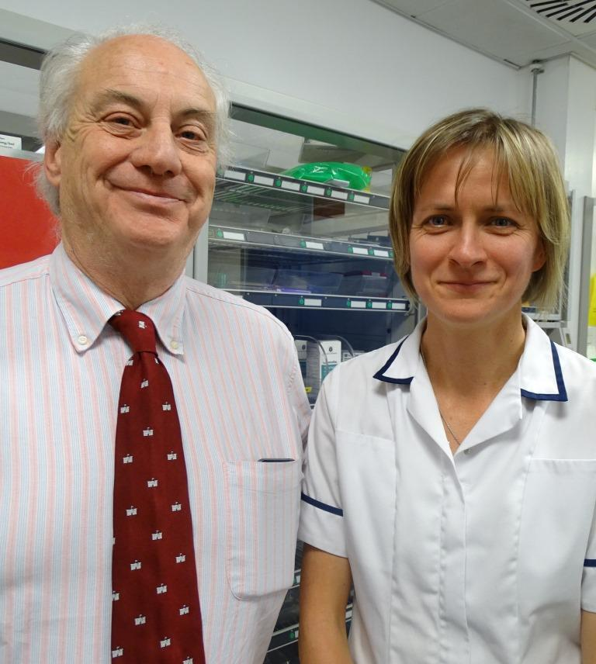
The study, led by Dr Ceri Battle, is being carried out as part of Morriston’s academic emergency medicine research programme.

Professor Adrian Evans and Dr Ceri Battle

It focuses on patients with chest injuries which, while being relatively minor, can lead to serious, potentially fatal complications.

Often, these complications do not emerge for several days, leading to people returning to hospital as emergency cases.

Now research at Morriston Hospital has resulted in the creation of a risk factor-based diagnostic tool that can identify from the start which patients are most at risk of developing complications.

Dr Battle, who leads the epidemiology division of the academic emergency medicine research programme, has been working on the project for a decade.

A further study now needs to be carried out but it is hoped the diagnostic tool will be used as standard across the UK within the next few years.

Dr Battle said: “We first started looking at this about 10 years ago.

“Chest trauma patients were coming into the Emergency Department (ED) and you couldn’t prognosticate which ones would do badly or not because they don’t tend to develop complications for about 72 hours.

“Quite a few patients weren’t doing so well and were coming back to the department with all sorts of problems.

“They were ending up on the ward or in the Intensive Therapy Unit, and some of them died.

“What we have done is work out the risk factors that are important for developing complications.

“These are age, the number of rib fractures, whether the patient has chronic lung disease, whether their oxygen saturations are low when they come in and whether they’re on anticoagulants.

“They get scored on these risk factors and the score tells you where the patient should go – home, to the ward, or to ITU.”

The initial work at Morriston Hospital led to the development of an early risk score and a pilot study was completed in collaboration with the ED.

This in turn developed into Dr Battle’s PhD work. It was supervised by Professor Adrian Evans, who heads the academic emergency medicine research programme, and saw the risk score fully developed and validated in a large UK-wide study.

Another, much larger UK trial is now needed to test whether the screening tool works in clinical practice.

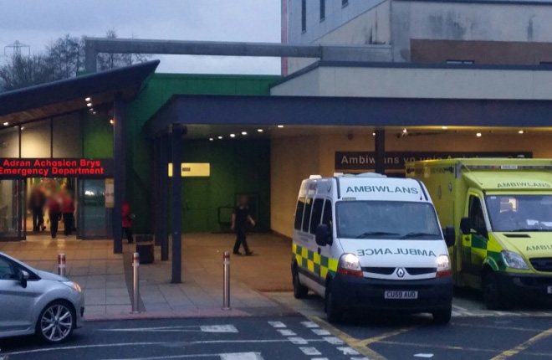
Dr Battle has secured a £230,000 Research for Patient and Public Benefit Grant from Health Research Wales for the feasibility study, which is effectively a scaled-down version of that larger trial.

It has already started and involves four hospitals in Salford, Manchester, Taunton and Newport, with around 300 patients in all taking part.

Data collection should start in February or March and continue for a further five months. The funding lasts until August 2018 but Dr Battle said she expected the results well in advance of that.

She added: “The feasibility study allows us to test all the different aspects of the methods for the big trial.

“After that we will recruit more hospitals and probably involve a couple of thousand patients, to test whether the score actually saves lives.

“The ultimate goal will be getting it into NICE* guidelines, which we hope will happen in perhaps three or four years.”

Professor Evans said: “Because there has not been a system of risk, a lot of patients were not – and still aren’t – treated appropriately.

“This diagnostic tool can save lives and improve care in a patient group which traditionally has been poorly managed.

“The injury may be relatively minor but if you add the risk factors it can quickly escalate.”

“Dr Battle is an outstanding researcher who has been successful not only in developing this study but has played an important role in developing other epidemiological studies with my colleagues in emergency medicine.”
*Note to editors: NICE (National Institute for Health and Care Excellence), provides national guidance and advice to improve health and social care.

Source: Abertawe Bro Morgannwg University Health Board

