Patient safety expert Paul to lend his expertise to UK-wide NHS role
Monday, 16 January 2017
A Morriston Hospital scientist who plays a crucial role in ensuring patient safety across ABMU is lending his expertise to NHS organisations UK-wide.

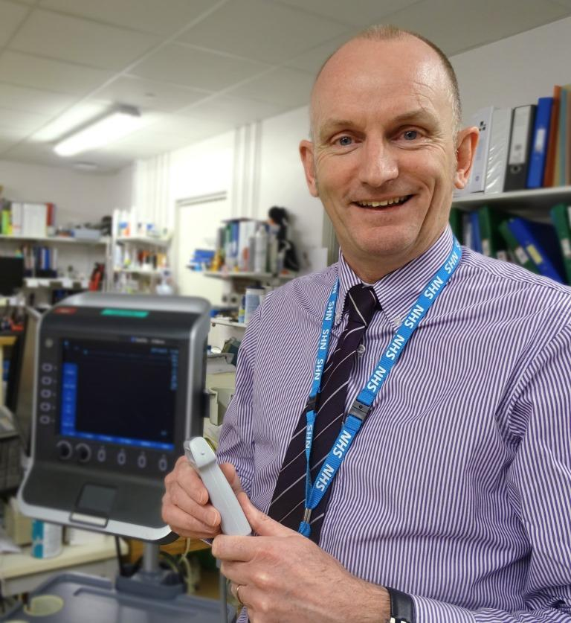
ABMU's medical device training manager Paul Lee has been seconded to NHS Improvement in London to work as its patient safety lead for medical devices until August this year.

Paul’s new role will be helping to develop national advice and guidance to the NHS on reducing risks to patient safety.

He will use his 30 years of expertise in the NHS, and 13 years' experience working in ABMU, to help focus on medical device-related incidents, as well as identifying emerging issues with new technology.

Paul will work closely with royal colleges, the Department of Health and other regulatory organisations and healthcare groups.

He said: “There are thousands of types of medical devices – everything from a cannula, the needle put into your hand to deliver drugs, right through to the ventilator that keeps you alive in intensive care.

“My current job is to design, develop and deliver medical device training courses for all our staff – doctors, nurses and other practitioners – based on what we consider to be the risks.

“My department is also involved in product evaluation – looking at new medical devices as they are rolled out, then identifying who needs to be trained and delivering ongoing training across the health board.

“I also look into incidents and errors, reviewing how the devices are used, the design of the machine and sometimes the environment in which it is used, so we can reduce the risks.”

Paul, a scientist registered with the UK Science Council, is also involved with research and publications, as well as innovative practical applications.

In 2015, for example, he worked with Morriston emergency consultant Kirsty Dickson-Jardine and control of infection nurse Joanne Walters – along with a private company – on a cannula safety pack to reduce the risk of infections.

After being successfully introduced in Morriston emergency department it was taken up by other Welsh health boards, and went on to win a MediWales innovation award.

With Swansea University graduate Mark Davies, Paul also developed a mobile phone app that improves patient safety by helping nursing staff calculate and monitor intravenous drips. It was downloaded worldwide.

His six-month secondment to NHS Improvement in London starts on 1st February.

Paul said: “I will have a strategic overview of all incidents and errors, and the usability of medical devices, right across the UK.

“My role will be to work with teams of experts to identify what the risks are, provide highly specialist advice and issue safety alerts to the rest of the UK.

“I will then have to check that action plans have been agreed and implemented, following the recommendations we issue.”

Paul, who lives in Bridgend, believes his wide-ranging remit within ABMU has put him in good stead for his new role.

“It’s a big challenge but when I come back to the health board in August I will have a much better overview of how we interact with government bodies, royal colleges and agencies.

“So in future, when we get these alerts coming to us, we realise the importance of the advice and the urgency to implement the actions, as they are based on real evidence of injury and harm.”

Source: Abertawe Bro Morgannwg University Health Board

