Cerys says thanks to surgeon who helped get her motoring
Wednesday, 10 January 2018
When teenager Cerys Evans passed her driving test there was one person her family couldn’t wait to share the good news with – consultant ophthalmologist David Laws.
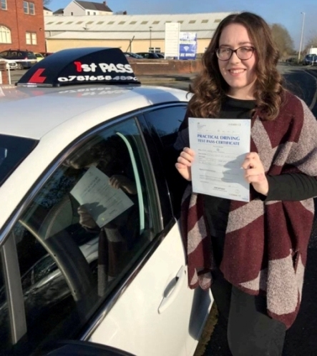
They say if it wasn’t for the fantastic care Cerys received from Mr Laws and his team at Singleton Hospital when she was a little girl she would never have been able to get behind the wheel.

Seventeen-year-old student Cerys, from Pontyberem, was diagnosed with cataracts on both her eyes when she was just two and a half.

Cerys Evans after she passed her driving test.

Mum Dawn said: “I noticed that she always seemed to frown in photos so I took her to an optician in Llanelli to get her eyes checked. They discovered the cataracts and that she had 40 per cent vision.”

After seeing the family GP and attending a clinic at Withybush Hospital in Haverfordwest, Cerys was referred to Mr Laws at Singleton and in November 2002 he operated to remove both the cataracts and replace them with artificial lenses.

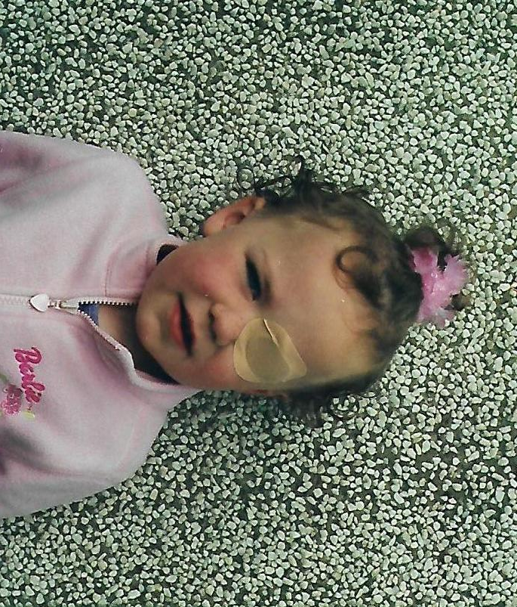
Her condition led to her having to attend regular clinics for check-ups and Cerys had to wear a patch to help improve her vision but even when she was still quite young she wanted to know if her eyesight would be good enough for her to get behind the wheel.

Cerys aged three during her treatment.

Dawn said: “We were outpatients for 10 years and we were delighted to watch her going through her milestones in school but even as a little girl Cerys’s biggest dream was always to be able to drive.”

As soon as Cerys returned from her successful driving test and could rip up her L-plates, Dawn and her husband Chris emailed Mr Laws to let him know.

They wrote: “We felt it was important to share this fantastic news with you. Because of your care our daughter’s dream has come true. We can’t express how grateful we are for what you did to help Cerys and the support we had as parents.”

Coleg Sir Gar student Cerys, who is hoping to become a paediatric nurse, is now the proud owner of her own car and likes nothing better than driving herself to the gym or going on a shopping trip.

She said: “I’m delighted to have passed my test, this has been a dream of mine for many years. If it wasn’t for the surgery I had as a young child it wouldn’t have been possible.

“I love driving as it’s given me so much independence. I’d like to thank Mr Laws and his team for their care.”
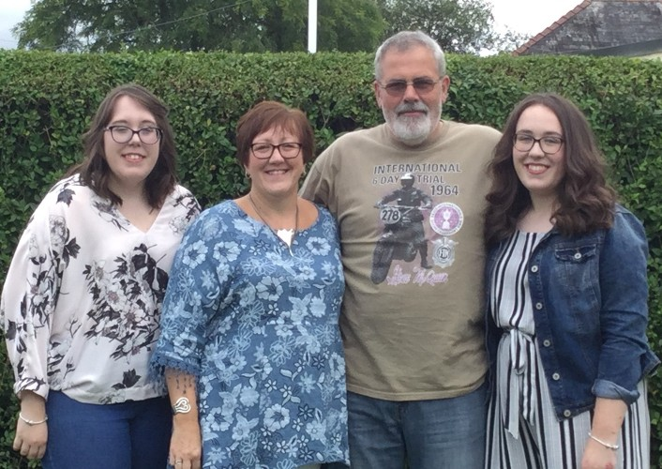
Cerys (right) with her sister Catrin, mum Dawn and dad Chris.

Her mum added: “Mr Laws was absolutely brilliant. When he operated back then he chose the right lenses that have allowed Cerys to do everything she has ever wanted to do.

“The staff at his clinic have also been fantastic over the years, they did things like teaching me how to put drops in Cerys’s eyes.

“We haven’t needed to see Mr Laws for about five years now but we have never forgotten the care Cerys received.”

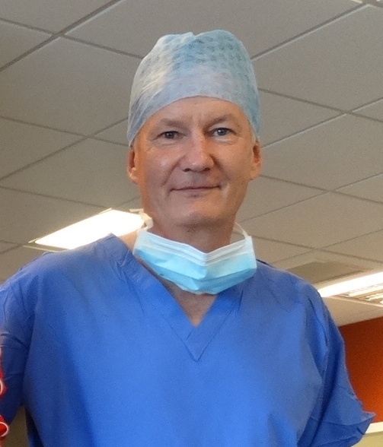
Mr Laws (left) said: “We are lucky to work in an area that has made so much difference to Cerys’s quality of life.

“Children’s cataracts are very complicated to manage and it would not be possible without a great team of orthoptists, optometrists, other doctors and nursing staff who take responsibility for different aspects of care. Not least is my secretary, Angela Jones, who fields frequent calls from worried parents.”

Source: Abertawe Bro Morgannwg University Health Board

