Family of gas explosion survivor Kyle donates to Morriston burns centre
Friday, 19 January 2018
A teenager who suffered extensive burns in a gas explosion just three months ago has been able to leave hospital to see his favourite football club in action.

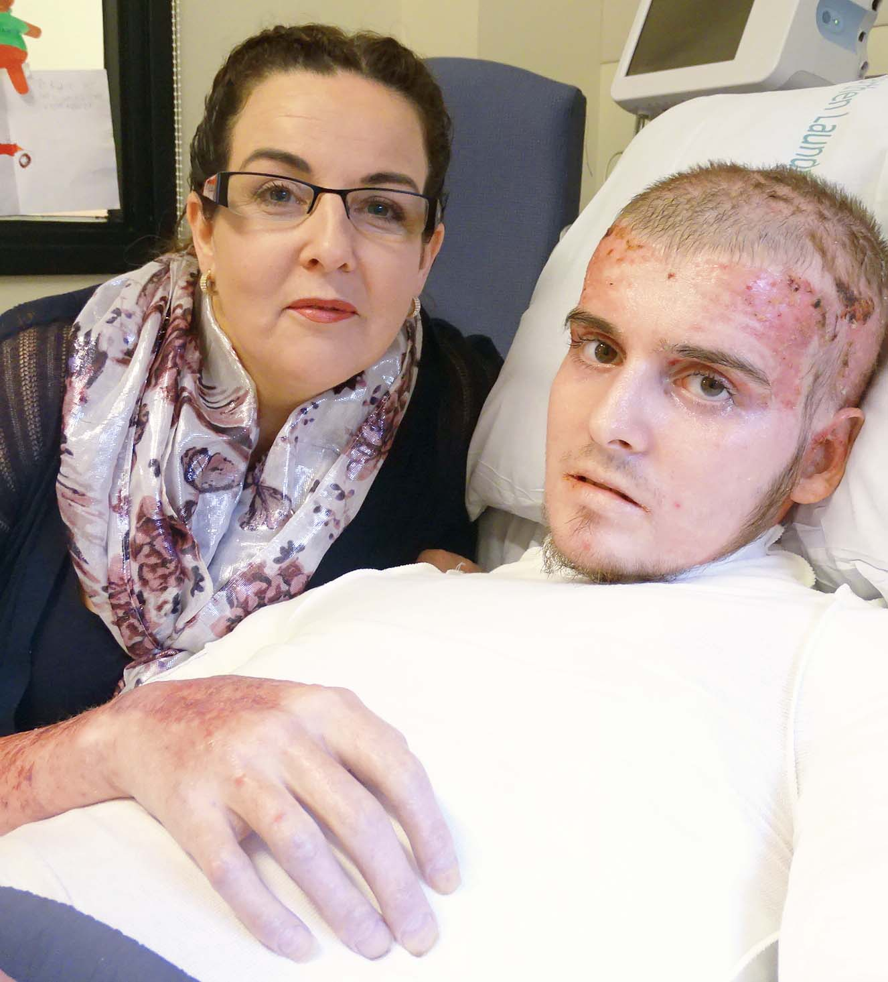
Kyle Roe defied the odds to survive the blast in his Wiltshire flat last October, which left him with 87 per cent burns.

Kyle Roe with mum Tracy, pictured in Morriston Hospital this week

Family and friends launched a fundraising campaign for the Welsh Centre for Burns and Plastic Surgery at Morriston Hospital, to thank staff who have been caring for Kyle – and have made their first donation.

Nineteen-year-old Kyle has undergone extensive skin grafts involving 13 separate operations, and is now in the rehabilitation stage.

Although he still has years of treatment ahead of him, he is now able to walk and is regaining strength.

Spurs supporter Kyle was even able to get to the Liberty Stadium to see his club’s victory over Swansea.

He is waiting to be transferred to Bristol Southmead Hospital, which is much closer to the family’s Chippenham home.

Kyle’s rehabilitation will continue there in preparation for him going home, while Bristol Southmead will also provide his subsequent outpatient care.

Parents Tracy and Chris Roe have been at his bedside in Morriston for the last 13 weeks.

Tracy said Kyle was doing remarkably well considering the extent of his injuries. “The chances of him surviving were very slim. Nobody thought Kyle was going to survive, if I’m honest.

“He had a cardiac arrest the night he arrived here, and they managed to get him back.

“He’s had multiple infections, had to go on dialysis and had ventilator-acquired pneumonia along with acute respiratory disease syndrome.

“He’s been through a lot and that’s on top of all the surgery he’s had just to try and get skin grafts on him – 13 operations.

“He’s had to have skin grown in the lab, to be sprayed onto his body, because he didn’t have enough skin for his grafting.

“Kyle is fully covered in skin now, and going through the rehab stage.

“He’s doing daily physio and occupational therapy, and cream massaging three times per day to manage contractures and tightness of the skin.

“The fact that we’re now at this stage 13 weeks on, where he’s on his feet and trying to walk, and having physio, is thanks to this hospital and all the staff that have looked after him.

“The standard of care he has received has been truly amazing.”

Tracy said Kyle was having ongoing problems and would need extensive treatment for the next two years at least.

“But in the grand scheme of things he’s doing remarkably well 13 weeks in.”

In November, the family – which also includes Kyle’s brothers Kallum, 22, Connor, 12, and seven-year-old Findlay – launched a fundraising campaign to say thank you to Morriston Hospital staff.

They set up a Just Giving page which is already close to hitting its £5,000 target. There has been a big fundraising effort in Chippenham, too, including contributions by Kyle’s employer Morrisons.

The family will be donating £1,000 to the League of Friends at Morriston, which has provided on-site accommodation for Kyle’s parents since the teenager arrived at the hospital.

The rest will be going to the Tempest Burns ITU Unit, where the family have already donated five televisions, replacing the small, 20-year-old sets which patients could not see or hear properly.

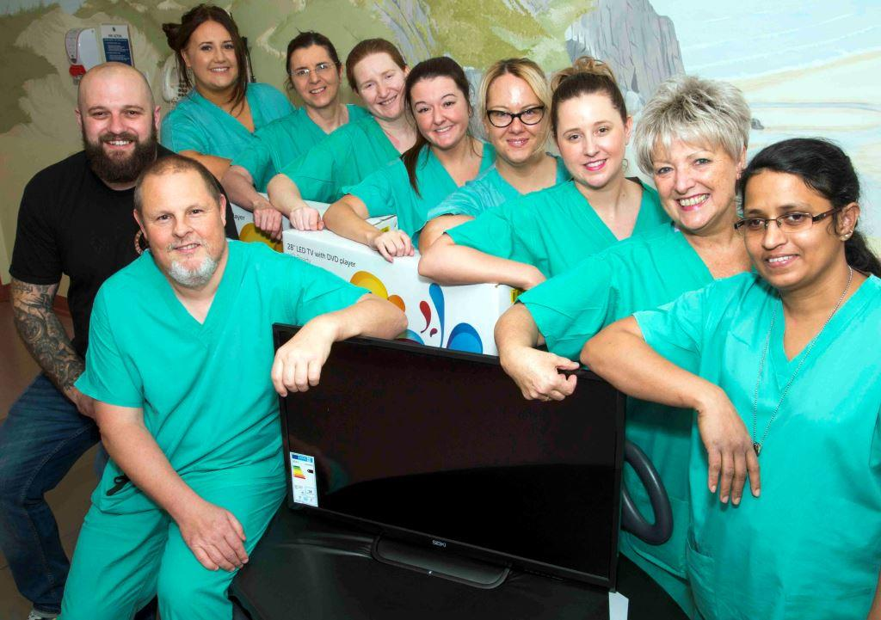
Chris Roe (far left of pic) presents TV sets to Tempest Burns ITU Unit staff: ward managers Martin Nicholls and Susan Salerno; staff nurses Bethan Phillips, Helen Jones, Lisa-Hookway Jones, Laura Scott, Lipsa (crct) Joseph and Abi Salisbury; and support office Babs Lanchbury

Tracy also thanked family and friends for their amazing support, helping to look after the children, helping out whenever they could and even cooking meals to drop around.

Jo and Robynne Hinkley have led the fundraising events on behalf of the entire family.

Tracy said: “Even now people are asking if there is anything we can do to help get things ready for when Kyle comes home. Their kindness has been unbelievable.

“We didn’t think we were ever going to take him home. We thought we were going to lose him.

“The fact that he has survived, and is doing as well as he is, is a testament to the care he has received here.”

The Welsh Centre for Burns and Plastic Surgery provides a service for the people of South, Mid and West Wales.

In 2010 it was designated the adult burn centre for the South West UK Burns Network, responsible for a population of 10 million as far afield as Aberystwyth, Portsmouth and Oxford.

Consultant plastic surgeon Sarah Hemington-Gorse said: “Given how unwell Kyle was when he came to us, it’s an absolute joy to see him at the point where he’s ready to go back to his local hospital.

“It’s a testament to how well the burns multidisciplinary team work together to provide holistic care – not just to the patients but their families too.

“Kyle has a lovely family and they’ve been so generous.”

You can donate to the Just Giving page here: www.justgiving.com/crowdfunding/robynne-hinkley-2

Source: Abertawe Bro Morgannwg University Health Board

