Health staff get set for special year to mark NHS anniversary
Tuesday, 9 January 2018
ABMU is kicking off 2018 by looking forward to a year-long celebration to mark the 70th birthday of the NHS.
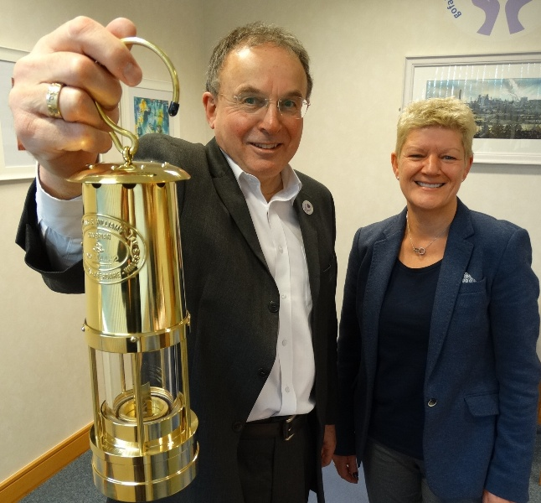
The health board is planning a wide range of events to run throughout the year to commemorate the foundation of the National Health Service in July 1948.

There will be an eye-catching addition taking a prominent place at each of the activities – a specially engraved miners’ lamp.

Chairman Andrew Davies and incoming Chief Executive Tracy Myhill with the commemorative miners’ lamp, the symbol of the health board’s year of celebration.

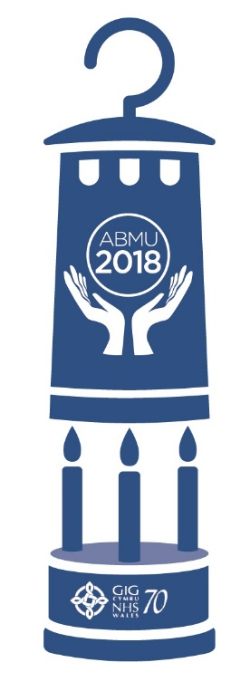
The lamp, made by Aberdare-based E Thomas and Williams, is being used to highlight the long-standing link between industry in South Wales and healthcare provision and will be the symbol of ABMU celebrations throughout the anniversary year.

Minister for Health in 1948, Aneurin Bevan called on his own experiences as a miner in the South Wales valleys and involvement with the medical aid society in his home town of Tredegar when it came to establishing the NHS.

Community-based organisations like the medical aid society in Tredegar sprang up across the UK and saw industrial workers contributing a portion of their wages towards providing medical care and paying for doctors and the earliest hospitals.

They helped inspire the NHS and the idea that good healthcare should be available to all, regardless of their wealth.

ABMU Chairman Andrew Davies said: “When the NHS was launched in 1948 it was based on the three core principles of providing care that meets the needs of everyone, is free at the point of delivery and is based on clinical need, not the ability to pay.

“The Wales-born NHS has shown the world the way: that healthcare is a fundamental human right, not a privilege to be paid for.

“Seventy years on we still hold those principles dear and see it as our duty not only protect them but also to celebrate the proud history of healthcare they have inspired.

“That is why 2018 is going to be such an important year for ABMU staff and the patients they care for.”

Details of the events taking place will be revealed throughout the year but already lined up are displays, conferences, a festival of music at hospitals and community venues and patients will be asked to get involved too by helping to create special bunting for the celebrations.

The activities will also include input from health board volunteers as well as ABMyouth, the Health Board's new youth advisory panel.

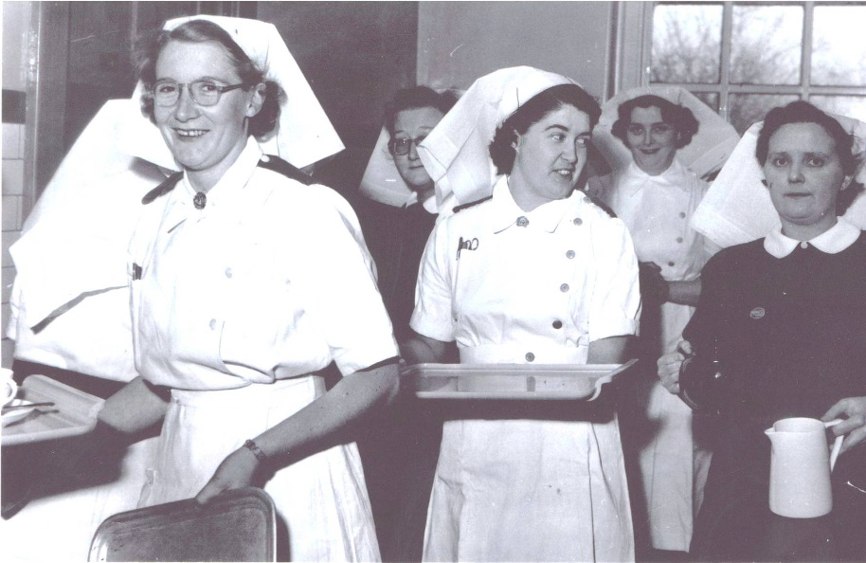
Anecdotes and photographs from staff, former colleagues and patients will all be featured in a special publication that will look back at the NHS’ contribution to communities around Swansea, Neath Port Talbot and Bridgend as well as outlining the innovative work going on to continue to develop healthcare in the 21st century.

Looking back – (above) the official opening of the Pathology Laboratory at Neath General in the early 1950s and (below) nurses at Cefn Coed Hospital during the 1960s.

There will also be a relay which will see the ABMU lamp travelling between sites across the health board to promote individual activities.

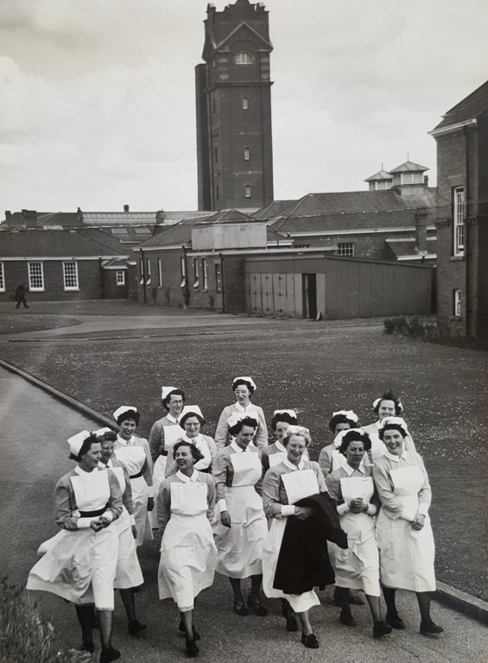
ABMU Heritage Group’s Martin Thomas and Rebecca Kelly are busy compiling oral histories which will give long-standing staff and patients a chance to record their experiences of the NHS and just why it is so important to them. These will also be used as part of the wider national project to mark the NHS70.

Martin is also a founding member of the Health Heritage Wales committee which is organising Wales-wide celebrations. He and and Rebecca will be flying the flag for ABMU by joining the delegation from Wales taking a miners lamp to Parliament for an official reception commemorating the Welsh roots of the NHS.

Adding her support to the celebrations is ABMU’s incoming Chief Executive Tracy Myhill. She said: “I am delighted to be joining the organisation in such an important year.

“Over the decades the NHS has constantly had to evolve to meet the changing needs of its patients and the populations it serves. It continues to face many challenges in the future but we must never forget what it has achieved in those 70 years.

“It transformed our society and we all owe the pioneers who helped establish such a remarkable service a huge debt of gratitude.

“It is very important that we not only mark their achievements since 1948 but also continue their legacy.”

Source: Abertawe Bro Morgannwg University Health Board

