Ladies Golf Club's generous donation to Angelton clinic
Tuesday, 9 January 2018
Keen golfers have given dementia patients a big surprise after a year of fundraising.

Ladies from St Mary’s Golf Club in Pencoed raised a whopping £1,230 for Angelton Clinic.

The clinic at Glanrhyd Hospital, which treats older mental health patients was chosen as the Ladies Captaincy charity for 2017.

The money was raised by holding raffles, puzzles and through generous donations.
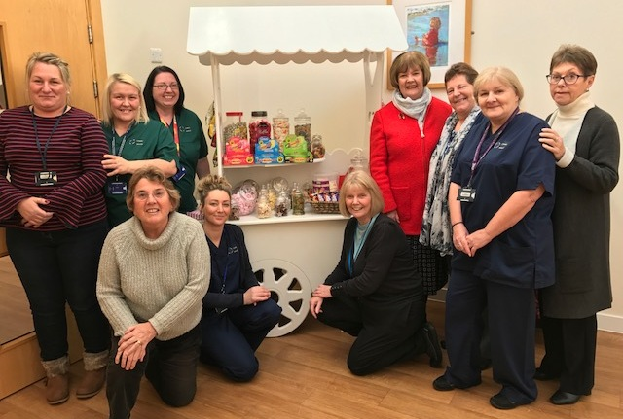
L-r (back row) Melanie Davies, activity co-ordinators Leanne Rumph and Anne Jones, Sue Bevan, Christine Davies, Julie Davies, Geraldine Jones (front row) Elizabeth Winkley, Cath Lowery and Elizabeth Ellis.

Ladies captain Elizabeth Ellis, who is also clerk at the clinic said “It was my pleasure to nominate Angelton Clinic as the Ladies Section’s chosen charity for 2017.”

So far the money raised has provided the clinic with a wooden vintage sweet trolley including jars and sweet treats, a ten pin bowling set, digital bingo calling machine and a wide variety of dementia specific items such as puzzles, floor targets and a wall mounted CD player.

Unit manager Jayne Church said “The difference this equipment will make to the our patients is huge.

“The interactions between our patients and staff can make such a difference to the patients’ daily experience of care at Angelton Clinic. We are so grateful for this donation.”

Source: Abertawe Bro Morgannwg University Health Board

