Lily gets running for Coronary Care Unit
Wednesday, 17 January 2018
Ten-year-old Lily Smith of Kidwelly raised £260 for Morriston Hospital’s Coronary Care Unit after a family friend was treated there.

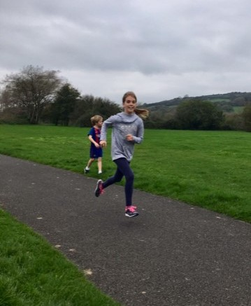
Lily said “I did a two mile run to raise money for CCU Morriston to say thank you for looking after our family friend, Pete Edwards who had a heart attack. Thank you to everyone who helped out and sponsored me.”

Family, friends, neighbours and teachers sponsored Lily and the money raised will be used to purchase equipment for the unit.

CCU unit manager Alison Jones said “Heartfelt thanks to Lily for giving up her time to raise funds for our unit, it is very much appreciated by all. Donations will help with the purchase of monitoring equipment”.

Source: Abertawe Bro Morgannwg University Health Board

