Morriston team awarded £150,000 grant for heart research study
Tuesday, 30 January 2018
Experts at Morriston Hospital have secured a £150,000 grant for a major research project into a common but potentially serious heart condition.

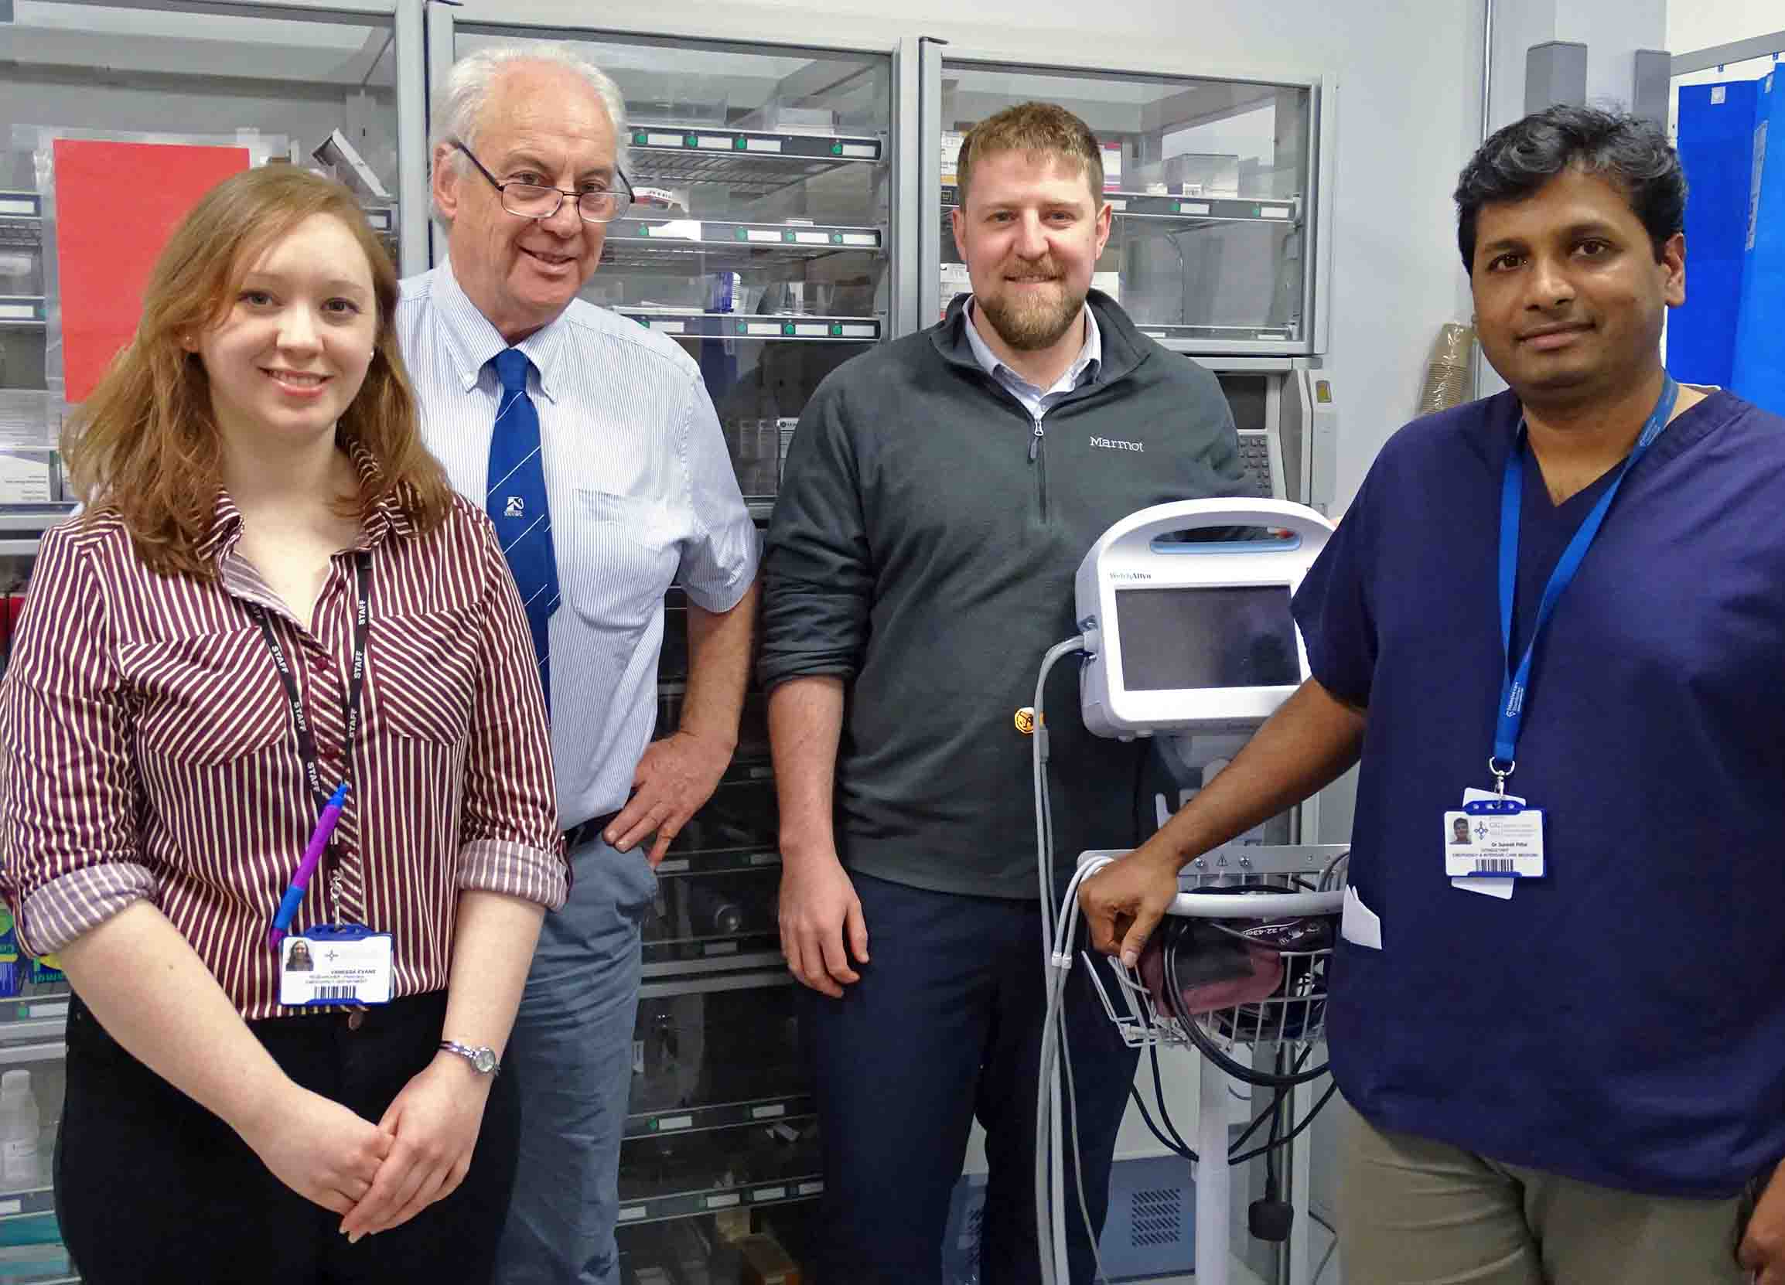
The two-year study involving around 120 patients will focus on atrial fibrillation (AF), a form of arrhythmia or abnormal heart rhythm.

L-r: Vanessa Evans, Professor Adrian Evans, Matthew Lawrence and Suresh Pillai, part of the Morriston research team

Although some people can have AF without serious consequences, in others it can cause a stroke, with all its devastating effects.

The Morriston team is investigating how AF can lead to abnormal blood clotting, which may cause a clot to break off into the heart chamber and travel to the brain.

It’s hoped their work will identify which AF patients have abnormal blood clotting, and are therefore most at risk of a stroke, so they can be given preventative treatment early.

The study is being run by a team led by Professor Adrian Evans at the Haemostasis Biomedical Research Unit at Morriston Hospital.

This is recognised as one of the leading units in the UK and Europe on clotting research in the field of emergency medicine.

Professor Evans said: “What are we trying to do is determine for the first time how AF and altered blood flow within the heart leads to the development of an abnormal clot structure in some people.

“Using a new biomarker we have developed here, we are trying to determine how that irregular heartbeat alters the clotting process – which may affect clot microstructure and its normal function, and in turn may lead to a stroke.”

AF can cause distressing symptoms of palpitations, breathlessness and chest pain. It affects one in 200 and gets increasingly common with age; one in 12 people aged over 75 has it.

The risk of stroke in people who have AF is six times higher than those who don’t – in fact, AF is responsible for about 20 per cent of all strokes.

Once AF has been diagnosed, anticoagulants such as warfarin can be prescribed to significantly reduce the chance of having a stroke.

But many people with AF do not have any symptoms so are unaware they have it – sometimes it is only diagnosed following a stroke.

As well as Professor Evans, the Morriston project involves emergency medicine consultant and ED stroke lead Kais Mustafa; emergency and intensive care medicine consultant Suresh Pillai; consultant cardiologist and electrophysiologist James Barry (whose expertise is in AF); consultant stroke physicians Tal Anjum and Manju Krishnan; clinical haemorheologist Matthew Lawrence and researcher Vanessa Evans.

The team secured the grant from the European Thrombosis Investigator Initiated Research Program, amid strong competition from more than 100 UK and European centres of excellence, to carry out the study.

It will involve two groups of 60 people each – those diagnosed with AF but whose condition is stable, and people brought into Morriston ED following an AF-related stroke.

Professor Evans said: “Patients who come into ED with stroke-related AF will have a simple blood test to see whether the new biomarker can identify how AF leads to abnormal clot development in some people.

“We will then follow them up after they have thrombolysis and repeat this several weeks later when they are on anticoagulants.

“Many patients are put on new oral anticoagulants. We hope the new biomarker will also be effective at showing how well they are anticoagulated, as conventional tests are not consistent enough.”

Professor Evans said not everyone with AF had abnormal clotting.

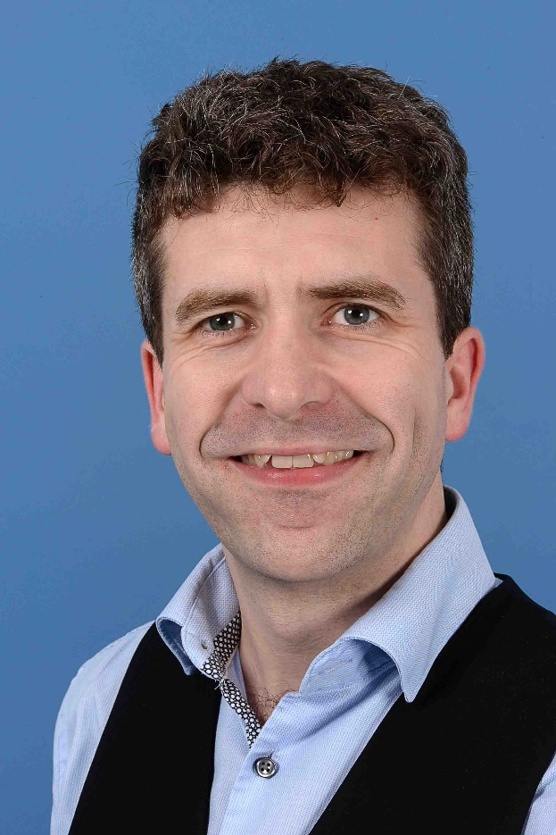
He added: “We hope the new biomarker will identify those who are stable but do have abnormal clotting so perhaps they should be coagulated sooner.”

The research at Morriston has been commended by Dr Terry Quinn (pictured right), joint Stroke Association and Chief Scientist Office senior clinical lecturer.

Dr Quinn said: “These are exciting times for stroke research in Wales.

“On my recent visit to Swansea, I was particularly impressed by Professor Evans's team and their work on stroke and blood clotting.

“This work has the potential to generate new treatments for stroke and vascular dementia.”

Source: Abertawe Bro Morgannwg University Health Board

