Cycling the road to recovery thanks to the skills of prisoners
Thursday, 13 July 2017
Mental health patients can now travel the road to recovery a little faster thanks to the skills of a group of prisoners.
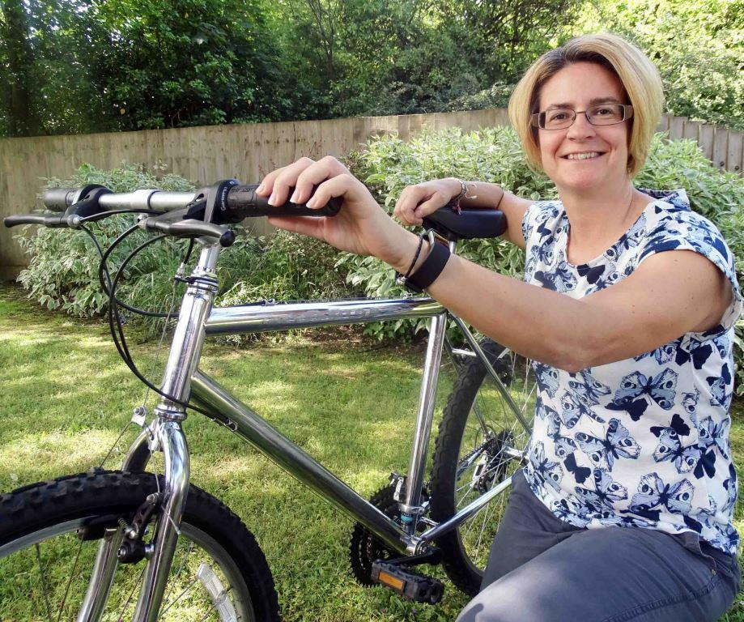
Seven bikes which had been left rusting in a shed at a rehabilitation and recovery unit are back to looking their shiny best again.

Occupational therapy technician Jo Poupon with one of the refurbished bikes

They have been completely refurbished and will be used by residents of Cefn yr Afon in Bridgend to help with their recovery.

The restoration was carried out by inmates at HM Prison Cardiff, who refurbish a large number of bikes every year for projects such as the bikes4Africa programme, as well as others closer to home.

Cefn yr Afon is an 18-bed unit in Quarella Road where patients from Bridgend, Swansea and Neath Port Talbot can build on existing skills and develop new ones after they have left hospital.

The aim is for them to take control of their own lives and move on to more independent living, sometimes with the support of the Community Rehabilitation Team. Having the bikes available will help meet that goal.

Cefn yr Afon occupational therapy technician Jo Poupon said: “Residents can use the bikes to assist their mental health recovery.

“They will be an invaluable resource in accessing the community, building people’s confidence, fitness, enjoyment, socialising…and it’s just a fun thing to do, especially during the summer.”

But just a short while ago all that was looking unlikely, as the bikes were in dire need of some tender loving care to make them roadworthy.

Jo said they had been left in a shed and, as there was neither the expertise nor the funds to keep them maintained, gradually fell into a state of disrepair.

Then Cefn yr Afon staff were put in touch with Wayne Harries, manager of the dedicated bike repair workshop in HM Prison Cardiff.

Jo said: “Not only do inmates achieve a greater sense of self-worth, they also learn practical skills which are transferrable to different occupations on release.

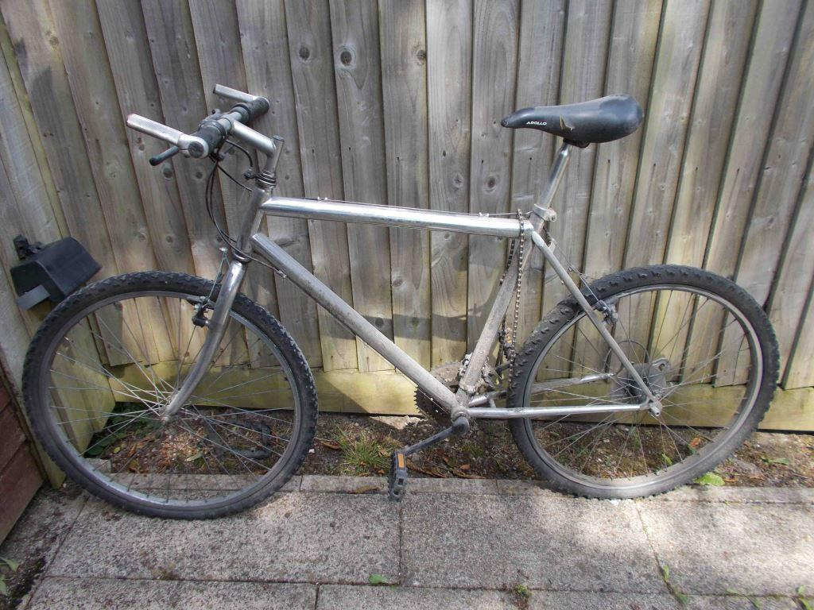
“The prisoners also get accredited certificates for the hours worked on the bikes and the skills learnt.”

Right: Rusty, dusty and unloved…the same bike before its restoration

When she delivered the bikes, Jo was met by Wayne and the prisoners who, she said, were courteous and polite.

Once the bikes were unloaded off the van, Jo was assured they would be restored to their former glory within a week.

She said: “I was gobsmacked when I returned a week later to collect the bicycles.

“The transformation was absolutely amazing and I cannot thank the workshop team enough for their skill and expertise.

“We can take the bikes back for regular servicing, too, so we are able to maintain safety standards.”

Source: Abertawe Bro Morgannwg University Health Board

