Dietitian offers new hope for people with Irritable Bowel Syndrome
Tuesday, 18 July 2017
A change of diet is transforming the lives of Bridgend people suffering from a common but extremely unpleasant condition.
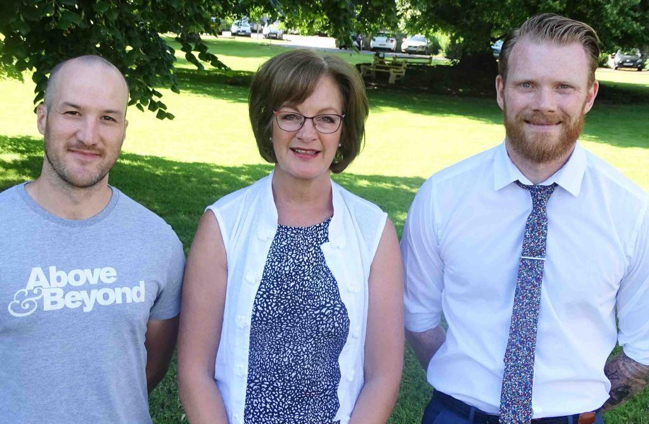
Irritable Bowel Syndrome affects up to one in five people and can cause stomach cramps, bloating and diarrhoea or constipation.

Prescribing support dietitian Debbie Thomas with Paul Leyshon (left) and Chris Phillips

A specialist dietitian is working with five Bridgend GP surgeries on a pilot involving a diet which identifies then eliminates foods believed to trigger the symptoms.

The results have been remarkable, with more than three-quarters of patients reporting their IBS has eased or even disappeared.

Now the project, run by ABMU prescribing support dietitian Debbie Thomas, has been shortlisted for an NHS Wales Award for using what’s known as the low FODMAP diet to treat IBS in primary care.

IBS affects 15-20 per cent of people, which equates to around 21,000 in the Bridgend area alone – and 450,000 across Wales.

They often have to take medication to control the symptoms. Some may previously have been sent for a colonoscopy or endoscopy which, apart from being highly invasive, costs the NHS around £200 a time.

Debbie said: “Often they go through all this and then are told it’s just IBS. But there’s no just about it. IBS is very debilitating, and it’s embarrassing so people don’t really talk about it.

“Some people have to spend endless time in the toilet or take time off work. It can have a really serious effect on their lives.

“Traditionally, GPs may refer the patient to a dietitian and they would be given advice such as looking at the regularity of their food, making sure they drink plenty of fluid and adjusting fibre.

“Unfortunately that has limited success.”

Fermentable oligosaccharides, disaccharides, monosaccharides and polyols (FODMAP) are carbohydrates that aren’t easily broken down and absorbed by the gut.

They ferment relatively quickly, releasing gases which can lead to bloating and other characteristic IBS symptoms.

High-FODMAP foods include some fruits and vegetables, animal milk, wheat products and beans.

GPs in the pilot project refer appropriate patients to Debbie, who sees them in their local surgery usually within two weeks.

"Usually only two appointments are necessary. During the first, I instruct them on the elimination part, which is when we take out all high-FODMAP foods.

“Once their symptoms improve, we arrange a second appointment for the reintroduction phase so they can identify the trigger foods causing the problem.

“This gives patients the choice to avoid trigger foods completely or eat them in small amounts – with the confidence that any symptoms will improve once they remove them from their diet again
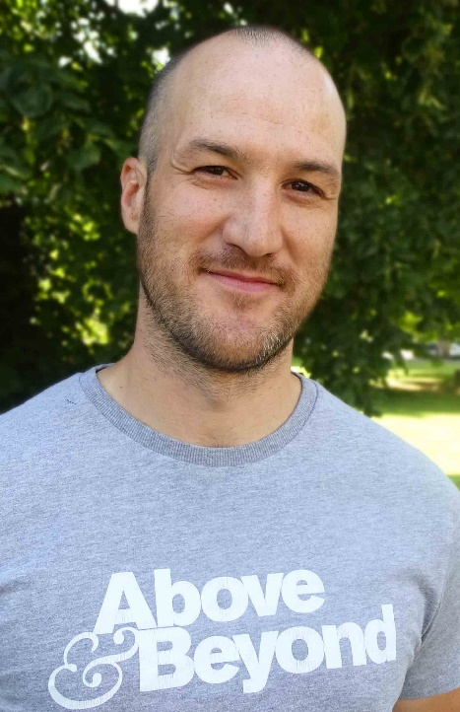
“Reintroduction is incremental so they not only know which food is a trigger but also how much they can tolerate before it triggers the symptoms.”

Since starting the pilot in early 2015, Debbie has seen around 200 patients. Not everyone chooses to try the diet, for various reasons, but upwards of 75 per cent of those who do have seen a remarkable change.

Paul Leyshon (right), aged 36, from Pencoed, suffered from IBS for 15 years and said it had a massive effect on his home and work life.

“I used to plan my day around the loo and wherever I went it was always based on whether there was a toilet nearby.

“It stopped me doing a lot of things – I’d make excuses not to go places. Or if I did have to go anywhere I’d dose myself up on medication first.
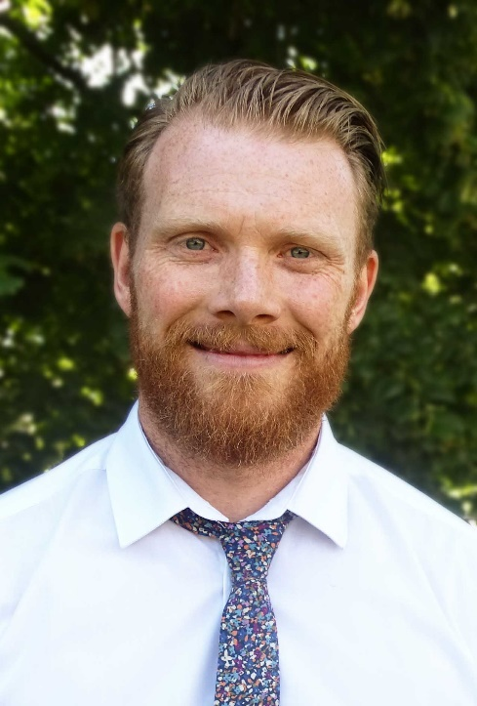
“The diet has transformed things in a positive way. I’ve stopped taking medication. Life is a hundred times better and I feel a lot healthier.”

Chris Phillips (left) says he has seen massive improvements in the physical aspects of IBS but admits the anxiety it causes has not gone away.

The 35-year-old from Bridgend said: “I have an hour-long commute to work and as it can come on at any time, there’s always that anxiety.

“The diet is really helpful, it’s the anxiety side I have to conquer now. It’s not just the food aspect but the mental aspect as well.

“It still affects how I plan my days, although knowing I have eaten the right food does help control the anxiety.”

The project is shortlisted in the Improving Health and Wellbeing and Reducing Inequalities category of the NHS Awards, with the winners being announced in September.

It also led to Debbie, who was specially trained in the low FODMAP diet in King’s College London, being selected for the Bevan Innovation Exemplar programme run by the Bevan Commission.

This supports individual NHS employees to lead innovative projects and share best practice with colleagues around Wales.

Debbie said: “I feel very passionate about helping people with IBS manage their symptoms by making temporary adjustments to their diet. The changes to their lives are amazing and dramatic.

“People try to follow this diet alone with information they’ve found on the internet.

“But the real success is shown when patients have the specialist advice and support of a dietitian trained in the low FODMAP diet.

“It is really effective, it doesn’t involve surgery and people can even come off medication. I want those with IBS to know there is hope.”

Source: Abertawe Bro Morgannwg University Health Board

