Health staff rewarded for years of dedicated service
Monday, 10 July 2017
Hundreds of ABMU staff with a combined service of almost 8,000 years have been thanked for their dedication and loyalty at a special celebration.

The recognition ceremony was for health board staff who had clocked up more than 25 years service - several of those who attended had recorded more than 40 years working for the NHS.

Before they received a commemorative certificate and badge from senior management, ABMU Health Board Chairman Andrew Davies paid tribute to the staff and their contribution.

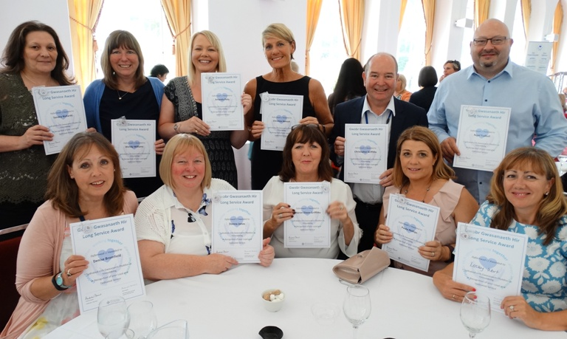
He said: “This is an opportunity for me on behalf of the health board to say a very big thank-you to all of you for your tremendous commitment over many, many years.

Some of the ABMU staff members who were honoured at the long-service celebration with their certificates.

“Today is about valuing and appreciating our staff because it is only through your passion and your commitment that we are able to produce an environment with a really high class service.”

Professor Davies, the son of a nurse himself, added: “We know that often it doesn’t come easy and often it involves making personal sacrifices to meet demands and provide those local services.”

The event, supported by ABMU’s Charitable Funds Committee and being held free of charge at Margam Orangery, was the first of three honouring long-standing staff members.

Colleagues were invited to share memories and anecdotes from their long careers ahead of the event and many of these were featured in special displays around the room.

During the ceremony Vice-Chairman Charles Janczewski read out the recollections of medical secretary Heather Lewis who started as a shorthand typist clerk at Maesgwyn Hospital in 1980.

Back then her duties included taking patients’ pension books to the Post Office, collecting the cash and going round the wards handing it out.

She said she had seen many changes during her career: “Everything back then was on paper, now it is on a PC. I have to say I like the new technology, except when the server goes down and then I think ‘bring back typewriters’ as no one can get any work done.”
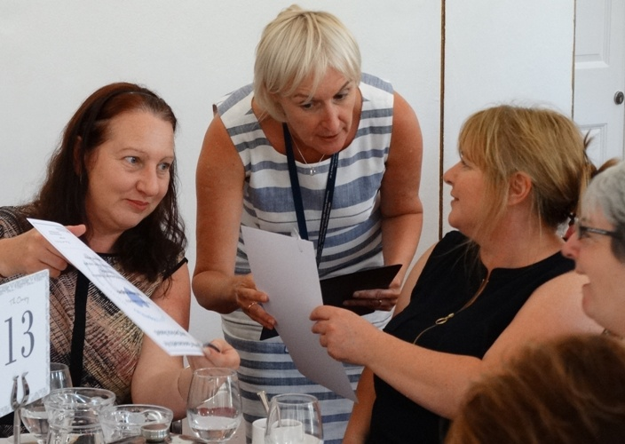
Princess of Wales Hospital Nurse Director Debbie Bennion hands out certificates to staff.

In another memory, read by Nurse Director for Primary Care Vicky Warner, lead nurse for public health Susan Jones described her surprise and delight at being appointed MBE for her services to children and young people in 2014.

“Not something that a timid 18-year-old in her yellow student nurse uniform starting work in Neath General Hospital in 1972 would have in her wildest dreams ever have thought might happen to her as a result of her nursing career 42 years later,” she said
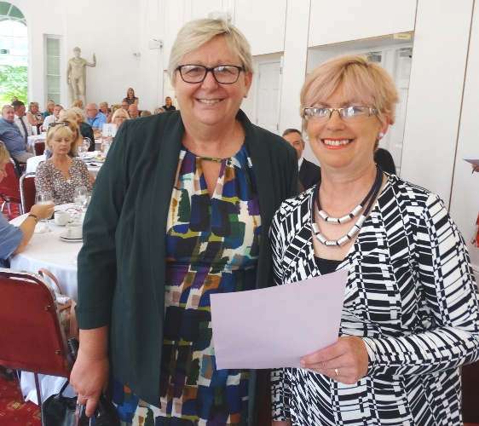
Director of Therapies and Health Science Christine Morrell also shared physiotherapist Jean Archer’s own special story about how her move to Singleton Hospital led to a life-changing encounter.

Christine Morrell (left) with Jean Archer.

A chance meeting with a chatty porter on her way to Ward 12 resulted in marriage and two children.

“It’s not many people can say their romance began in a hospital lift,” said Jean.

She added: “When they asked for memories I was happy to share mine, I thought it was a bit different.

“I’ve really enjoyed the event today, it was very worthwhile and it has been a pleasure to be here.”

Besides being reunited with friends and former colleagues, the guests also enjoyed a special display of photographs collected by ABMU Heritage Group from a variety of sites and departments illustrating how how the health service has changed over the years.

The group’s Martin Thomas is now on the hunt for more artefacts, pictures, documents and memories – particularly ahead of next year’s 70th anniversary of the NHS – and everyone who attended was invited to add to the health board’s growing heritage collection.

If you have think you have something of interest that could be included please get in touch with Martin at ABM.HeritageGroup@wales.nhs.uk
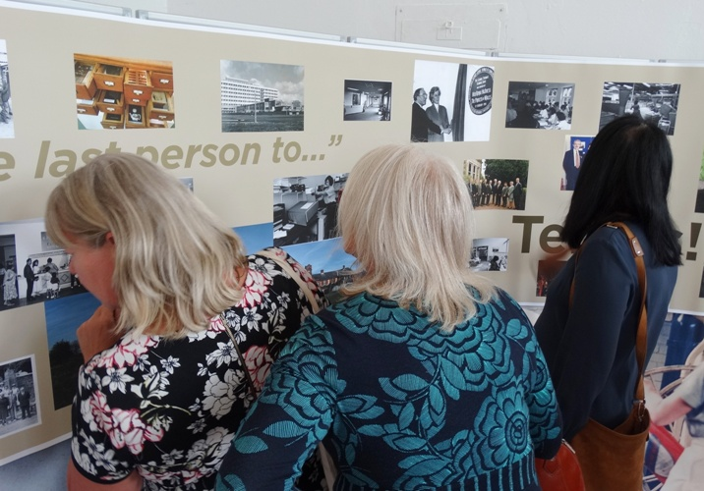
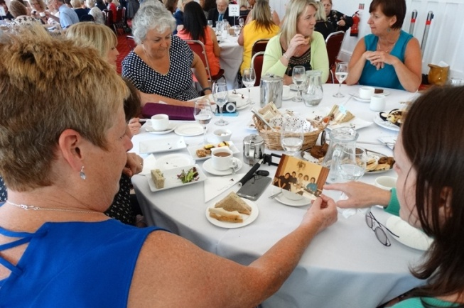

Source: Abertawe Bro Morgannwg University Health Board

