Health teams building on success after fall in children's tooth decay
Tuesday, 25 July 2017
The teams responsible for encouraging good dental health across ABMU have got plenty to smile about after helping to drive down tooth decay in children.

A dental survey by Public Health Wales has revealed the lowest decay rates since records began, with ABMU seeing a consistent decline in the number of children with missing or decayed teeth.

Now the health visitors, school nurses and the Designed to Smile team are determined to continue their fight to keep youngsters teeth healthy and have pledged to build on this success.

Currently health visitors are supporting more than 28,000 children under five and their parents across ABMU, and a crucial part of that support is reinforcing key health messages like how to look after their teeth properly.

To do this they work closely with dentists, school nursing team and colleagues from Designed to Smile, the Wales-wide oral health programme which was launched in 2009 to prevent dental decay in pre-school and primary school settings.
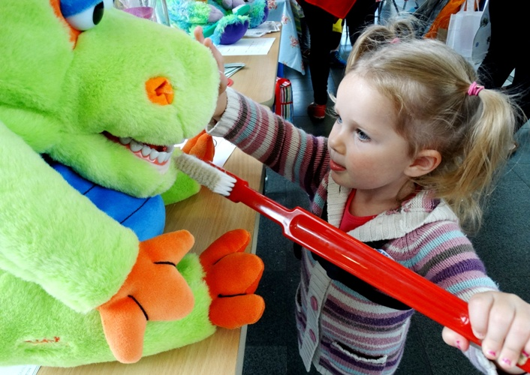
Lia Mainwaring has been learning how important it is to clean her teeth properly. She got in some extra practice at the Designed to Smile stall at this year’s Teddy Bears’ Picnic at the National Waterfront Museum in Swansea. The fun day out for families, organised by Swansea Council, celebrated the work of the Flying Start programme.

It’s a strategy that is now paying dividends when it comes to oral health, says lead health visitor for public health Jane O’Kane, who is also chair of ABMU’s Healthy Teeth Steering Group.

She said: “Dental decay is completely avoidable and we cannot over-emphasise the importance of good oral health in our children.

“Besides the pain it causes, tooth decay can also mean children losing vital hours in school while they attend dental treatment.

“This is a great partnership between Designed to Smile health, visiting, schools and the combination and range of dental services in the community. It’s fantastic to see this work is now paying off.”

The survey looked at 8,000 five-year-old children at more than 500 schools in Wales in 2015-2016. It showed in 2007-08, about 14 out of a class of 30 (47.6%) children had decay, with an average of 4.2 teeth affected.
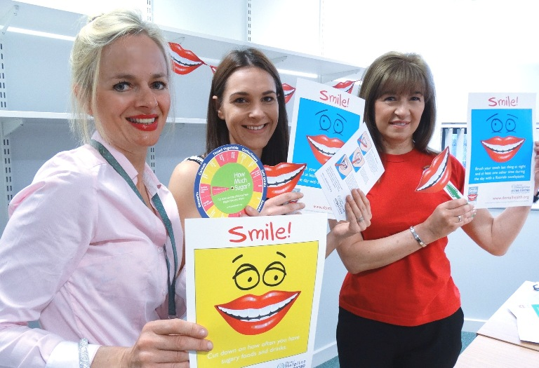
But by last year, this had fallen to about 10 children out of a class of 30 (34.2%), with an average of 3.6 teeth affected.

Lead health visitor for public health Jane O’Kane, health visitor Rachel Kerswell and Mandy Silva, dental health manager for the Designed to Smile programme promoting the importance of good oral health

An analysis of the survey results by health board area showed ABMU had a consistent and significant year-on-year reduction in the amount of decay recorded in children’s teeth and was closing in on national targets.

Carried out by the Welsh Oral Health Information Unit, the survey shows that dental disease levels continue to improve across all social groups with most deprived areas seeing the largest reduction in decay.

The report said: “The fact that children attending schools in the most deprived quintile are those seeing the greatest improvements in decay experience is likely to be due to the impact of the Designed to Smile programme.”

The positive results just go to prove that dental decay is preventable not inevitable, says Mandy Silva, ABMU’s dental health manager for the Designed to Smile programme.

As well as nurseries and schools, her colleagues visit parent and toddler group, weaning groups and parenting classes. They set up toothbrushing programmes for three to five year-olds and train staff to supervise brushing.


The Designed to Smile mobile dental van has become a familiar site across ABMU.

The team also promotes oral health to six to 11 year-olds so they learn how to look after their teeth for life.

Mandy says there are four key messages to promote good oral health:
- Diet;
- Tooth brushing;
- Fluoride; and,
- Dental attendance.
Mandy added: “We are delighted at the results of this survey. It’s been a great example of teamwork and shows how our partnership with health visitors and school nursing is making a real difference to children’s oral health.

“However, we know there is more work to do so we want to build on this and continue to spread the word about how to protect our children’s teeth for the future.”

To continue this progress the team say new preventive projects are already well underway. They are focussing on prevention and improvement of oral health in children aged up to three so they can spot any decay before a toddler’s first visit to a dentist.

To help play their part in keeping their children’s teeth healthy parents should always:
- Clean their child’s teeth last thing before they go to bed and one other time during the day with fluoride toothpaste;
- Help clean their children’s teeth until they are seven;
- Try to wean babies off dummies by 10 to 12 months, avoid dipping dummies in sweet food or cleaning a dummy by putting it in their own mouths – this can pass on bacteria which wouldn’t normally be in a child’s mouth;
- Choose sugar-free non-acidic snacks and drinks
- For pre-school children remember milk and water are the only drinks they need; and,
- Take them to visit the dentist regularly.

Source: Abertawe Bro Morgannwg University Health Board

