Lee’s dedication to his patients earns him another award
Wednesday, 12 July 2017
A healthcare supporter worker has been honoured for the dedication and compassion he shows to his patients.
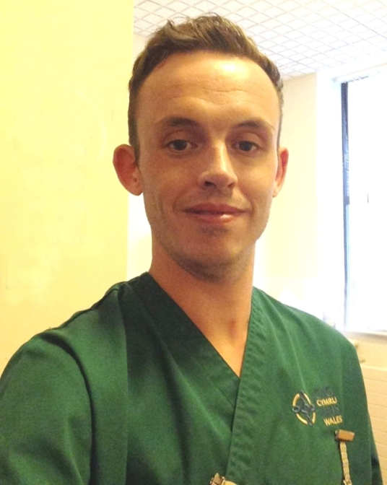
Lee Cook (left) was named the winner of the Patients’ Choice Award at the University of South Wales School of Care Sciences annual student showcase.

The prestigious event aims at celebrating the achievements of its nursing and midwifery students who have demonstrated excellence in practice.

Lee works on Ward 18 at Princess of Wales Hospital, which cares for frail elderly patients, many with dementia, while also studying part-time for a Certificate of Higher Education in Health Care Nursing Support Worker Education with the University

He was nominated by relatives of a patient who felt Lee had been instrumental in a vast improvement in their father’s mood and behaviour.

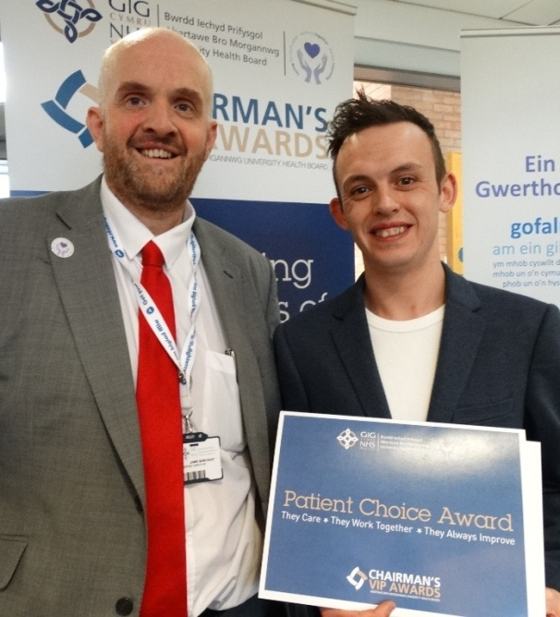
In their nomination, they said the patient had initially been finding it difficult to trust the nursing and medical staff but Lee’s dedication, compassion and professionalism had earned his trust and reassured him that he would be looked after.
Lee said: “After getting the nomination, my ward manager read the letter out to the whole team - I had to hold back the tears! Caring for my patients and making sure they are comfortable is what makes me happy.”

This is not the first time Lee has been singled out for praise by grateful families. Back in January 2016 he received six separate nominations for our own ABMU Patient Choice Awards.

Lee Cook with Princess of Wales Hospital Director Jamie Marchant receiving his ABMU Patient Choice Award in 2016.

Putting Lee forward then Anne and David Williams said: “Lee impresses us on every level, his demeanour, attitude and friendly character set the tone for the professional way he goes about his work. It seems everyone on Ward 18 - staff, visitors and patients - benefit from Lee’s presence.”

Practice education facilitator Majella Kavanagh said: “Lee epitomises the words of nursing pioneer Virginia Henderson who said those working in the caring professions require a combination of head, hands and heart.

“Those that question why nursing studies require academic ability would be wise to heed Miss Henderson’s words.”

Majella explained that HCSWs who successfully complete the certificate that Lee is now studying can then apply for a full-time place on the second year of the traditional Bachelor of Nursing programme.

“However, they don’t have to. The certificate may be accessed as a purely developmental opportunity, benefiting the individual, the health board and ultimately the patient,” she said.

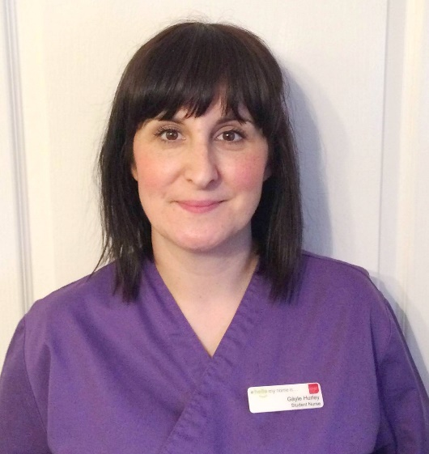
Someone who has taken the opportunity to develop her career is Gayle Hurley, who studied for the certificate while working in the eye theatre at Princess of Wales Hospital and also picked up a top award at the event.
After gaining her initial qualification Gayle (left) went on to study full time for the nursing degree and was named Adult Nursing Student of the Year.
“Gayle is just about to complete her nurse training and we wish her absolute success as she is about to embark on a new path in her nursing career,” added Majella.

Healthcare workers can find out more about how to develop their career by looking at the HCSW Career Framework www.nhswalesdevelopinghealthcare.wales

Source: Abertawe Bro Morgannwg University Health Board

