New Swansea clinic frees up nurses and treats more patients too
Tuesday, 18 July 2017
A clinic that launched in Swansea this summer means one nurse can now treat as many patients as it used to take four to do.
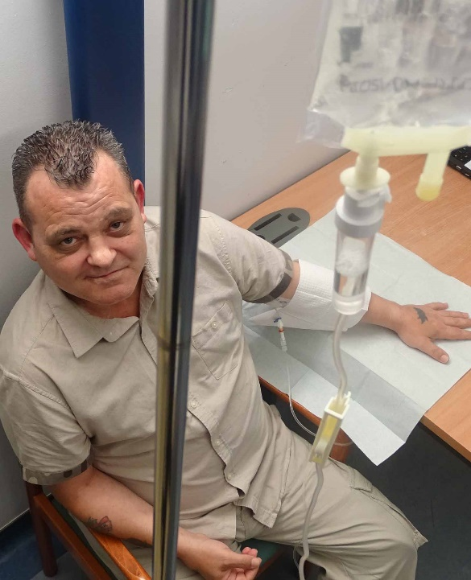
People needing intravenous antibiotics used to have to stay in hospital for weeks at a time even after they were well enough to go home.

Over the last two years, Swansea’s community-based Acute Clinical Team (ACT) has been providing an IV antibiotic service in the patient’s home if they were well enough to come out of hospital.

Mark Ford has his IV antibiotic infusion at Gorseinon Hospital

Because of the distances involved, nurses were spending much of their time travelling between appointments – limiting the number of patients they could see each day.

But last month saw the launch of a seven-day-a-week IV antibiotic clinic at Gorseinon Hospital for people who are able to get there. This not only frees up nurses’ time but means more patients can be treated.

Mark Ford makes the journey there from his home in West Cross, where he was originally treated after coming out of Morriston Hospital in May.

The 45-year-old severed his aorta 18 years ago in a car accident. Four months ago he developed pneumonia which not only caused the old wound to reopen but left him with a hole in his lung.

Mark had specialist surgery in London before returning to Morriston, and was allowed home a week later. But without the community IV antibiotic service he would have been stuck in hospital for three months.

Mark said: “I much prefer coming to Gorseinon. It gets you out more and you know where you stand with appointment times.

“When the nurses are out in the community anything could happen to delay them and through no fault of their own they could be late getting to you.

“But here you know what time you’re listed and then you can get on with your day. It’s brilliant.”

Swansea ACT comprises 45 staff including a consultant, advanced practitioners, GPs, sisters, qualified nurses and healthcare support workers.

It provides a rapid response to treat acutely unwell people at home so they don’t have to go into hospital.

If they have been in hospital and have improved but are still unwell, the team continues their treatment at home so they don’t have to stay in hospital any longer than necessary.

Advanced practitioner lead Sarah Davies said people needed IV antibiotics for a range of conditions such as spinal abscesses, pancreatitis, joint infections and infections following heart procedures.

“Often they were in hospital for weeks or months to have these antibiotics when they were otherwise well enough to leave.

“We started going to their homes to do the treatment there. But because we cover such a wide area we often spent more time on the road than with patients.

“If they are frail and housebound, we still treat them at home.

“However, many patients are fit and well. They are mobile so there is no problem attending Gorseinon Hospital.

“I can fit a lot more patients in each day because it cuts out all the travelling time for the nurses.

“The clinic is open seven days a week and is run by one nurse on a rota basis. That one nurse can see the same number of patients that maybe four nurses would have seen previously.

“It’s a better environment because it’s a clinical setting and the timing is better for the patients as they’re practically assured of being seen within the slot we give them.”

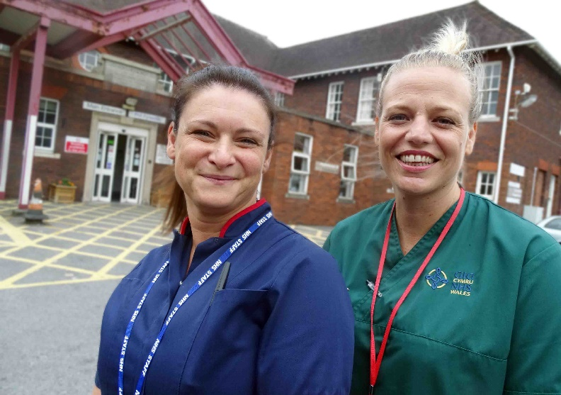
Advanced practitioner lead Sarah Davies (left) with healthcare support worker Louisa Jones at Gorseinon Hospital

Also, nurses can only do half-hour home infusions because of the time they must spend with the patient beforehand and afterwards.

If people needed a longer infusion they would have had to go to hospital. But there is no such time limit in the clinic.

Sarah said Gorseinon was an ideal setting as it meant the community team could do integrated work within a community hospital.

Gorseinon Hospital lead nurse Sarah Taylor said: “This has come about because of partnership working between the hospital and the acute clinical team.

“We hope there will be more of this in the future as it could have further benefits to the ward and to the community.”

Source: Abertawe Bro Morgannwg University Health Board

