Pupils' posters bring splash of colour to hospital building site
Friday, 7 July 2017
Eye-catching designs by Swansea pupils are helping to brighten up building work at Morriston Hospital.
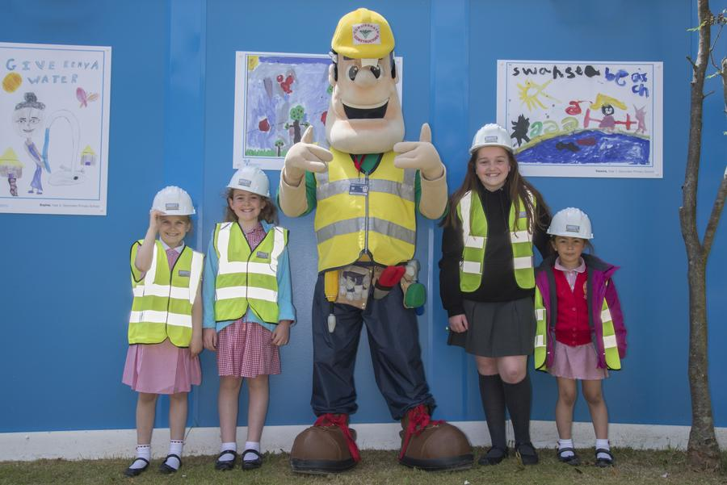
Children from Morriston and Glyncollen primary schools took part in a special competition organised by the construction firm currently carrying out the latest phase of redevelopment at the hospital.

Paula, Sophie, Beth and Yesenia from Glyncollen Primary School with Ivor Goodsite.

Building bosses at Interserve Construction asked for posters illustrating themes such as living in Swansea and the environment that they could use on the hoardings put up during demolition work.

After sifting through 240 entries, they chose eight winners from Morriston and Glyngollen primary schools. Besides having their work on display for patients, staff and visitors to see, the youngsters also got to visit the hospital to receive their prizes.

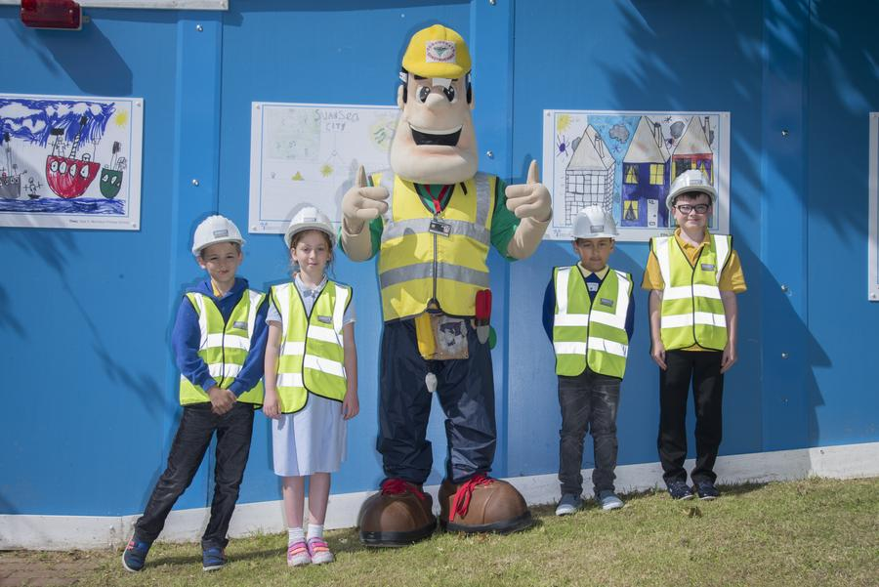
The winning entrants, their parents and school staff came along to see their posters being unveiled on the hoardings by Ivor Goodsite, the mascot of the Considerate Constructors Scheme, which runs the annual hoarding competition at building sites across the country.

Morriston Primary School’s Ellis, Tamsin, Theo and Liam with Ivor Goodsite.

Ivor gave each of the children a special goodie bag and also presented both schools with a new Samsung Galaxy tablet, courtesy of Interserve Construction.

This year the competition saw more than 3,000 children come up with ideas that have been helping to improve the look of building sites across the country. The Swansea schools' entries were so good they were chosen as runners-up by national judges.

Source: Abertawe Bro Morgannwg University Health Board

