Team looks after ABMU staff so they can look after patients
Tuesday, 11 July 2017
A hospital service with a difference is helping staff stay fit and healthy so they can carry on looking after patients.

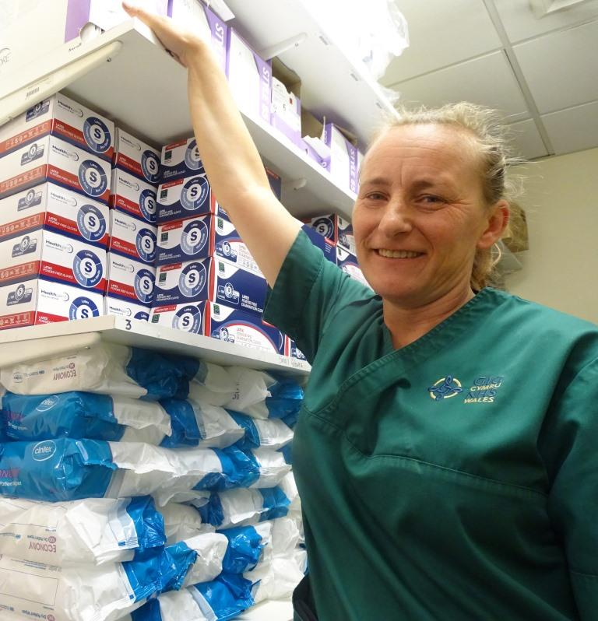
Over the last two years the Welsh Government-funded Staff Wellbeing and Attendance Project has supported a range of ABMU employees, such as healthcare support worker Dawn Jones.

Dawn Jones now has full movement in her shoulder thanks to the team’s support

Dawn works in Morriston’s Emergency Department – one of five locations the project covers – and loves her job. But she was hampered by a shoulder problem which required surgery.

After an initial assessment and discussions between the project team and Dawn’s manager, she was given lighter duties so she could remain in work while awaiting her operation.

Then, after surgery, she had regular sessions with physiotherapist Mat Tidball, one of the three-strong team involved in the project.

Dawn said: “Mat helped me to come back to work early, again on light duties. If I needed any advice he was on the end of the phone.

“I needed to get back to work as quickly as I could because I’m not one to sit down. They were brilliant, really supportive. It’s a really good service.”

ABMU has a health and wellbeing service which all employees can access. The Staff Wellbeing and Attendance Project is part of it but has worked intensely within specific areas of the health board.

The team comprises Mat, lead occupational therapist Rachel Turner and workforce programme manager Bethan Lavercombe (pictured l-r below).

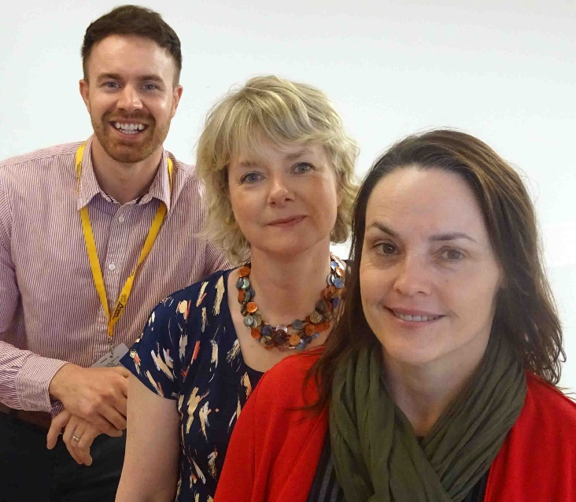
They started in Morriston’s portering service, later working in the hospital’s ED and its critical care unit, Singleton Admissions Unit and wards seven and eight in Princess of Wales.

Bethan said: “They were identified for support following discussions with managers, operational human resources and staff side colleagues.”

Meetings were held with staff to explain why the team were there and what support was available for those who wanted to access it in confidence.

The team then spent time within departments, gaining a deeper understanding of staff and the issues they faced.

Mat said: “We’re on hand as physios and occupational therapists to provide wellbeing support to anyone with muscle or joint problems, or emotional health problems such as stress, anxiety or depression either in or outside of work.

“Our ultimate aim is to help people remain fit and well in work, or if they’re off work to support a safe and effective return.”

Portering services manager Alan Thorne has not only seen colleagues make use of the service but has benefited from it himself.
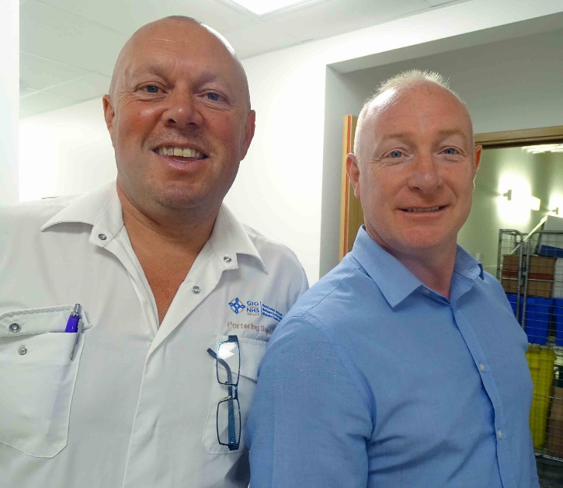
Alan said: “I had nerve damage in my shoulder. I had physiotherapy over a period of time and the result was superb.

“My injury has gone completely and I’m fully fit again. It’s a fantastic service and they’re a fantastic team.”

Portering supervisor Mike Powell added: “Every member of staff who took it up has given great feedback.”

Portering services manager Alan Thorne (right of pic) with portering supervisor Mike Powell.
In Morriston ED, emergency care service manager Lynne Haeney and office manager Heather Grice also had nothing but praise.

Lynne has a problem with one of her feet. When she broke the other foot and couldn’t get around she felt very down, and was helped through it by occupational therapist Rachel.

Lynne said: “Rachel was excellent and I now recommend her and the service to everybody.”
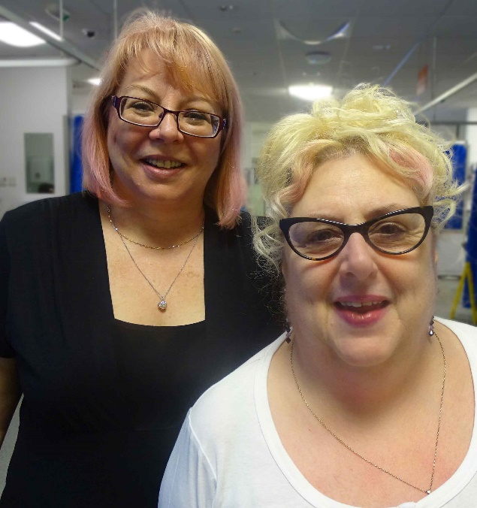
Heather, who had physiotherapy from Mat after injuring her elbow, said: “The fact that we can be treated while in work makes a big difference because we don’t have to take a lot of time off. I found it really useful.”

Right: Heather Grice (left in picture) and Lynne Haeney

Earlier this year the project’s innovative approach saw it become runner-up in the national Advancing Healthcare Awards.

Rachel said: “It has been very worthwhile. We’ve gained a rapport with the staff and the outcomes have generally been very positive.

“We also aim to help staff feel more valued, which will hopefully have a positive impact on patient care and experience.”

Source: Abertawe Bro Morgannwg University Health Board

