Therapists pass on knowledge to help care home residents
Thursday, 6 July 2017
Staff from care homes across Swansea have been getting some expert advice on how to look after clients with swallowing difficulties.

A special training event called Swallowing Awareness saw 75 delegates from 17 nursing and care homes find out more about the risks posed by swallowing difficulties or dysphagia, the importance of good nutrition, oral health and food preparation.

The multidisciplinary day was organised by Swansea Community Speech and Language Therapy team Ailsa Rees, Katherine Miller, Sarah Brown and Deborah Douglas and featured a mixture of presentations, workshops and practical demonstrations.

Ailsa Rees said: “It is an important issue because identifying and managing swallowing difficulties quickly and appropriately is essential to maintaining a client’s health, helping to avoid chest infections, malnutrition and potential admissions to hospital.”
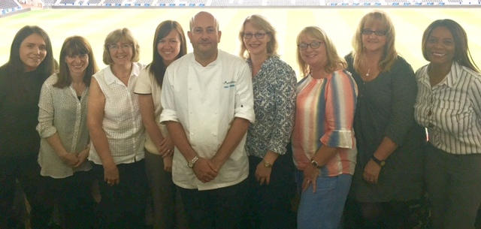
Pictured with specialist chef Gary Brailsford are (from left) Kristy Hopkins Sarah Brown, Ailsa Rees, Rhianon Labacik, Katherine Miller, Deborah Douglas, Rosalyn Davies and Lolita Byfield-Moore

The speech and language therapists work with clients with dysphagia in their own homes and nursing/care homes, assessing where the swallow is breaking down and offering advice about the safest consistencies for food and fluids as well as offering help on positioning and feeding.

During the training day they explained the normal swallow, how it can go wrong and factors to consider when supporting a client. If a person has a swallowing difficulty there is a risk of choking, or food or fluid can be aspirated and enter the lungs.

The day was made up of a mixture of presentations, workshops and practical demonstrations. The therapists also pointed out factors for staff to consider when they are supporting a client.

Community Resource Team dietitian Rhianon Labacik explained that 30 to 40 per cent of elderly residents can be at risk of malnutrition and provided practical advice about how to maintain and enhance nutrition.
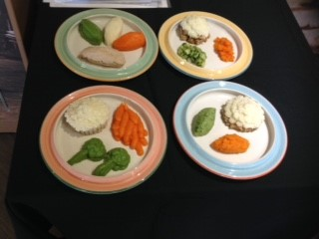
Rosalyn Davies, of the Community Dental Service, highlighted the importance of oral hygiene to reduce the risk of aspiration pneumonia and maintain general health.

Specialist chef Gary Brailsford, who is an expert in providing texture modified diets was on hand to demonstrate some of his recipes (left) that he has developed to offer an appealing and balanced diet.

Gary, who teaches professional chefs and catering staff in nursing homes, laid on a series of hands-on practical sessions that were informative as well as tasty.

Lolita Byfield-Moore, from sponsors Nestle Health Science, demonstrated the method of thickening fluids to achieve the 3 stages of fluid we may recommend following our assessment.

The day was such a success the team are already planning another event in October 2017.

“We had so many positive responses we have already had a lot of interest in joining us again for our next date,” said Ailsa.

One of the delegates said: “Every care worker should attend to be aware how important food/diet and nutrition are and how they all link together.”

Another said the event had provided “excellent knowledge to help us in our jobs” and had also shown that “diets can be very appealing if done right”.

“Everything was useful. This information should be cascaded to every member of staff in residential and nursing homes,” added another attendee.

Source: Abertawe Bro Morgannwg University Health Board

