UK first as forensic artist joins team rebuilding faces at Morriston Hospital
Wednesday, 12 July 2017
A forensic specialist has been taken on at Morriston Hospital to work with surgeons carrying out intricate facial reconstruction surgery.
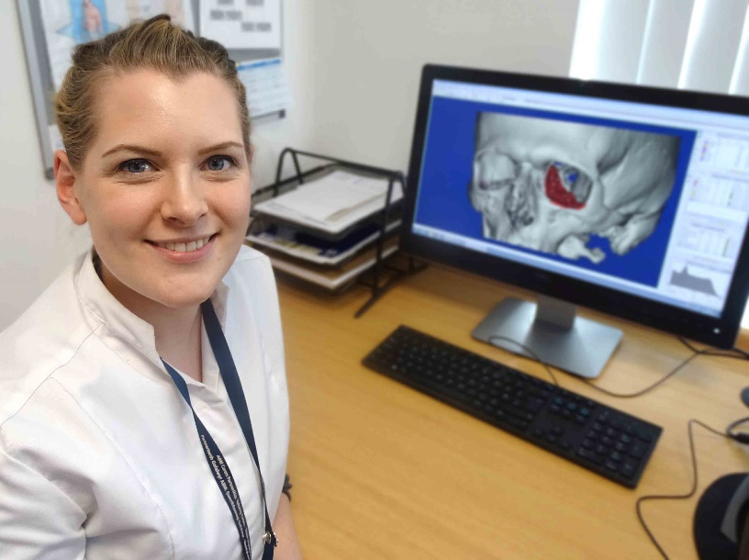
Heather Goodrum is the first biomedical 3D technician to be appointed by any NHS hospital UK-wide carrying out maxillofacial surgery – which treats injuries and diseases affecting the mouth, jaws, face, head and neck.

Other centres are now looking to follow suit and have asked Morriston for guidance.

Heather could have used the skills she developed in university to specialise in facial reconstructions from skulls – in the same way that Richard III’s face was reconstructed after his skull was found during the archaeological excavation of a Leicester car park.

Alternatively she could have worked with the police, such as drawing faces for e-fits based on witness descriptions.

Instead Heather applies her skills to digital planning for maxillofacial consultants carrying out reconstruction surgery, designing implants and cutting guides which are 3D printed once they have been approved.

As the implants and cutting guides are designed using the patient’s own CT images, they are as anatomically accurate as possible – ensuring a better outcome and saving theatre time.

Peter Llewelyn Evans is the Maxillofacial Laboratory Services manager at Morriston Hospital.

He said the service created a wide range of implants and prostheses, including legs, breasts and ears – though Heather’s role was mainly in head and neck surgery.

“The digital 3D planning for head and neck reconstructions has really grown in the last five years or so,” said Mr Evans.

“But units are struggling to do the digital work because they have not had anyone specifically trained to do it.

“The role didn’t exist in the NHS so we created a special post as we felt it was something that would continue to grow.
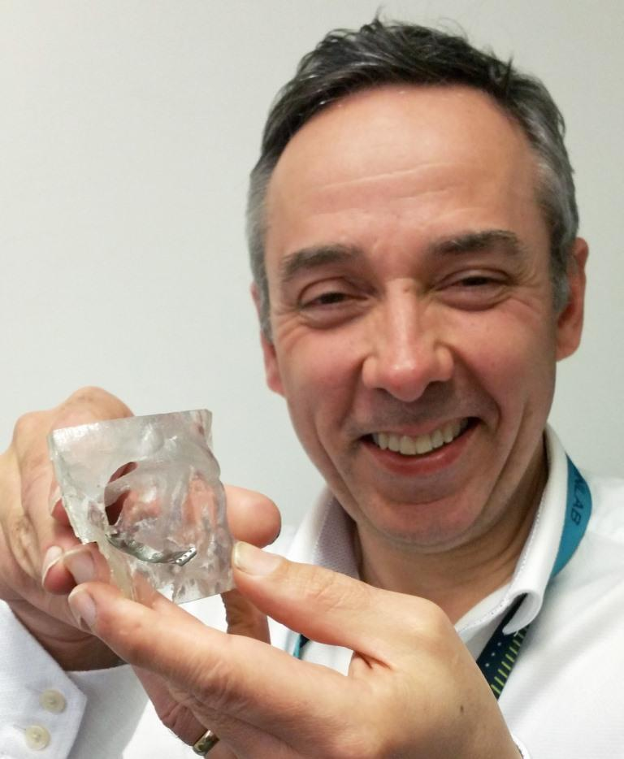
“Heather has a Masters degree in forensic reconstruction and she used the same 3D modelling software we use, so we were very fortunate to attract someone with her experience.

“Originally the idea for the post was to clean up the data on the CT scans when they came in as that is very time consuming, but her digital skill has enabled her to do much more.”

Right: Peter Llewelyn Evans with a 3D printed implant for a fractured eye socket (in detail below)

Heather did her BA Hons degree in theatre design at Nottingham Trent University, where she developed an interest in digital design and 3D software for the stage.

After that she completed her MSc (Masters) in facial forensic art, doing facial reconstructions from skulls – first using clay and then digitally.
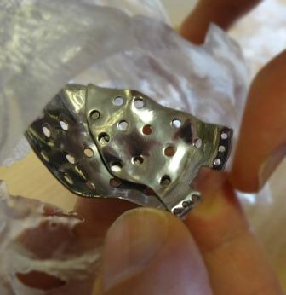
Heather then became interested in how the digital work could be applied to maxillofacial surgery. When the Morriston job was advertised, she successfully applied for it.

Heather explained: “The surgeons decide how they want to be able to do the surgery and the design side is then down to me and the reconstructive scientists in our team.

“I’ll design the part required and the team and I sit down together to make any alterations. Once complete it is sent away for 3D printing.”

Heather said she enjoyed the variety of her role, as she was able to work on implants for a range of procedures.

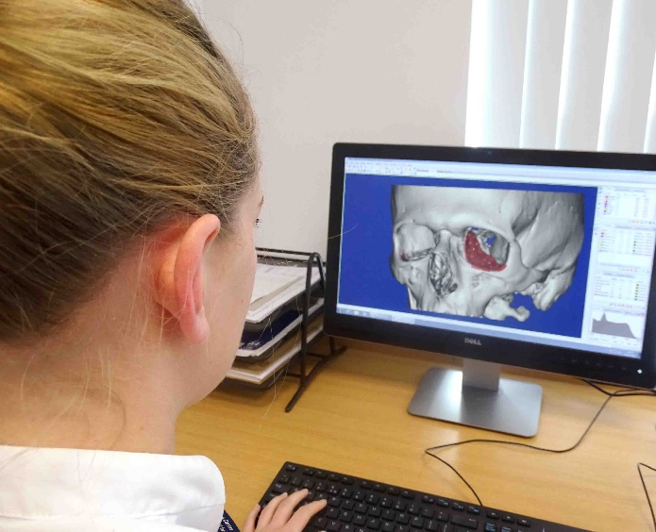
“I’ve also learnt a lot from being able to go into theatre and getting feedback straight away.

“You’re really part of the team and you do develop a rapport with the surgeons. You know you are literally helping patients rebuild their lives.”

Mr Evans said having digitally-designed and 3D printed implants meant better outcomes for the patients, as they were a perfect fit.

It also saved surgeons’ time as they no longer had to shape the implants by hand.

He added: “Other large centres around the UK have been in contact about Heather’s role because they want to create a similar post in their units.

“So it’s great to be able show another innovative approach to patient care from ABMU.”

Source: Abertawe Bro Morgannwg University Health Board

