Dedication earns hospital unit badge of quality
Friday, 6 July 2018
A UK-wide badge of quality has been awarded to a hospital unit for its years of dedication to improving services for patients.
The endoscopy department at the Princess of Wales Hospital in Bridgend has been given JAG accreditation in recognition of staff’s competence in delivering a safe, patient-centered, high-quality and appropriate service.
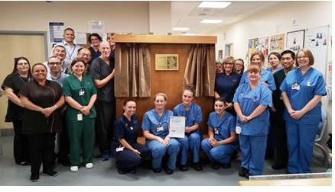
JAG stands for Joint Advisory Group on Gastrointestinal Endoscopy and is part of the Royal College of Physicians.

Regarded as one of the most innovative and effective schemes in the healthcare sector in the UK and around the world, the programme helps endoscopy departments focus on improving staff training and patient experience.

During an endoscopy an endoscope - a long, thin and flexible tube with a camera and a light at the end – is used to relay pictures from inside a patient’s body to a screen where they are viewed by an endoscopist. It is commonly used in the investigation of gastro-intestinal problems.

Years of dedication and commitment from the multidisciplinary team resulted in the endorsement. Achievements were independently assessed against recognised standards.

It is the first unit within Abertawe Bro Morgannwg University Health Board to achieve JAG Accreditation.

The accreditation is reviewed annually and will stand for five years after which time the unit will undergo a further on-site formal review.

Dr Tom Yapp, clinical lead for endoscopy services, said: “This has been a big team effort and everyone should be rightly proud of their contribution to this fantastic achievement. Our aim is to provide an excellent, timely endoscopy service to all of our patients and this accreditation recognises this.”

Source: Abertawe Bro Morgannwg University Health Board

