Glanrhyd sets the standard as first Welsh hospital to gain Green Flag Award
Monday, 16 July 2018
A hospital which looks after nature as well as caring for people has become the first in Wales to receive the prestigious Green Flag Award.
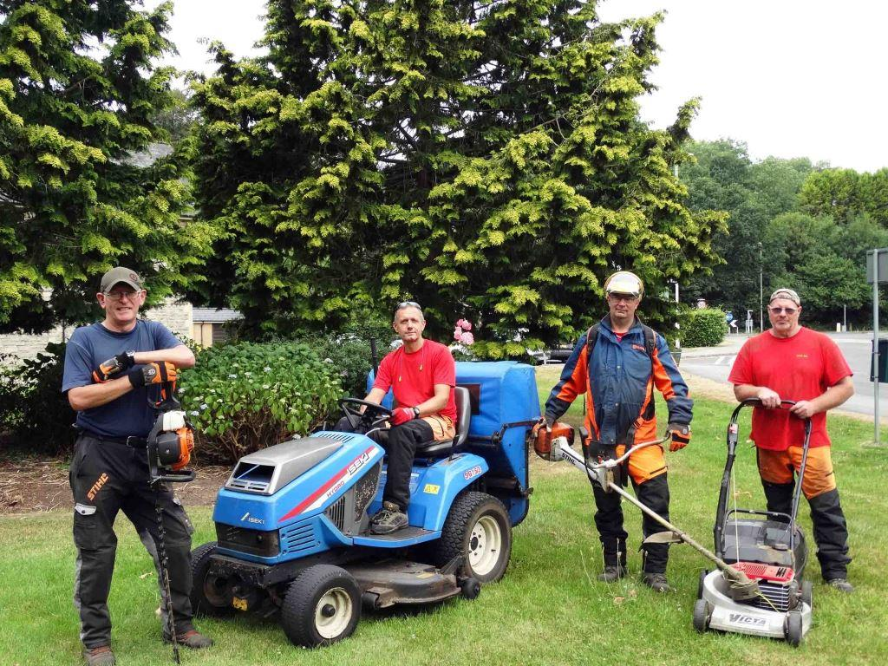
Glanrhyd in Bridgend is only the second hospital in the UK to receive the award, which recognises the finest parks and green spaces.
L-r: gardeners Steve Macduff, Andrew Clatworthy and David Evans with gardening supervisor Paul Waters
The historic site has bird and bat boxes, insect-friendly “bug hotels” and interpretive signs explaining the flora and fauna that can be found there.

Local organisations worked alongside the environment team within ABMU’s estates department on the wildlife-friendly features.

Health board Chairman Andrew Davies, who also chairs the health board’s environment committee, said: “Glanrhyd is an excellent example of how having an attractive natural environment can improve people’s quality of life.

“There is very clear evidence that being able to enjoy the natural environment has a positive impact on the wellbeing of patients, staff and visitors, and on recovery after illness.
“We have a strong commitment to greening our estates and have been working with our partners to achieve this.

“This work is also helping us deliver the goals of the Wellbeing of Future Generations Act.”

ABMU Chief Executive Tracy Myhill added: “This is a great initiative which benefits the wellbeing, not only for our patients, but our staff and the wider community too.

“Being the first in Wales and only the second in the UK to achieve this status is a great endorsement to the innovative approach being taken within our health board.
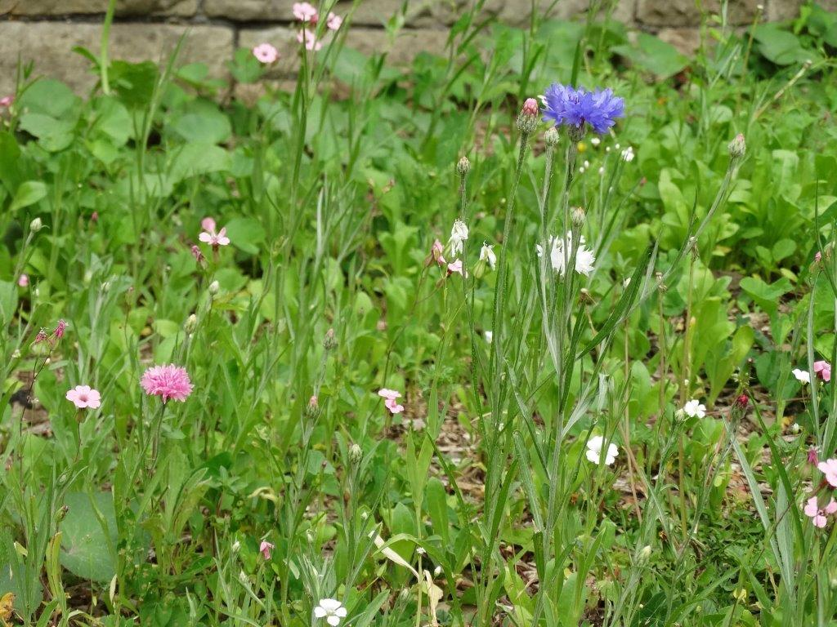
“I commend everyone’s efforts in this achievement as it demonstrates what can be accomplished when we work together with our partners.”
The Glanryhd Hospital site was first laid out, in its distinct Victorian Gothic style, in 1864.

Right: some of the wildflowers found at Glanrhyd

It was originally known as the Glamorganshire County Asylum and is one of only a few former county asylums still active in mental health use.

Earlier this year, the health board secured a tree preservation order on a 120-year-old lime tree in the hospital’s quadrangle.

But a lot of other work has been going on to create a haven for wildlife and a welcoming green space for patients, staff and the wider public.

Mark Humphreys, assistant technical services officer within ABMU’s estates department, said: “We have carried out a number of improvements to encourage wildlife and enhance biodiversity around the site.

“Around 30 bird boxes are being installed and bat boxes will be going up. Log piles have been formed and a wildflower site has been trialled to encourage bees and other insects.

“We have also put up interpretive boards at various locations, to highlight the wildlife and historical landmarks, and showing the site is a welcoming green space for local residents to enjoy.”

ABMU has worked with staff and patients, and several community groups and local organisations on the environmental improvements at Glanrhyd.

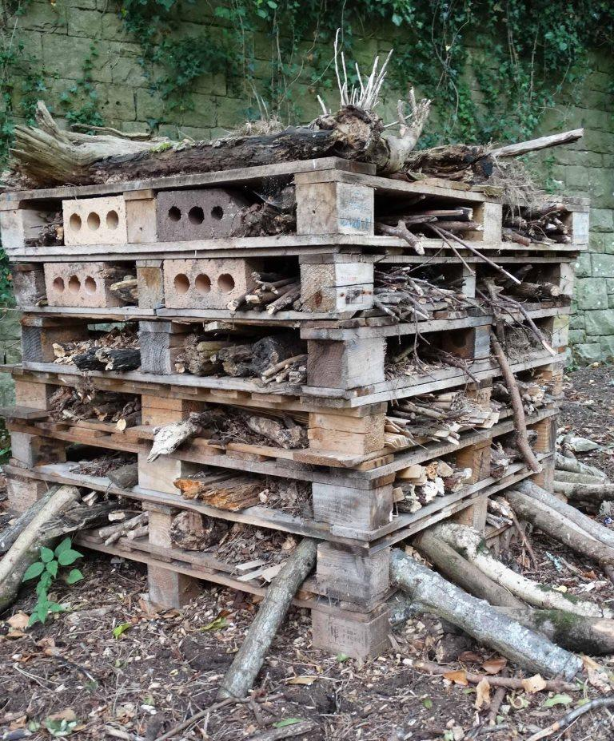
One was Wood B, part of the Awen Cultural Trust in Bridgend, which offers employment opportunities for adults with disabilities. They used fallen trees to build the frames of the interpretive boards.

Left: a bug house

Mental Health Locality Manager, Mike Sullivan, who is based in Glanrhyd, said: “The hospital grounds have long been an asset to patients and staff.

“Increasingly they are becoming a place of recreation and local interest to members of the community.

“This award not only recognises the beauty of the surroundings and the dedication of ABMU staff to tend and nurture the environment, but also it reflects how the hospital and mental health care in general are becoming the less stigmatised and separate from the local community.

“The award, I hope, will be a springboard for greater accessibility and interest in the grounds and opportunities for patients, members of the public and nature groups to celebrate a local hidden gem.”

The Green Flag Award programme is delivered in Wales by environmental charity Keep Wales Tidy with support from Welsh Government.
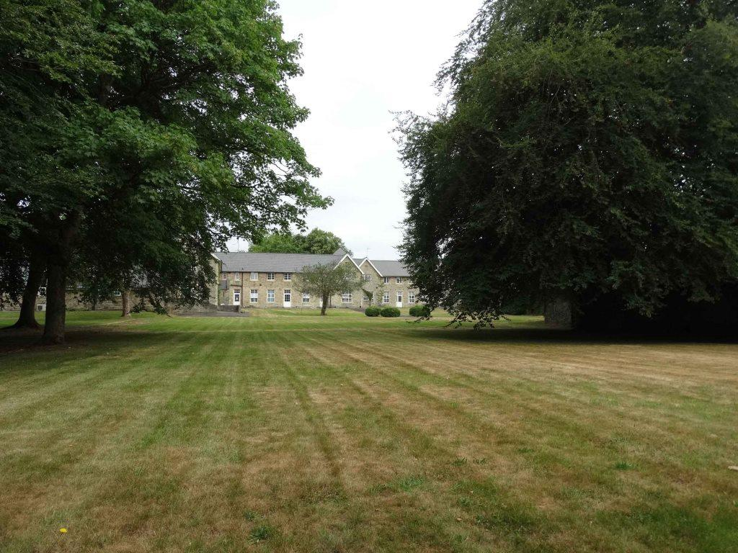
It is judged by green space experts, who volunteer their time to visit applicant sites and assess them against eight strict criteria, including horticultural standards, cleanliness, environmental management and community involvement.

Right: There's plenty of green in Glanrhyd even during a heat wave

Keep Wales Tidy’s Green Flag coordinator Lucy Prisk said: “We’re delighted to be celebrating another record-breaking year for the Green Flag Awards in Wales.

“They are a testament to the dedication and enthusiasm of the staff and volunteers across the country who work tirelessly to maintain Green Flag Award standards.”

Source: Abertawe Bro Morgannwg University Health Board

