Greener Glanrhyd's achievements are flagged up
Friday, 27 July 2018
Otters, bats, birds, foxes and centuries-old trees are not normally what you’d expect to see in hospital grounds.

But the green space around Glanrhyd Hospital in Bridgend is teeming with so much life that it has been called “a reservoir for biodiversity”.

That extensive work has secured the site a Green Flag Award - a first for a hospital in Wales – and representatives of ABMU, including chairman Andrew Davies, collected the flag at a special ceremony in Barry.
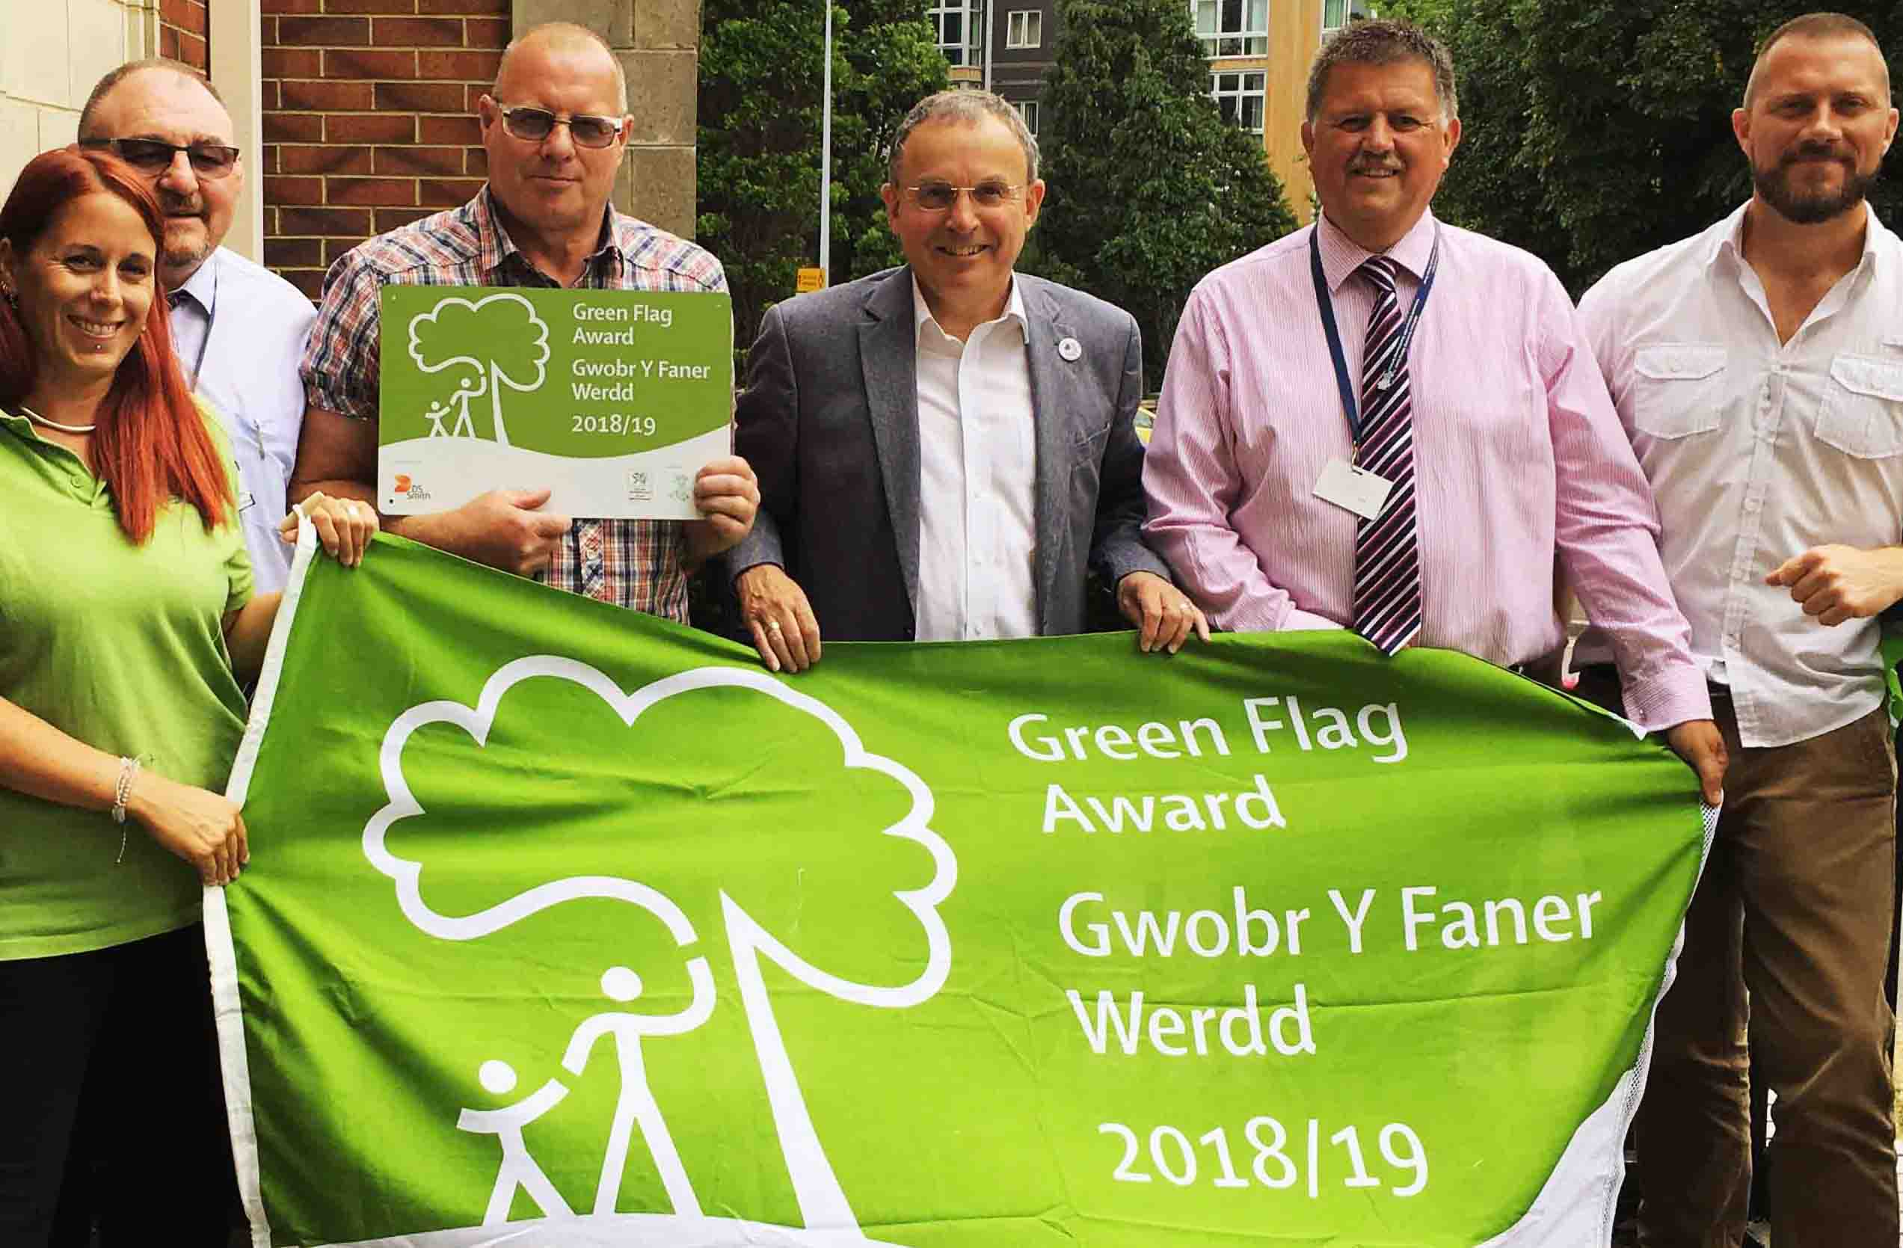
Left: Gardening supervisor Paul Waters (third from left), ABM University Health Board Chairman Andrew Davies (centre), Mark Humphreys, assistant technical services officer (second from right) and Dan Lock, Awen development manager (right) collect the Green Flag from Keep Wales Tidy

But it’s not just the health of the animals, insects and invertebrates that occupy the trees, hedgerows and riverbank that is set to improve.

It’s hoped the hospital patients who helped health board staff and their partners with the gardening and the public who come onto the site will also see the benefits.

“The beauty of places like Glanrhyd, where you invite people in, are that you have people coming into contact with the wildlife which is thoroughly good for us,” said Dan Lock, who is based at Bryngarw Country Park in Bridgend county and is a development manager for natural heritage with Awen Cultural Trust, which assisted with the project.

“There are all sorts of studies showing that half an hour outside lowers blood pressure and cortisone levels.” (Cortisone is a hormone released by the body in response to stress.)

“These places are important from a physical health point of view and a mental health point of view.

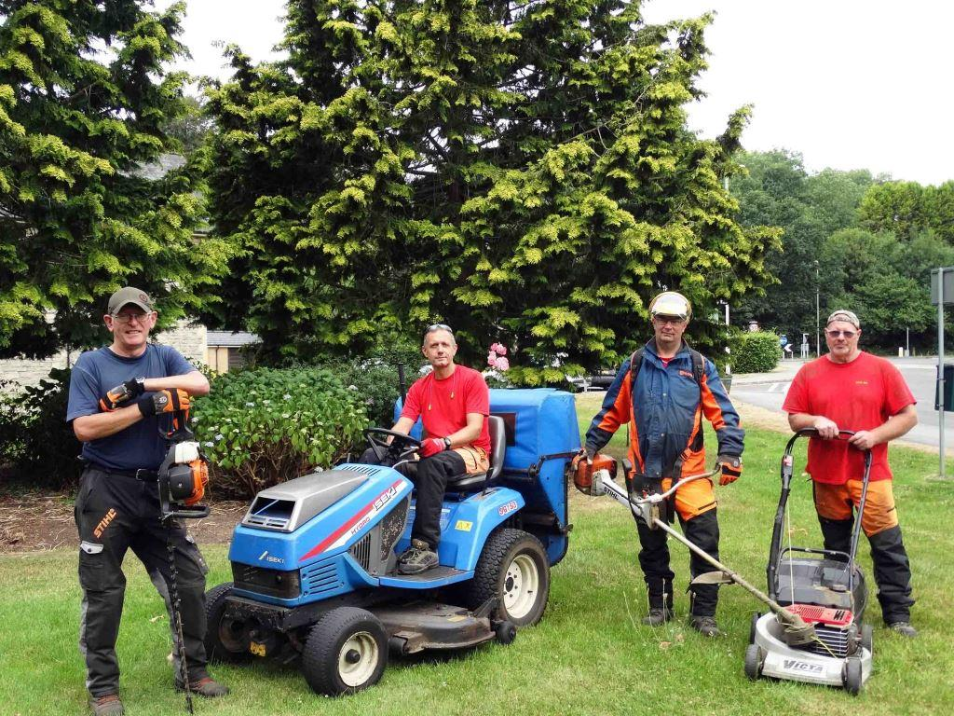
“And from a social point of view, they help to bring people together doing simple, healthy things.”

Left: (l-r) Gardeners Stephen MacDuff, Andrew Clatworthy, David Evans and supervisor Paul Waters

Opened in 1864 as the Glamorganshire County Asylum, the grounds were designed to standards at the time, which dictated that patients should have adequate room for agricultural, horticultural and recreational activities.

And although they have been kept to a high standard ever since, a large amount of work was done to satisfy the criteria required by environmental charity Keep Wales Tidy to secure the Green Flag, only the second awarded to a hospital in the UK.

Mark Humphreys, assistant technical services officer (environment) at ABM UHB, said: “We started looking at it from our point of view and structuring a two-year management plan, looking at how we could develop and welcome people to the grounds of Glanrhyd Hospital.

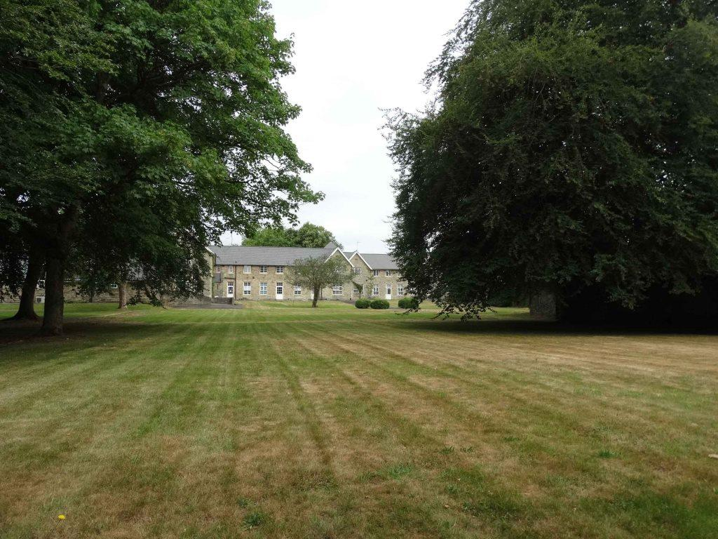
“To achieve the award we had to be a welcoming place, have a safe environment for people coming on site and also look at the facilities we have got that we could utilise for the general public coming through, like our cafeteria and opening that up, looking at our grounds, looking at biodiversity improvement and plans going forward.

Right: Trees in the grounds of Glanrhyd Hospital

“A lot of it was interacting with local interested parties outside like Bryngarw Country Park and getting them on board and then meeting with our staff and patients.

“The intention then was to get enough of the criteria that would fit the bill for obtaining the award.”

Patients from Caswell Clinic and Taith Newydd on the site have helped to dig over and plant up beds with wild flowers and also helped to build the three bug hotels.

Caswell patients have also taken part in litter-picking sessions and observed birds and animals within the grounds and helped to clear invasive Himalayan balsam from the river path just outside the grounds.
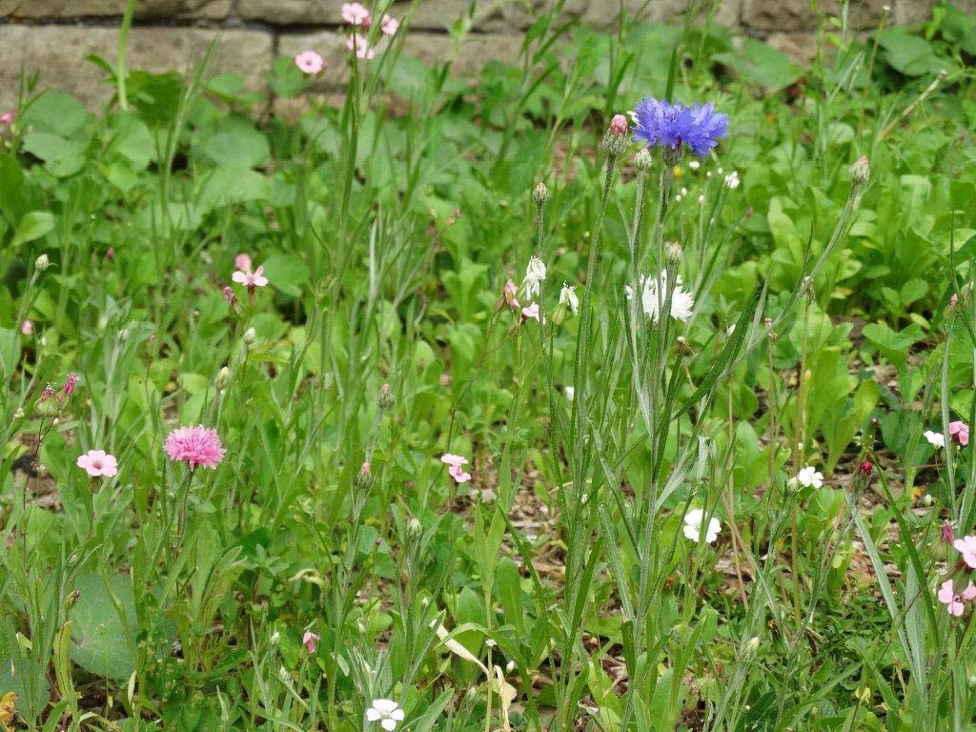
Ruth Battye, occupational therapy technician at Caswell Clinic, said: “Staff and patients at Caswell Clinic enjoy and appreciate the Glanrhyd Hospital grounds and surrounds and often chat to people walking their dogs in the area.

Left: Wildflowers planted by patients

“We think the wider community like the site too and would like to know more about what we do here. All the people who use the site have been happy to see the progress of the Greener Glanrhyd project.”

Bird and bat boxes are also set to be installed and interpretive boards have been erected around the site detailing the wildlife that lives there.

ABMU worked with Awen’s WoodB – which offers employment opportunities for adults with disabilities – on this, with the trainees using fallen trees to build the frames for the interpretive boards (below right).

As for the future, further work is planned to ensure that Glanrhyd’s grounds get even greener.

Damian Lewis, environmental support officer for the health board, said he hopes patients and local community groups will take ownership of each of the sections in the segmented garden, growing flowers and even their own crops to eat.

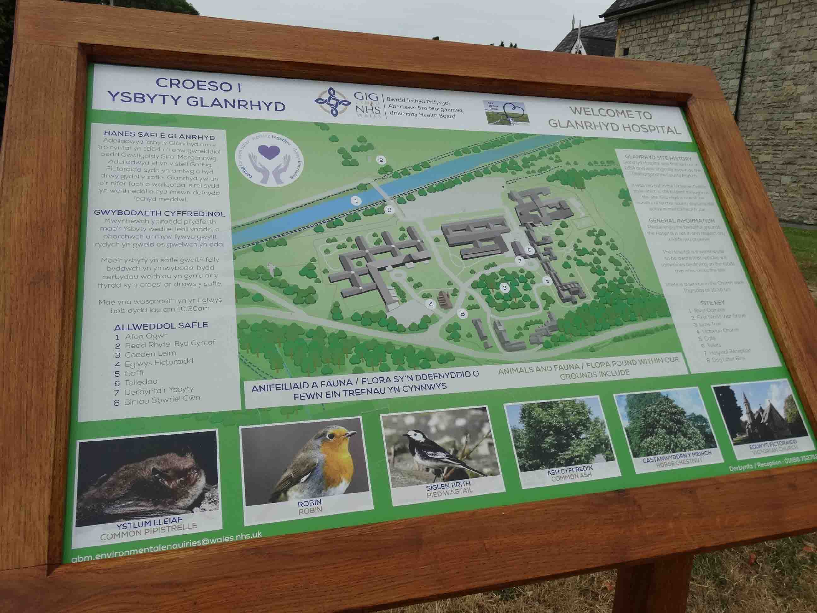
“What we are hoping to do with these segments is to get patient involvement, local community groups - perhaps local allotment groups who are looking for space to grow their own food,” he said.

“What we’d also like to do is involve local schools or the Guides, Brownies and Scouts. They do an environmental badge so this would be absolutely ideal for them.”

Dan Lock said well-managed green areas like the grounds at Glanrhyd are vital in maintaining healthy populations of wildlife.

“It’s hugely important because we need houses and development, but it does push wildlife into ever smaller territory.

“So when you have an area like Glanrhyd that is managed sensitively, it becomes a reservoir for biodiversity and it will spill out into the rest of the area.”

He said the work undertaken to achieve the Green Flag award will create the conditions for all sorts of things to flourish.
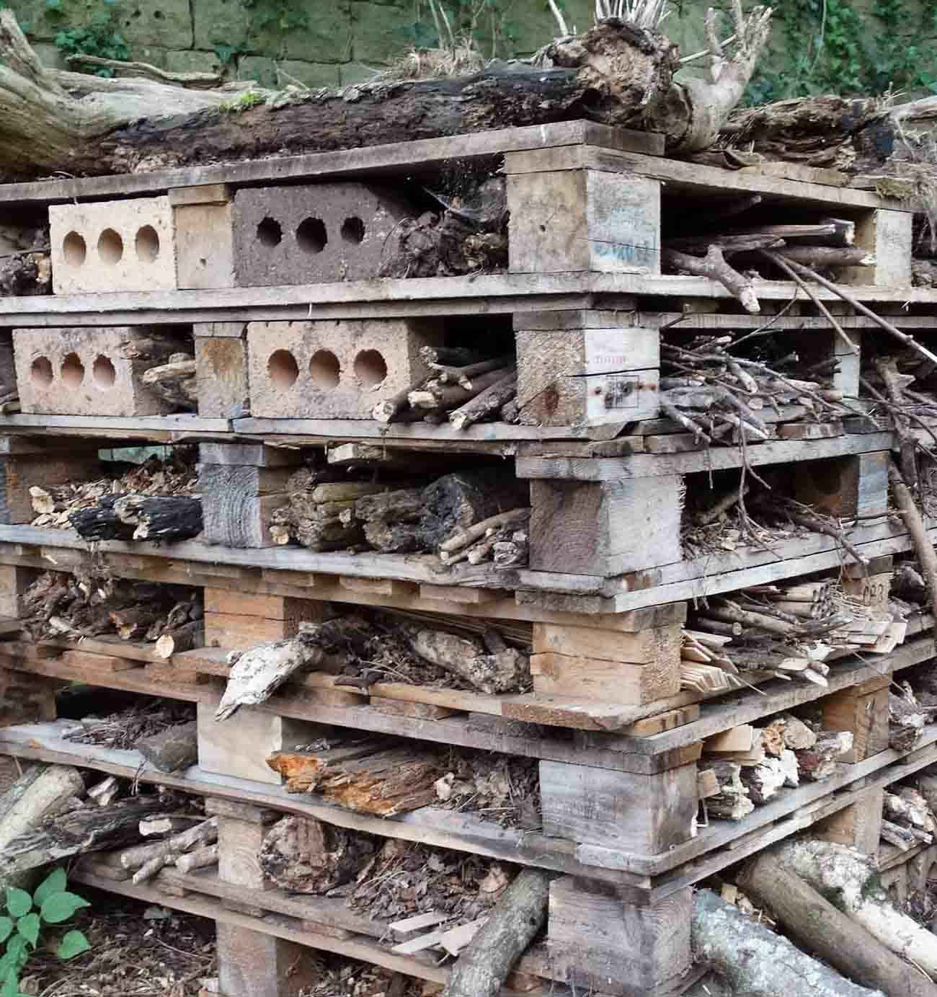
“The better the conditions, the more healthy the population of bats and other things will be.”

Sian Harrop-Griffiths, director of strategy at ABMU, said: “We are thrilled that Glanrhyd Hospital has become the first in Wales to be awarded a Green Flag.

Left: One of the three 'bug hotels' on the site

“The health board is committed to environmental improvements such as those achieved there as this benefits wildlife, our patients and the public.

“I’d like to pay tribute to all of the staff and volunteers that have been involved with this project and I look forward to seeing the grounds at Glanrhyd develop further.”

Source: Abertawe Bro Morgannwg University Health Board

