New book offers help on parenting children with autism
Tuesday, 24 July 2018
Bedtime, using the toilet, eating a meal and leaving the house often pose unique problems for parents whose children have been diagnosed with autistic spectrum disorder.

But a speech and language therapist from Swansea has teamed up with a mum to offer advice and coping strategies based on their years of first-hand experience.

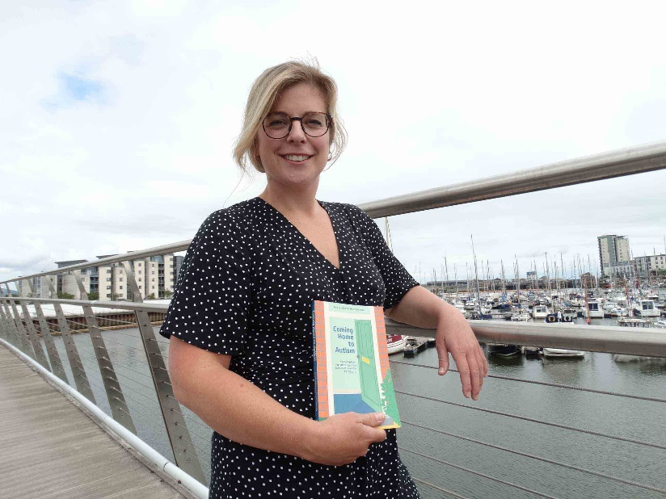
Rhian Grounds, pictured left, who works for Abertawe Bro Morgannwg University Health Board, and friend Tara Leniston have published a book called Coming Home to Autism, a down-to-earth guide for parents who need support to communicate with their child and help them take part in and complete the daily tasks which most people take for granted.

“A lot of books were from a professional or parental approach, we wanted both voices to offer practical advice,” said Rhian, from Mumbles, who works in specialist teaching facilities and special schools throughout the Swansea area.

“It’s a room-by-room approach, so that’s why it’s called Coming Home. For instance, in the bathroom section it’s all around toileting and in the bedroom it’s about sleep and how to support the sleep process.

“Tara comes from an emotional, parental and interior design view point, and I come from a communication development point of view.”

Tara’s son Dylan, now eight, was diagnosed with autistic spectrum disorder (ASD) as a toddler.

Eager to help him and to understand the condition, Tara began in-depth research but was confronted by a plethora of books which were either written in impenetrable medical language or ones which were highly emotive but not practical.

So she joined forces with Rhian, 38, to write the book which is packed with facts, tips and strategies to try.

Chapters range from The Bedroom to The Playroom, exploring each room within the home and how parents can address the challenges that lie within each.

Rhian and Tara give their own take on each room, offering insights, ideas and, in the chapter entitled The Kitchen, Tara even shares the recipes she has devised to help Dylan when he struggles with food choices, as many children with ASD do.
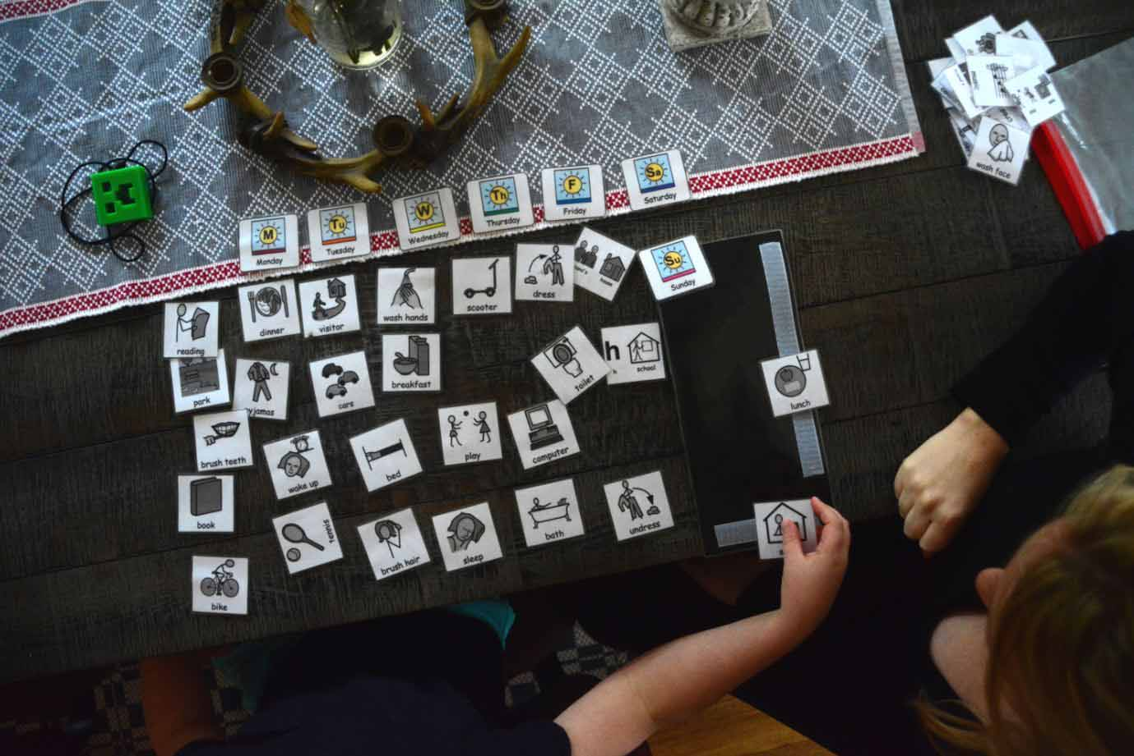
Rhian said the book has been designed as a guide which parents can dip into as and when they need it.

Right – In this picture from the book Tara and Dylan use pictures to communicate and understand what order things will happen in each day

Using the garden and going out are also covered in their own chapters.

Tara, an actress and mum of three who lives in Brighton, said: “When my son was diagnosed with autism five years ago I was looking for a book like this. I needed simple, practical advice that was easy to read and something I could use at home. All the books that were available at the time were either very medical based, diaries of other people’s journeys or books on pointing fingers as to why your child had autism.

“While I was writing I was thinking of all the information I wish I’d had in one place – as opposed to spending hours, weeks and months researching and wasting a lot of money on things that didn’t really help at all.

“One thing I found when I was researching and trying to help Dylan, is that I would often have to read a whole book to get an answer to one question.

“I was also emotionally and physically drained, so I found it very difficult to concentrate on anything let alone reading.

“I really wanted the book to be easy to read and be a book you could dive in and out of. So that if you were having a problem with your child’s eating habits, you could just go to the kitchen section, or if your child was not sleeping, go to the bedroom section.

Originally from Gorseinon, Rhian became interested in helping children to communicate more effectively when she was a teenager and volunteered with a local family who had a child with ASD.

“The biggest frustration with the family was that they couldn’t communicate with their child,” said Rhian.

Having qualified as a speech and language therapist she worked in London, which is where she met Tara, and also for the Hands Around The World charity in Kenya, before returning home to South Wales.

Rhian is now based in Central Clinic, Orchard Street, Swansea.
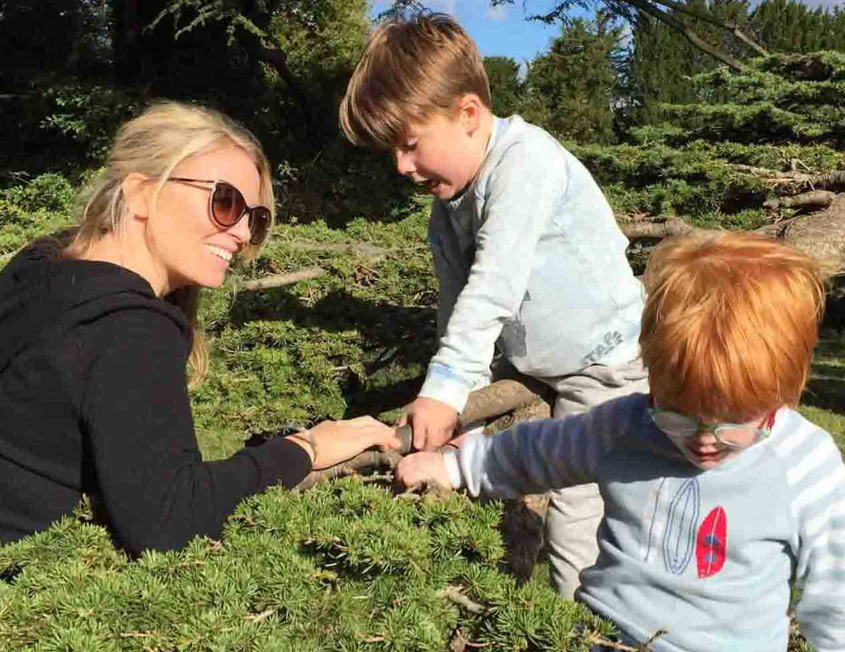
“There isn’t one reason (for autism) and there isn’t one solution,” she said.

“It’s trial and error and I always want to empower parents and young people with additional needs.

Left - Tara Leniston with sons Dylan, eight, and Luca, five, far right

“While people are waiting to see the speech and language therapist, occupational therapist or the paediatrician there are things in here that they could try. It’s really practical ideas.

"Tara is getting a lot of feedback from parents that this is really useful.

"It’s gone on some reading lists with some NHS trusts post-diagnosis as a book that might be useful for parents to look at.

“As parents you want the ‘how to’ and ‘why should I?’ answered.”

Coming Home to Autism is available in both a paperback and Kindle edition from Amazon UK priced at £12.37 and £9.51 respectively. It’s also available from the Jessica Kingsley Publishers website in paperback and Ebook format.

Source: Abertawe Bro Morgannwg University Health Board

