Outstanding and innovative work is celebrated at 2018 Chairman’s VIP Awards
Friday, 6 July 2018
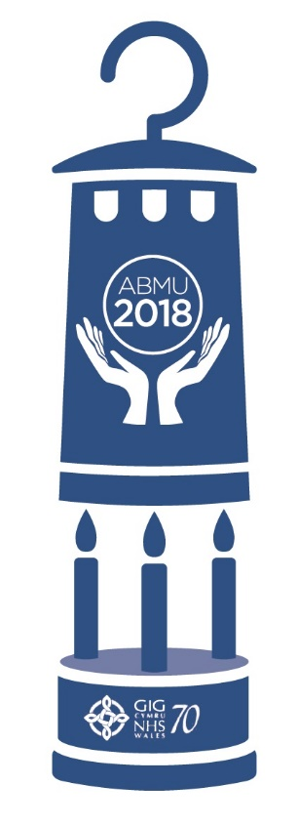
Health staff who go the extra mile for patients have been celebrated on the same day as the NHS marked its 70th birthday.

Individuals and teams who have gone above and beyond to develop services and conduct research which improves the lives of patients were recognised at the Chairman’s VIP (Values Into Practice) Awards on Thursday, July 5, at Margam Orangery.

The 11 winners were selected via an ABMU-wide staff vote, having been shortlisted following a record 225 nominations.

Now in its fifth year, the categories had been revised and streamlined to reflect the core purpose of the awards.

And among categories including Putting Patients First and Volunteer of the Year was the NHS@70 Values Into Practice Award, which was specially created to mark the anniversary.

Winners on the night included the Traumatic Brain Injury Service, which was honoured with the Commitment to Research and Learning Award.

When their patients in the community told them they felt they were “existing” and not living, they set about developing a way for them to get the most out of life post injury alongside colleagues at Swansea University.

The interventions they designed to help patients make the most of what they could do reduced levels of depression and anxiety, while improving quality of life and wellbeing.

And the special NHS@70 Values Into Practice Award went to two colleagues who were met with scepticism when they set up one of the first services in Wales designed to improve the care of patients within the community and prevent hospital admissions.

Now the Early Response Team in Neath Port Talbot is seen as a beacon which is being copied elsewhere.

The awards ceremony was supported by charitable funds and sponsors and helps staff to learn from others and spread success across the organisation.

ABMU Chairman Andrew Davies said: “This year’s celebration is particularly poignant as it coincides with the 70th anniversary of the NHS. The Values Into Practice awards give us the opportunity to acknowledge and celebrate the inspirational work of the many staff and volunteers across the health board who deliver exemplary service and exceptional care on a daily basis.

“I believe that exemplary care is provided by people who are motivated, dedicated and loyal. That type of care requires passion and commitment and all the finalists show these characteristics in their work.”

Tracy Myhill, Chief Executive, said: “The last five months since joining ABMU have been exciting and challenging. I have seen tremendous examples of the excellent work undertaken along with great ambition to improve what we do for the population we serve and the patients we care for.”

Here is the full list of winners and their achievements:

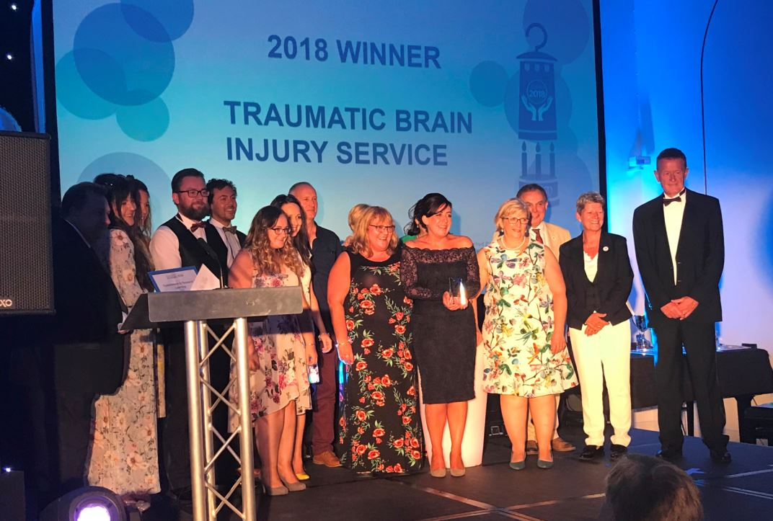
Commitment to Research and Learning Award: Traumatic Brain Injury Service

Focusing not only on ‘fixing what is wrong’ but also ‘building what is strong’, the team worked with Swansea University to helps patients supported by the community neuro-rehabilitation service make the most of what they can do.

Interventions were developed to give patients purpose and to use their strengths and feel valued, despite many facing permanent cognitive, physical and emotional problems.

As these issues can often cause relationship breakdowns and a failure to return to work and leisure activities, the team developed the GENIAL model, which works on the premise that improved mental health through positive relationships, social interaction and fulfilment leads to improved physical health.

Their work has been published and presented at conferences.

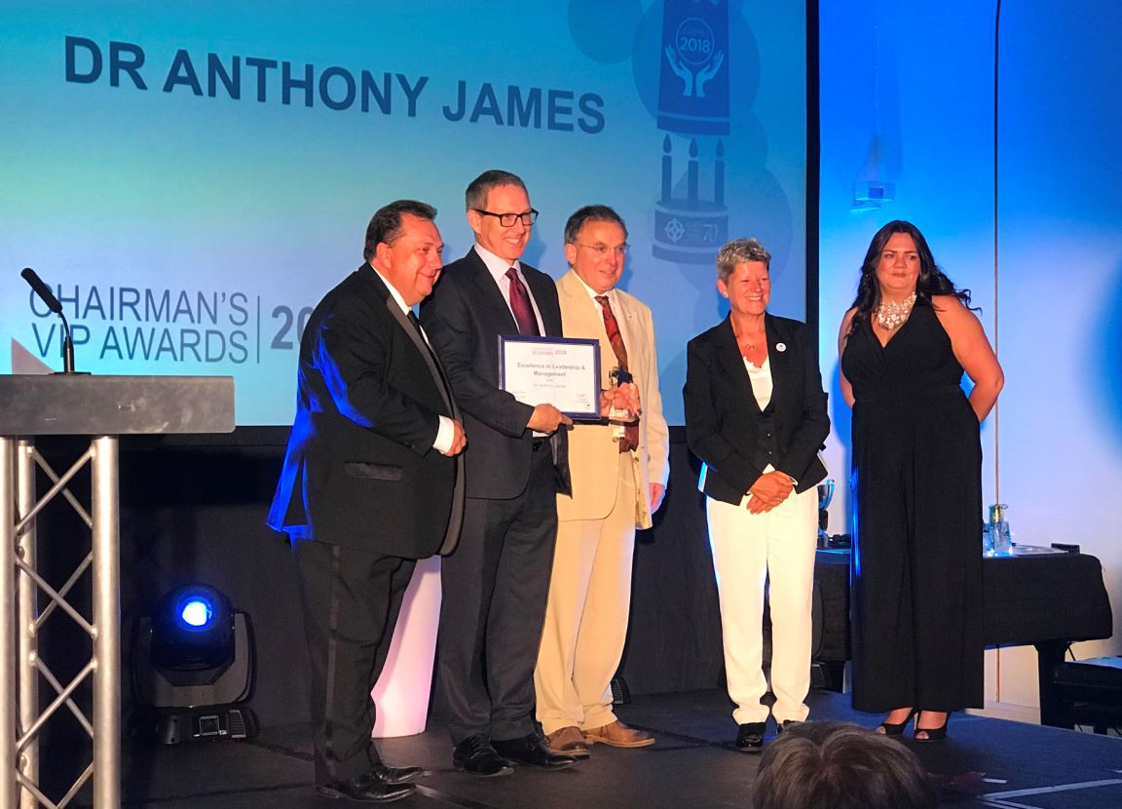
Excellence in Leadership and Management Award: Dr Anthony James

The patient is at the heart of everything this consultant geriatrician does. But through his work in Bridgend over the past 20 years he has also become known for the support he gives colleagues and fellow professionals developing their skills and qualifications.

His nomination states that Dr James is constantly seeking ways of improving and developing services that meet the fundamental needs of the patients. He is not afraid to challenge poor practice as a means of improving patient experience. He encourages others to pursue and grow their ideas for improving practice and patient care.

Overall Dr James is looked upon as a role model for others.

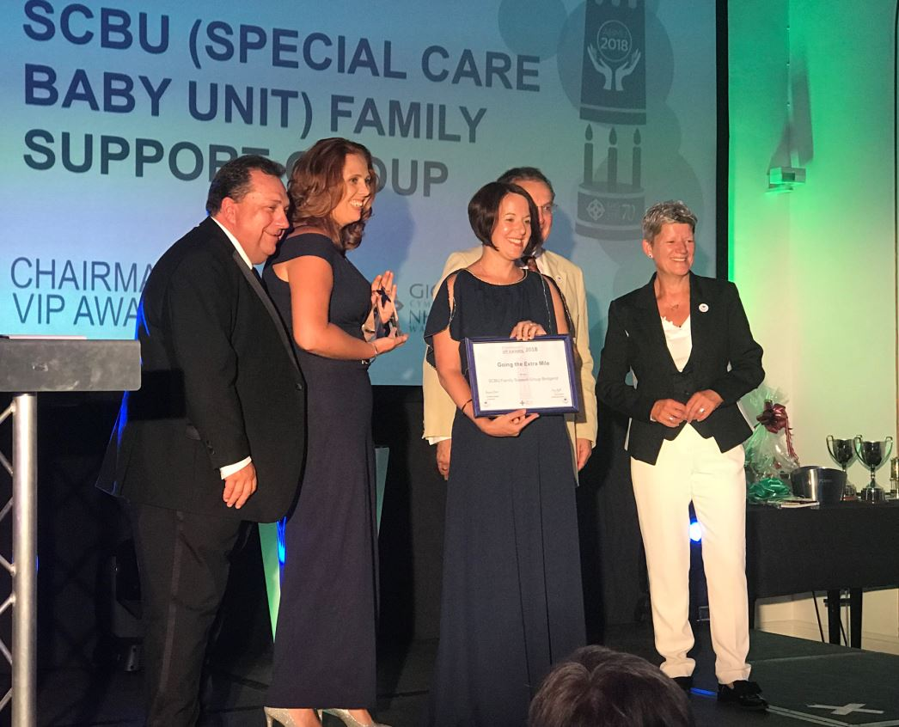
Going the Extra Mile (GEM) Award: SCBU (Special Care Baby Unit) Family Support Group Bridgend

Lisa, Tanya and Rhian don’t limit their commitment to their shifts on the unit. They also run a family support group in their own time for the families of the sick and premature babies they care for.

Held once a month in the residences, the families benefit greatly from the group as they can put questions to the skilled professionals who know their children having cared for them in hospital. The trio also organise different activities and talks for the families and siblings.

The meetings also give parents the chance to meet other mums and dads in the same situation.

In addition the SCBU Family Support Group has also raised a lot of money for the unit.

Improving Health and Wellbeing Award: Fit for the Future – Traumatic Brain Injury
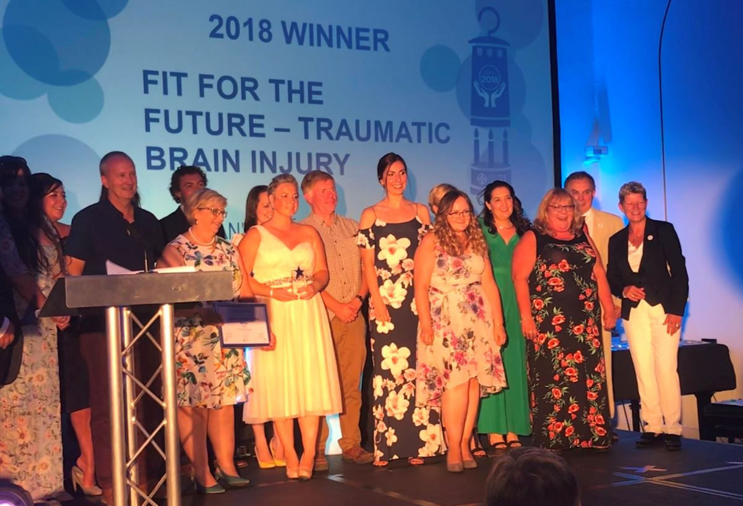
The ABMU Brain Injury Service from Morriston Hospital in Swansea has teamed up with Swansea City AFC Community Trust for the benefit of patients recovering from traumatic brain injury.

They have put together a programme of 12 weekly, five-hour sessions at Morriston at which professionals from both teams use their specific skills to ensure patients can build an alternative, positive future despite any disabilities.

While the occupational therapists and dieticians from ABMU can provide back-to-work advice and nutrition education, qualified trainers from Swansea City AFC Community Trust provide physical fitness sessions based on individual patient goals.

As a result patients have been able to undertake gardening, walking football sessions and gain qualifications in food and nutrition and football coaching among many other things.

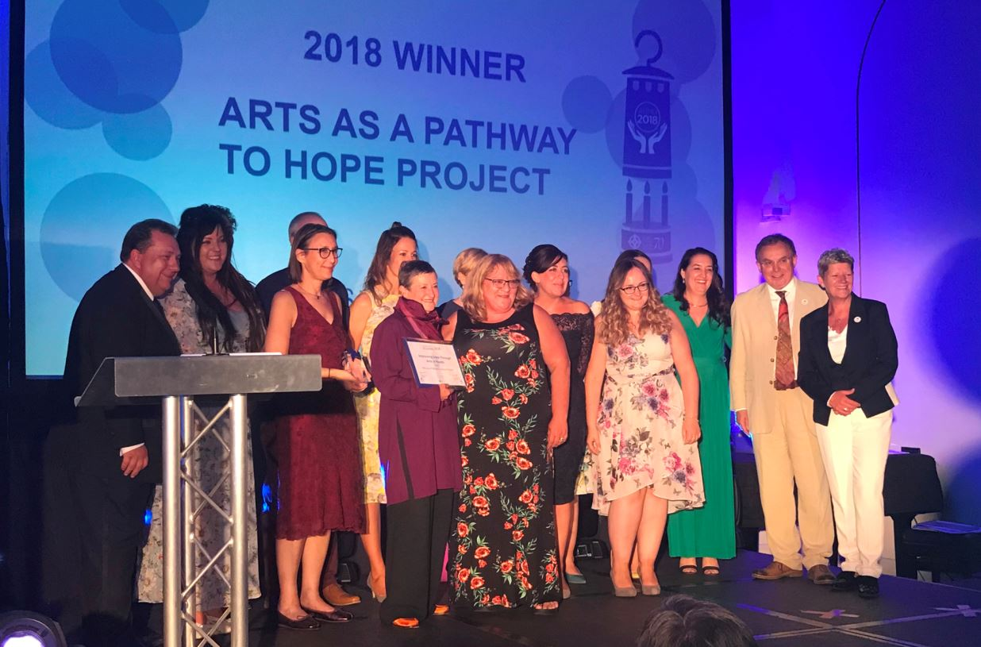
Improving Lives Through Arts in Health Award: Arts as a Pathway to Hope Project
The walls of part of Morriston Hospital are a lot livelier these days thanks to artwork produced by patients who have suffered a brain injury.

Two arts in health practitioners were recruited to work alongside hospital staff at special patient workshops where they explored their environment to create works including making impressions in porcelain clay, printing and book making.

Special scoring was used to measure the improvements in patients’ mood and wellbeing as the workshops progressed.

As well as pieces created individually by the patients who took part, the project resulted in a leaf-themed trans-illuminated artwork in the activity room in their base at the occupational health offices and so-called echoes in the reception area and corridor.

Improving Lives Through Arts in Health – Photography Award: Emma Mugford
This year’s Staff Photography Competition was developed by the maternity team who wanted to create a space for bereaved families who have lost a baby to meet with specialist staff away from the maternity unit.

All families are offered a meeting following their discharge from the hospital with the team who provided their care during pregnancy and birth.

The quiet room is situated within the hospital’s outpatient department and will be decorated in soothing colours.

Deputy head of midwifery, Sue Jose, chose water as the special theme for this year’s competition.

Emma’s winning image, taken from a cliff overlooking a tranquil beach and the sea, will be displayed in the room.

NHS@70 VIP (Values Into Practice) Award: Dr Firdaus Adenwalla and Mrs Annette Davies
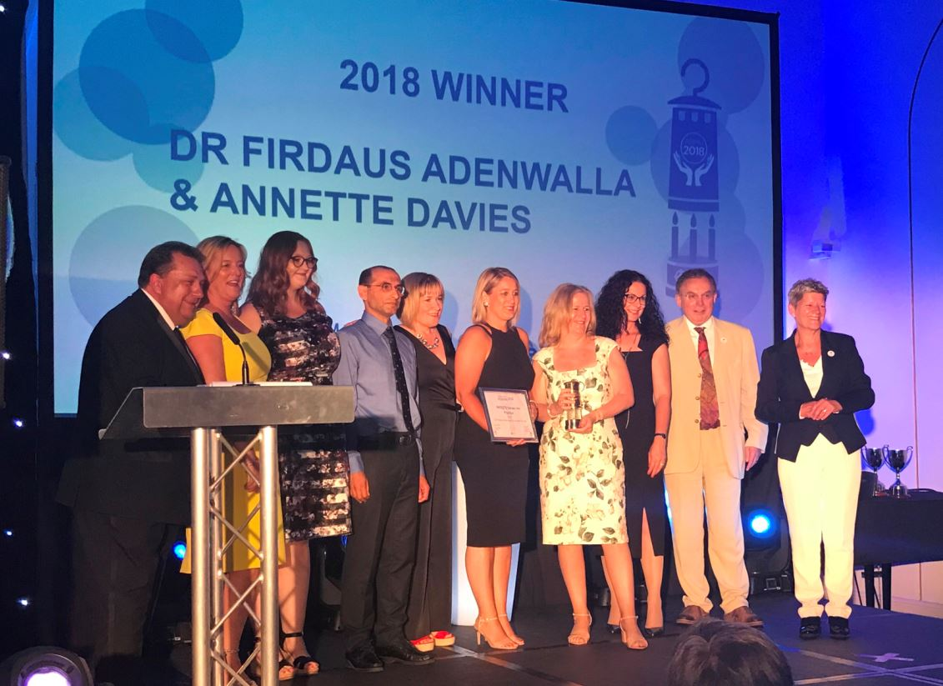
The pair founded the Early Response Team in Neath Port Talbot in 2005 when Annette was a district nursing sister and Dr Adenwalla a consultant physician/geriatrician.

The aim was to improve the care provided to adult residents, particularly older people, in the Neath Port Talbot area and prevent avoidable hospital admissions.

They were one of the first teams in Wales to attempt such a challenge and appear to be the most successful to this day, according to their nomination.

The team of two has now grown to a whole-time equivalent of 22.5 people, including advanced clinical practitioners, sisters, staff nurses, healthcare support workers and clerical staff.

Managed by Annette with the support of Dr Adenwalla, the team manages a case load of complex and often acutely unwell patients.

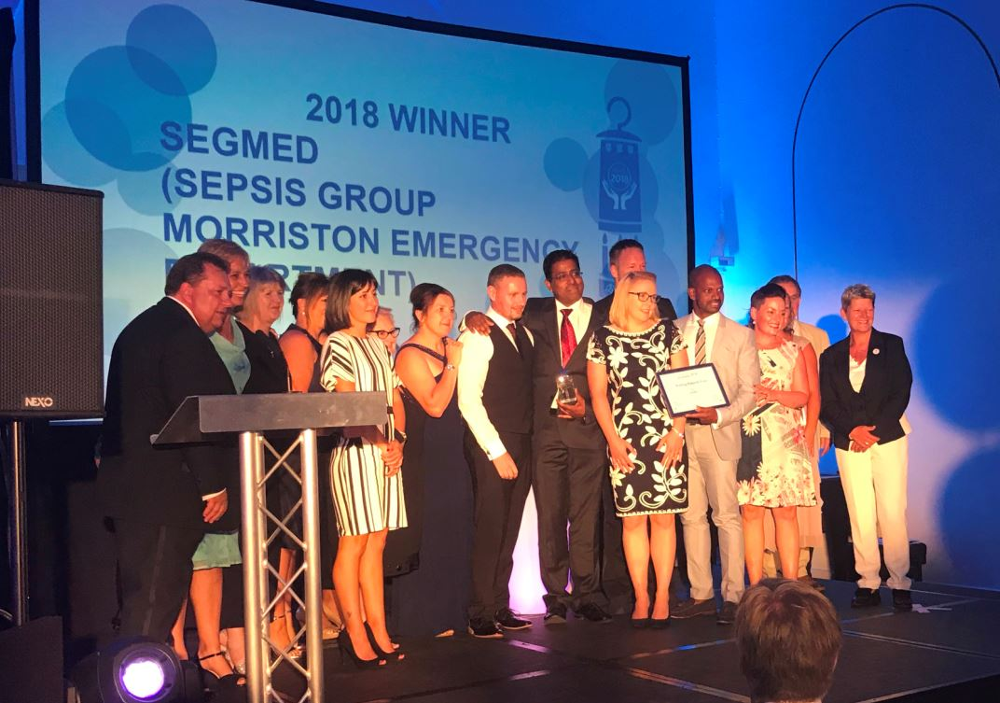
Putting Patients First Award: SeGMED (Sepsis Group Morriston Emergency Department)
Sepsis is a potentially life-threatening condition where the body’s immune system goes into overdrive as the result of an infection.

This can reduce the blood supply to vital organs such as the brain, heart and kidneys and, without prompt diagnosis and treatment, can be fatal.

In 2016 the Emergency Department (ED) at Morriston Hospital formed the SeGMED working group encompassing a wide range of staff from a consultant to reception staff.

It carried out teaching and update sessions to ensure all staff in the ED were aware of the importance of early identification in patients and updated the sepsis screening tool and constantly looked for methods to try to improve compliance of completion of sepsis forms.

The group then moved to raising awareness throughout the hospital, which led to the creation of sepsis awareness days where staff can meet real patients who suffered from sepsis and the friends and family of those who lost their lives to the condition.

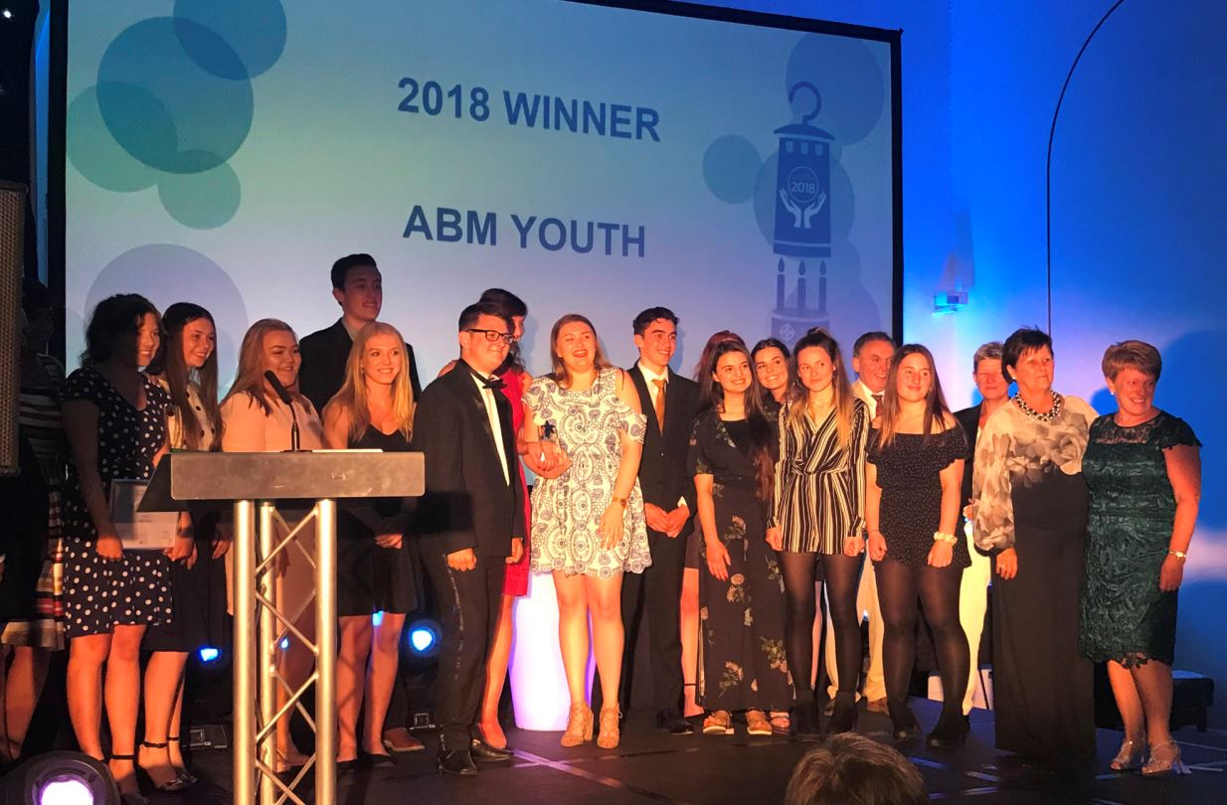
Volunteer of the Year Award: ABMyouth
In a first for the Welsh NHS, this youth action panel made up of 20 volunteers aged 13 to 23 from Swansea, Bridgend and Neath Port Talbot champions the rights of children and young people within ABMU.

Reporting directly to the executive board, the group undertakes various projects including visiting and assessing paediatric wards and sharing their findings with staff in order to sustain improvement.

These young volunteers, who study full time, have also sat alongside professionals on interview panels when new members of staff are recruited.

In February ABMyouth were joint winners in the Health, Social Care and Wellbeing category at the Third Sector Awards Cymru and have also met Welsh Health Secretary Vaughan Gething to promote ABMU’s Children’s Charter and ensure issues affecting young people were raised at the highest level.
Welsh Language Award: Rhian Bowen
This highly specialist speech and language therapist was concerned that a screening and intervention programme in Neath Port Talbot and Swansea schools, which was designed to identify children of nursery age with speech and communication problems, was only available in English.

With Welsh-medium schools also uneasy at using the Wellcomm programme as a result, Rhian was concerned that children starting nursery in the Welsh schools would not be able to access this screening and intervention package and miss out on valuable early support.

So she took on the challenge of translating the screening assessment into Welsh as well as the training package for school staff to ensure they were comfortable with it.

Working Together for Patients Award: Macmillan Therapy Team
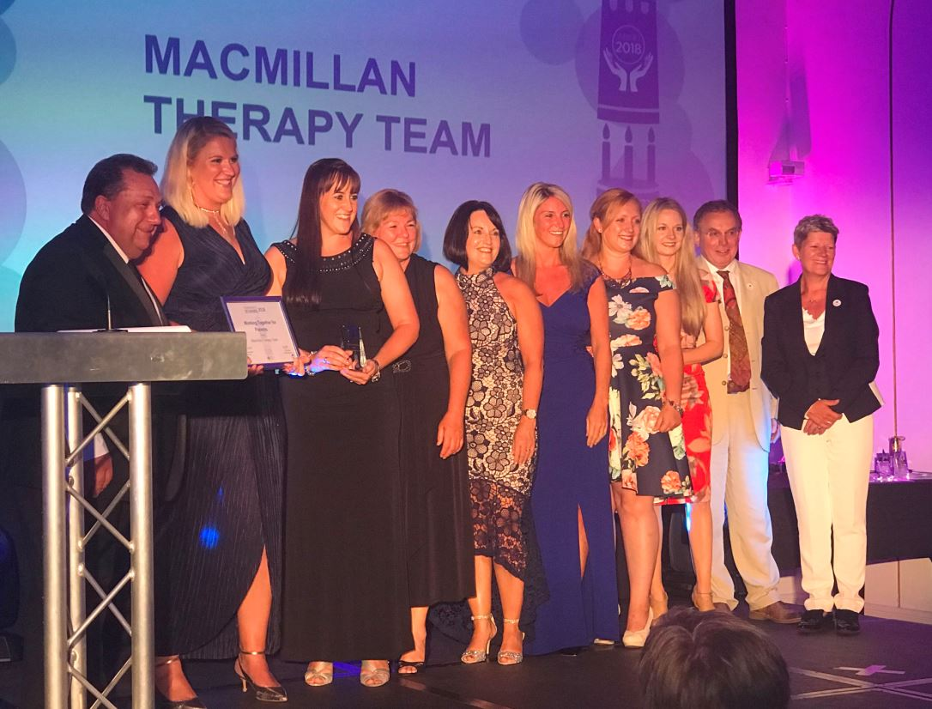
The Macmillan Therapy Team is a team of occupational therapists, physiotherapists and rehabilitation technicians who provide specialist holistic therapeutic rehabilitation and support for anyone admitted to ward 12 in Singleton Hospital in Swansea.

Working in partnership the team provides a collaborative and streamlined approach which benefits patients, whereas before they worked separately resulting in problems in patient care and pressure on the therapists themselves.

By working as one, the rebranded team now keep just one single set of notes, carry out one patient assessment instead of two, share their knowledge and skills with each other and provide cover for each other during periods of sickness and leave.

The changes, implemented over a three-month period, saw the number of rehabilitation sessions carried out per day double from 11 to 22.

Source: Abertawe Bro Morgannwg University Health Board

