Staff feeling fighting fit, thanks to wellbeing champion Jade
Monday, 9 July 2018
The paediatric team at Morriston Hospital are taking steps towards fitness, thanks to their own wellbeing champion.
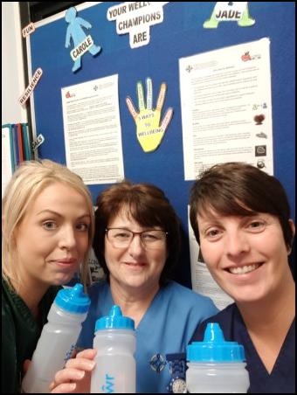
Healthcare support worker Jade Joseph is one of our network of staff across ABMU dedicated to encouraging colleagues to stay fit and well as well as signpost them towards wellbeing services if they need them.

Jade Joseph (left), deputy ward sister and fellow wellbeing champion Carole Davies and sister Sarah James show off the water bottles they have been given.

Jade contacted Welsh Water and arranged a donation of 150 drinks bottles for staff across the paediatric unit to make it easier for them to stay hydrated at work.

Oakwood Ward sister Sarah James said: “Jade has been making a real difference and takes her role very seriously. She has also encouraged us to go walking during our breaks as part of National Walking Month and several staff have enjoyed taking part in this.

“We are really grateful for her help and enthusiasm.”

Jade said: “As wellbeing champion my role is to raise awareness of initiatives like National Walking Month with my colleagues and give them ideas about how they can make simple changes to stay healthy.

“I am delighted they have been so keen to get involved.”

Source: Abertawe Bro Morgannwg University Health Board

