Stay safe in the sun warning after heatwave leads to sunburn admissions
Wednesday, 4 July 2018
Warnings have been reissued to keep safe in the sun, after Morriston Hospital’s specialist burns centre revealed it has treated seven patients with severe sunburn in the last four weeks.

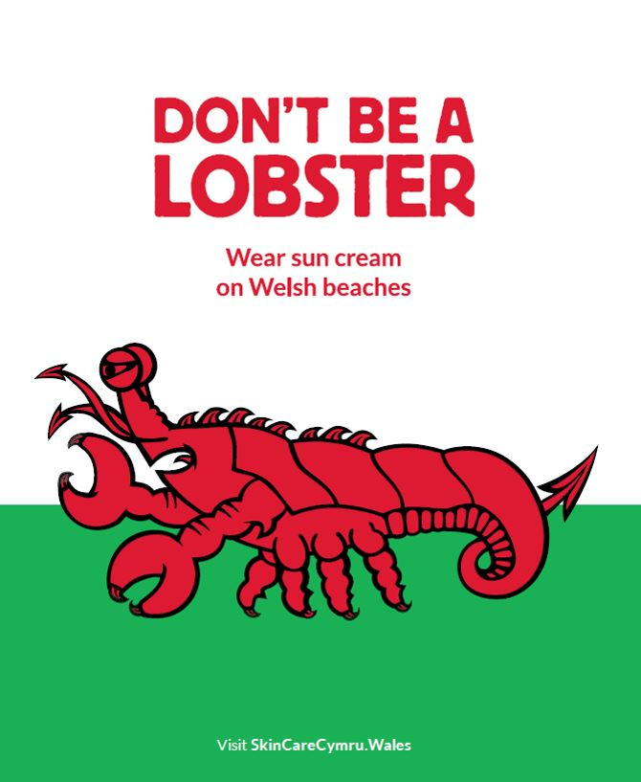
Searing sunshine in a cloudless sky on Saturday also led to some people - including Wales Air show attendees – getting badly burned over the weekend.

Morriston Hospital’s Emergency Department is currently dealing with a high number of people presenting with sunburn, and in some cases they have been severe enough to be referred to the Welsh Centre for Burns and Plastic Surgery.

The centre provides care to people with the most serious burns. So far this summer it has had seven patients referred to it with severe sun burn in June and the start of July. Most of these patients are children, and some had to be admitted as inpatients.

The deep thermal burns develop massive blisters, cause extreme pain and can affect mobility because movement of limbs is restricted by the damage to skin. These patients need specialist burns dressings and face weeks of burns outpatient appointments to get their dressings changed.

Clare Baker, Burns Centre matron, said:

“These are deep thermal burns which we are dealing with, very severe sunburn. It is really important to protect your skin in the sun. Sun cream needs to be reapplied regularly and remember that if you sweat, it will come off and must be reapplied.

“We are seeing the most severe cases here, but there will also be a lot of people with sunburn who are being managed by their GP, and who don’t get referred to us.”

Clare warned that skin damaged by sunburn meant people had an increased risk of developing skin cancer later in life.

Becky Gammon, head nurse at Morriston Emergency Department, echoed Clare’s call for caution in the sun and said:

“We’ve been really busy with people presenting with sunburn – adults and children. Some people don’t realise how strong the sun can be in the UK, and they are not using adequate protection.”

Burns centre advanced practitioner occupational therapist Janine Evans agreed:

“People may not realise that sunburn doesn’t just happen on holiday – you can burn very easily in the UK, even when it’s cloudy.

“More people die from skin cancer in the UK than Australia, with Wales having the highest incidence of skin cancer in the UK.

“It’s not just sunbathing that puts you at risk, but being outside in the sun without adequate protection. Sand, concrete and water can reflect the sun’s rays onto your skin, and a mild breeze or getting wet in the sea or pool may cool you down so you don’t realise you’re burning.”

As the heatwave continues, clinicians are urging people to ensure they:
- Slip on sun protective clothing
- Slop on SPF 30+ sunscreen with at least 4 start UVA protection
- Slap on a wide-brimmed hat
- Slide on quality sunglasses, and
- Shade from the sun whenever possible
If you or your child has sunburn, you should get out of the sun as soon as possible. Mild sunburn, where the skin is red and painful but not blistered, and where there are no other symptoms of heat exhaustion (chills, high temperature of 38 degrees C or above, dizziness, headaches, feeling sick) can usually be treated at home with moisturisers. The following advice may help to relieve symptoms:
- Cool the skin by having a cool bath or shower, sponging it with cold water, or holding a cold compress to it;
- Use cream or ointment moisturisers on affected areas;
- Drink plenty of fluids to cool you down and prevent dehydration;
- Take pain killers, such as paracetamol or ibuprofen; and,
- Avoid further sun exposure.
If the sunburn blisters, there is severe swelling, or you feel unwell, contact your GP, go to your nearest minor injury unit or call 111 if you live in Swansea, Neath Port Talbot, Bridgend or Carmarthenshire.

Source: Abertawe Bro Morgannwg University Health Board

