Beat goes on for police officer Joanna who almost died while out running
Friday, 16 June 2017
A police officer who nearly died after becoming unwell while out running has put her life back on track with the support of a Morriston Hospital service.
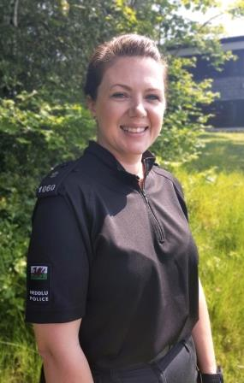
Joanna Brown was training with a running club in Neath when she suffered an acute subdural haematoma, a serious bleed on the brain.
Back in work…Joanna pictured June 2017
The Gwent Police constable underwent an emergency craniotomy at the University Hospital of Wales in Cardiff.
After several weeks in hospital, Joanna was well enough to go home, albeit in a lot of pain, with a shaven head and lots of medication.
But her physical recovery was only part of the story because Joanna found herself facing an uphill battle dealing with the mental aspects.
Now, thanks to the support of Morriston Hospital’s neuropsychology service, she feels like she has turned her life around – not only back in work but with a beautiful baby daughter too.
In July 2015, Joanna – who had only moved to the Neath area a few weeks earlier – went out with a local running club.
“I’d been running for years and wanted to keep my fitness up. Not only that but I thought it was a good way to make new friends.
“I just felt something was really wrong. I didn’t have any symptoms, just a gut feeling that something wasn’t right.
“I gave my mobile phone to one of the runners, a list of people to contact and instructions to call an ambulance – I had my police head on.
“I was taken by ambulance to Morriston hospital A&E. After I got there, I lost consciousness and woke up at the Heath hospital in Cardiff where in my confusion I tried to rip my breathing tube out.
“I was put back under only to wake again and be told I'd had successful brain surgery.”
It was only when Joanna eventually returned home after surgery that she realised how isolated she was. With her family and her partner’s family both living away, she had no real support network.
“I looked like something from outer space. I was very lonely and frightened and traumatised.”
Struggling to come to terms with what had happened, Joanna was referred to ABMU’s regional neuropsychology service. Since then she has had regular sessions with neuropsychologist Dr Nia Wyn Davies.
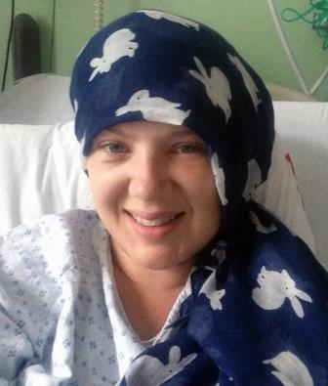
She said Dr Wyn Davies talked through what had happened, showing her scans and explaining the process so Joanna could start to accept it.
“I was never given an explanation of what had happened. I was told it was just one of those things.
“I can accept that now but at the time I really struggled. I was a healthy, fit young woman, a police officer, and then something like that happens on my day off.
“I was terrified. I thought I had done something wrong and deserved it and should have died.
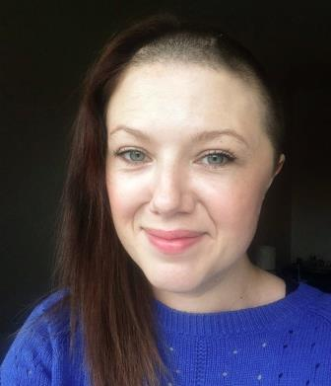
“But Nia was able to help me move my thoughts around. It happened, so how could we get me back to the person I was before?
“My mental health was affected because I couldn’t explain it. The neuropsychiatry service was able to put me back together internally.
“It wasn’t enough to have brain surgery. You need this aftercare as well.”

Right: Two pictures of Joanna following her emergency surgery
Thanks to Dr Wyn Davies’ help, along with the support of family, friends and work colleagues, Joanna returned to Gwent Police in February 2016. Eight months later she became mum to a baby daughter.
Joanna, who also attended a positive psychology course which ABMU runs in collaboration with Swansea University, said: “I feel like I’ve turned everything around.
“I want people to understand how much I appreciate the support I’ve had from Nia and the neuropsychology service.
“They’ve done some fantastic work to build up my confidence and self-esteem, and manage anxiety and negative thoughts.”
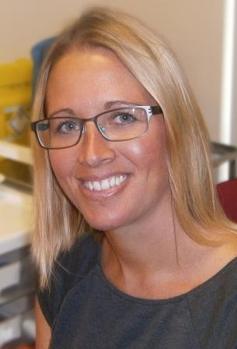
The neuropsychology service provides neuro-rehabilitation for those who have experienced brain injury. It provides assessment, support and intervention to patients and their families.
The aim is to maximise recovery, increase independence and help the person cope with any difficult physical, cognitive or psychological symptoms following the brain injury.
Dr Wyn Davies (left) said: “Joanna is doing incredibly well and is a real inspiration.
“She is making fantastic progress thanks to her hard work and determination. I’m very proud of her.”
Source: Abertawe Bro Morgannwg University Health Board

