Choir set to sing out for special care baby unit
Friday, 23 June 2017
Tickets are still available for choir Maternal Harmony's summer concert on Friday, 30th June.

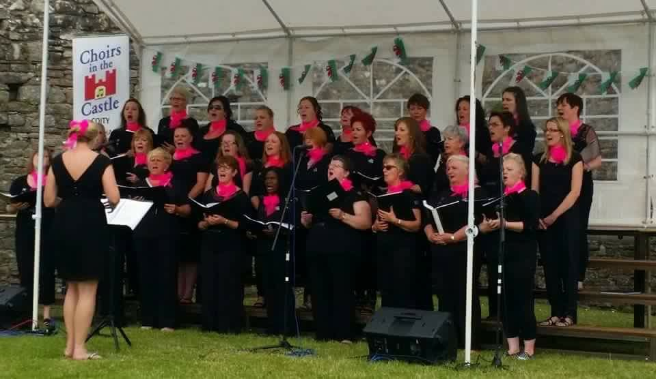
It is being held at St Mary’s RC Church in Bridgend and all proceeds from the evening will be going to the Special Care Baby Unit at the Princess of Wales Hospital.

Tickets cost £4 and can be purchased from any choir member or at the door on the night. There will also be refreshments and a raffle.

Originally set up by the Perinatal Response and Management Services (PRAMS) at Princess of Wales Hospital and aimed at women with postnatal depression, the choir now welcomes those with other mental health issues, their family members or anyone who just wants to support the cause.

The choir is always on the hunt for new recruits.

Gail James, lead nurse for PRAMS and choir committee member, said: “We would love to see some new members signing up. You don’t need to have been referred by the PRAMS team – you don’t even have to be able to sing – you just need to be supportive of our cause and want to spend your time making music with a great group of people.”
The choir rehearses every Thursday from 7pm to 9pm in the Communal Residences Hall at Princess of Wales Hospital.
For further information contact Gail on 07960 602383 or fellow committee member Debbie Emment on Debbie.emment@wales.nhs.uk

Source: Abertawe Bro Morgannwg University Health Board

