Claire in running for top learning disability nursing award
Tuesday, 27 June 2017
A nurse who is at the forefront of ABMU’s improvements in care for patients with learning disabilities has been shortlisted for a top award.

Claire Jenkins, who is based at Princess of Wales Hospital, is a finalist in the learning disability nurse category at this year’s prestigious National Learning Disabilities & Autism Awards.
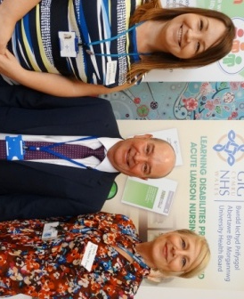
“I am absolutely delighted. It is very satisfying but this really is recognition of a team effort, especially the hard work of my colleague Joanne Edwards,” she said.

Claire Jenkins (right) with Learning Disability
Liaison Service colleagues Joanne Edwards and Christopher Griffiths.

The pair are both specialist nurses in ABMU’s Learning Disabilities Liaison Service which was launched a year ago and is led by consultant nurse Christopher Griffiths.

The service aims at identifying and supporting vulnerable patients as soon as they are admitted to hospital and promoting better collaboration between the staff who look after them.

Claire’s role also sees her offering advice and training to staff as well as supporting the growing number of ward champions – members of staff in a ward or department with an understanding of learning disabilities.

“The champions are making a huge difference across ABMU, they are the people who there working with patients and their families every day.

“We need to listen to family and carers as they have the expert knowledge about the person with a learning disability.”
She also paid tribute to Jonathan Ridd and Jayne Nicholls, of the Paul Ridd Foundation, who have worked closely with health board management to develop the service and a learning disability care bundle now used on all wards.

“We wouldn’t have been able to do all that we have so far without them,” added Claire, who would now like to see the service extended to cover Neath Port Talbot and Singleton hospitals.

The annual awards, which take place on 14th July, celebrate excellence in the support for people with learning disabilities and aim to pay tribute to those individuals or organisations who excel in providing quality care.

The Learning Disability Nurse category acknowledges the important role specialist nurses have in promoting the emotional, physical and psychological health of the people they support.

ABMU’s Nurse Director for Mental Health and Learning Disability Hazel Powell said: “I am incredibly proud of how Claire and the whole team have taken forward our learning disability liaison service.

“They have worked extremely hard to build relationships across the health board, support education and training of health care staff and improve the experiences of people with learning disability and their families accessing hospital care effectively reducing health inequalities.

“Being shortlisted for this prestigious award is recognition of all that hard work – well done!”

Claire will now be attending the awards ceremony in Birmingham’s International Convention Centre accompanied by her friend and colleague Joanne.

“It just seems appropriate - we’re in this together so I am really pleased she can be with me,” added Claire.

Source: Abertawe Bro Morgannwg University Health Board

