Expert advice on staying safe at this year’s Wales Air Show
Thursday, 29 June 2017
People might have their eyes on the skies this weekend as the Wales Air Show returns to Swansea but they need to keep their mind on their skin – and how to protect it.

Last year an estimated 200,000 enthusiasts of all ages flocked to the city to try to bag prime location to watch breath-taking displays by the likes of the Red Arrows.

The two-day event has become one of the city’s tourism highlights but besides providing entertainment it also means families spending hours outdoors and this can increase their risk of getting sunburn.

Staff at the Welsh Centre for Burns and Plastic Surgery at Morriston Hospital are now eager to remind people about the importance of using sun protection when they are out and about, particularly at events like the air show.

Advanced practitioner occupational therapist Janine Evans: “The event is very popular and sees thousands of people spending hours close to the seafront enjoying the displays. They may not realise that sunburn doesn’t just happen on holiday – you can burn easily in the UK, even when it’s cloudy.”

The weather forecast for Saturday and Sunday is for dry weather but even though there will be cloud and maximum temperatures of 17 degrees C, people still need to make sure they slap on the sun cream.

She said: “More people die from skin cancer in the UK than Australia, with Wales having the highest incidence of skin cancer in the UK.

“It’s not just sunbathing that puts you at risk, but being outside in the sun without adequate protection.

“Snow, sand, concrete and water can reflect the sun’s rays onto your skin and a mild breeze or wind, or getting wet going in and out of the sea or a pool, may make you feel cool so you don’t realise that your skin is burning.“

So far this year five adults and 12 children have been admitted to the centre to receive specialist treatment for sunburn.

The staff’s call is being echoed by Swansea-based charity Skin Care Cymru which is behind the Don’t be a Lobster awareness campaign.

Its first eye-catching notice reminding sunbathers and swimmers to keep using sun protection went up at Black Pill lido last month.

The charity, dedicated to helping anyone with a skin disease in Wales, is now in talks with other Welsh councils to put up the signs at their beaches too.
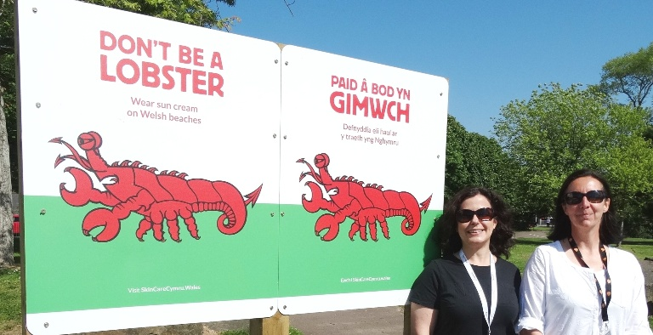
J​anine Evans and Nerys Williams from the Welsh Centre for Burns and Plastic Surgery at the launch of the new Don’t Be a Lobster
signs at Black Pill last month.

Charity trustee and Singleton Hospital dermatology consultant Avad Mughal said: “Feedback about the campaign has been really positive so far but more people need to be aware of the message.

"We are still getting cases of sunburn which will lead to skin cancer.”

Dr Mughal added that even one episode of blistering sunburn in childhood or adolescence more than doubles your chance of developing skin cancer in later life.

Remember, no sunscreen provides complete protection, so you should never rely on sunscreen alone to protect your skin from sunburn. Follow the five rules of sun safety:
- Slip on sun protective clothing
- Slop on SPF 30+ sunscreen with at least 4 star UVA protection
- Slap on a wide-brimmed hat
- Slide on quality sunglasses
- Shade from the sun whenever possible.
If you or your child has sunburn, you should get out of the sun as soon as possible. Mild sunburn, where the skin is red and painful but not blistered, and where there are no other symptoms of heat exhaustion (chills, high temperature of 38 degrees C or above, dizziness, headaches, feeling sick) can usually be treated at home with moisturisers.

The following advice may help to relieve symptoms:
- Cool the skin by having a cool bath or shower, sponging it with cold water, or holding a cold compress to it.
- Use cream or ointment moisturisers on affected areas.
- Drink plenty of fluids to cool you down and prevent dehydration.
- Take pain killers, such as paracetamol or ibuprofen.
- Avoid further sun exposure.
If the sunburn blisters, there is severe swelling, or you feel unwell, contact your GP, go to your nearest NHS walk-in centre or call NHS 111. You may require specialist ointments and dressings, or even an admission to hospital.

Source: Abertawe Bro Morgannwg University Health Board

