Hook’s boots go up for grabs to raise cash for carers
Tuesday, 20 June 2017
Rugby star James Hook is helping staff at Neath Port Talbot Hospital to kick start their latest fundraising mission.

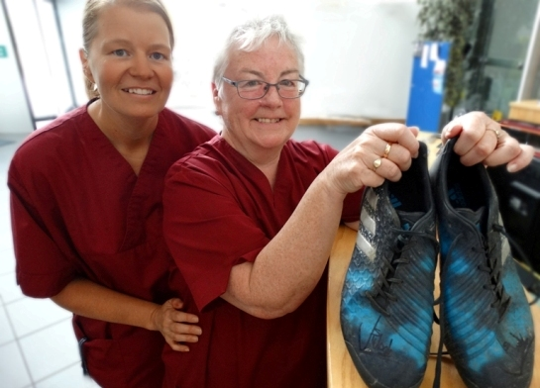
They want to convert the cash they raise by auctioning off a signed pair of his rugby boots into providing support for carers.

The auction has been arranged by Gaynor John and Maria O’Callaghan (left), who work in Blocks A and D at the hospital, and they will be donating all the proceeds to Neath Port Talbot Carers’ Service.

The service aims at providing support to anyone, whatever their age, who provides unpaid support to family or friends who could not manage without this help.

This could be caring for a relative, partner or friend who is ill, frail, disabled or has mental health or substance misuse problems.

In Neath Port Talbot 20,365 people are unpaid carers, according to latest figures. Many people may not regard themselves as carers or realise that they need advice and support, let alone where to get it from.

The service works closely with hospital staff and patients, especially since Jan Thomas took up her role as carers health liaison officer earlier this year.

Jan’s post sees her touring wards every week, explaining what help is available to those who might need it. Gaynor and Maria now hoping heir auction will help raise money to support the service’s work.

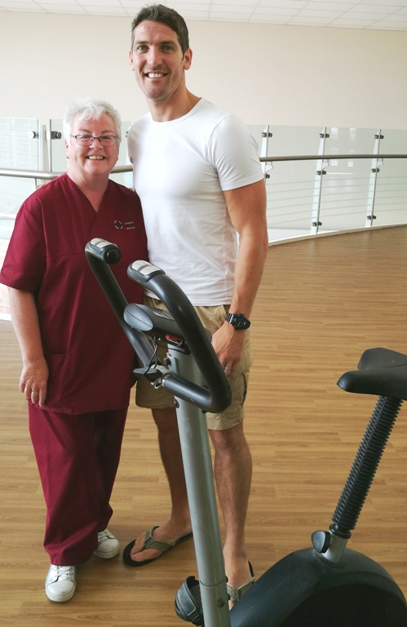
The size 10 and a half Adidas boots worn by James, who rejoins the Ospreys next season, are now available to the lucky recipient who makes the highest bid by Monday, 31st July.

James Hook with Gaynor John at Neath Port Talbot Hospital and (left) his signature on the boots.

James has already done his bit to support one of Gaynor’s previous fundraising missions. She staged a two-day exercise bike challenge at the hospital in aid of Alzheimer's to coincide with this year's Wellbeing Week and Workout@Work Week.

By the end participants had cycled 284 kilometres – the equivalent of Port Talbot to central London – and their donations totalled more than £600. James was among Gaynor’s first willing volunteers and after taking part said he was happy to support any other fundraising ideas she had.
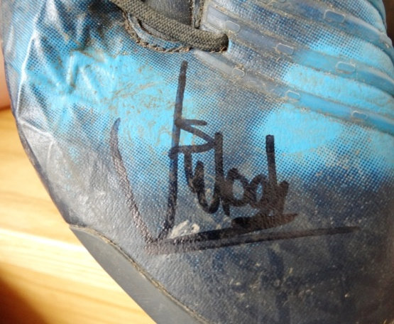
Gaynor said: “He was lovely and spent ages having a go on the bike, posing for photographs and supporting the challenge. He gave us these boots and wondered if we could use them to raise money.

“The work the carers service does is very helpful so we’d like to support that - now we hope lots of rugby fans will be keen to come forward and put in their bids to get hold of the boots.”

To place a bid email Maria at jessiebear112@hotmail.co.uk

Source: Abertawe Bro Morgannwg University Health Board

