Howard prepares to put in peak performance to help stroke patients
Tuesday, 6 June 2017
As a keen walker Howard Lewis knew the perfect way he could raise cash to say thank you to staff at Princess of Wales Hospital.

When it came to supporting the hospital’s Stroke Unit he took his inspiration from his favourite past-time and set himself a gruelling 18-mile mission across the Brecon Beacons.
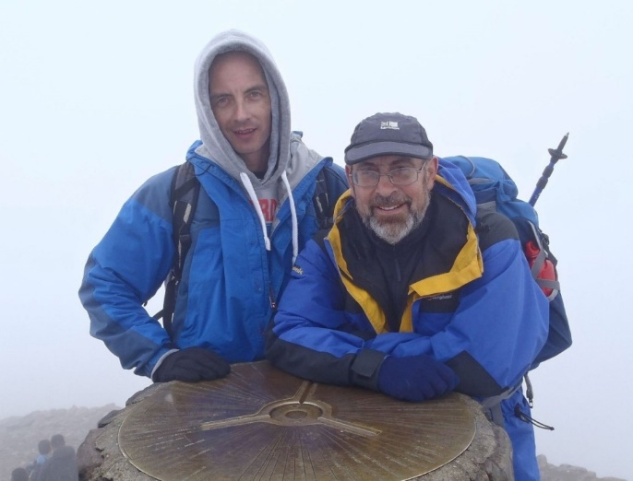
His Three Summits Challenge will see him climb the three highest peaks in the Beacons – Pen y fan, Corn Du and Cribyn – individually before he heads back up to climb the trio in a circuit.

He will clock up a total of 18 miles during fundraiser on Saturday, 1st July.

Father-of-three Howard, who is from Bridgend, will be joined on the day by his son Gareth (pictured together), who is also a regular walker as well as friends and supporters.

He said: “Some of us will do the full challenge, while others will join in throughout the day and just do what they feel comfortable with, maybe one or two summits.

“It all counts, as long as people turn up, join in and have a good time – while raising as much sponsorship as possible.”

He explained that his late parents Joyce and Albert Lewis had both suffered strokes while his brother Alan, who is now 65, survived one when he was in his early 40s.

“I am doing a summit for each of them and to mark the care that they received when they had their strokes.

“I am taking photos of my mum, dad and brother with me on the day so it will be like are with me on my challenge. I wanted to do something to say thank you to the unit and its marvellous staff.”

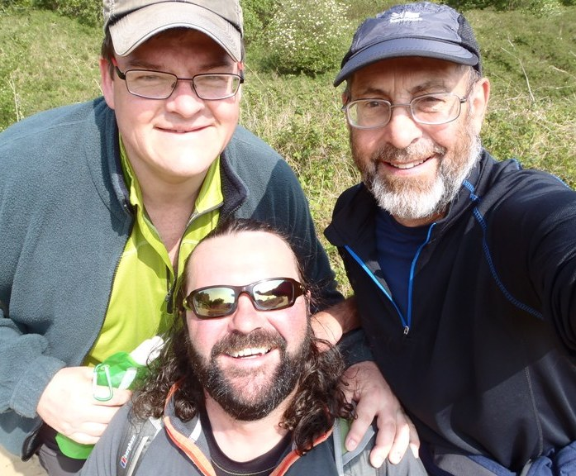
Howard, who will be accompanied by his regular walking companions Gareth Evans and Wayne Morris (pictured), added: “I have always walked and climbed, I go out regularly and the Brecon Beacons is one of my favourite walks so I thought this would be the perfect way to combine my hobby with fundraising.”

Although she can’t take part on the day, Ward 2 manager Joanne Thomas is backing Howard all the way – and is even sending her brother and son to join in.

She said: “We are really pleased that Howard has chosen to raise money for our ward and that he arranged this fundraising event.”

She said the money he raises will go towards new equipment for the ward and is hoping to be able to buy a reclining shower chair for patients with limited mobility.

“This would make a big difference to our stroke patients as some are in hospital for a number of weeks,” she added.
“Staff from the ward will be going along to support Howard on the day, some are doing the full challenge while others are just joining him for one or two peaks.

“But however they help I’d like to say how grateful we are for everyone’s willingness to take part and for raise money for our Stroke Unit. “

If you would like to support the challenge go to https://www.justgiving.com/crowdfunding/joanne-thomas-2

Source: Abertawe Bro Morgannwg University Health Board

