Ministers celebrate success of outstanding health professionals who have achieved ‘Grand Slam’ of nursing and midwifery award triumphs in 2017
Wednesday, 14 June 2017
Press release issued on behalf of Welsh Government

First Minister of Wales Carwyn Jones and Health Secretary Vaughan Gething have met with Wales’ award winning health professionals to celebrate their outstanding achievements in 2017.
Wales swept the boards at nursing and midwifery awards earlier in the year; today the First Minister and Health Secretary met:
Melanie Davies, from Morriston Hospital in Swansea, who was named RCNi Nurse of the Year, for her work making far-reaching changes to the care of vulnerable patients with learning disabilities.

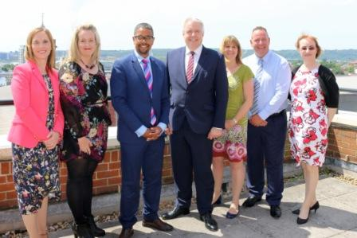
(l-r) Laura Wyatt, Melanie Davies, Health Secretary Vaughan Gething, First Minister of Wales Carwyn Jones, Sharon Fernandez, Cemlyn Roberts, Chief Nursing Officer Prof Jean White.
Health Visitor Lead Sharon Fernandez, for Powys’ Perinatal Mental Health services, who won the Journal of Health Visiting Awards 2017, Health Visitor of the Year Award.
Bereavement midwife, Laura Wyatt, from Cardiff and Vale UHB, who has been awarded the Emma’s Diary Mums’ Midwife of the Year 2017 for Wales. The award is one of the Royal College of Midwives Annual Midwifery Awards, recognises the remarkable work done by inspiring midwives across the country.
And, Cemlyn Roberts, from Betsi Cadwaladr University Health Board, who has won the RCNi- UK Healthcare Assistant Award Winner 2017. Cemlyn won the award for improving care for people with learning disabilities through an individualised, gentler approach to taking blood.
First Minister Carwyn Jones said: “It was an absolute privilege to meet this outstanding group of health professionals today. They are shining examples of what our health service in Wales does on a daily basis – helping those who need it most.
“They have proved themselves to be the best at what they do in the UK. It is important that we celebrate success and I congratulate them on their fantastic achievements. I hope they inspire other health professionals across the country to reach the heights of what they’ve achieved this year.”
Health Secretary Vaughan Gething said: “Our grand slam of nursing and midwifery award triumphs shows just how exceptional our healthcare staff truly are.
“It was a great to meet the group today. Each one is an ambassador for this country. I hope nurses, midwives and other health professionals from across the UK will look to Wales as a place where they would want to pursue a career in the future.
“I have said it before, Wales is a fantastic place to train, work and live; a place where we will continue to offer NHS Bursaries for eligible student nurses, midwives and allied health professionals in 2018/19. It’s a place where we will continue to support professional development. We continue to invest in nursing and midwifery education, and the number of nurses working in NHS Wales continues to increase year on year.
“Melanie, Laura, Sharon and Cemlyn should be very proud of what they’ve achieved for themselves, their families and the NHS as a whole in Wales; we certainly are.”

Source: Abertawe Bro Morgannwg University Health Board

