Morriston ED team leads new campaign to tackle silent killer
Tuesday, 6 June 2017
A team of champions is being enlisted across Morriston Hospital as part of a new campaign highlighting a potentially fatal condition.
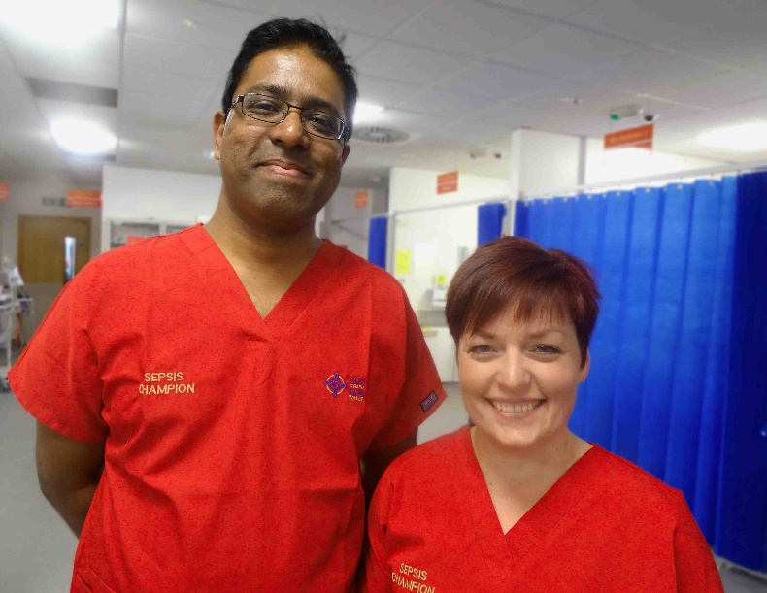
Sepsis, known as the silent killer, occurs when the body’s response to infection injures its own organs.

Left: Dr Rangaswamy Mothukuri and Hannah King

It can lead to shock, organ failure and death, especially if it is not recognised and treated early.

Very often it is caused by common bacteria which people come into contact with every day without any adverse effects.

Identification can be difficult because the symptoms often resemble other, less serious conditions.

The Morriston campaign originated in the Emergency Department (ED) where two open days to promote early treatment and management of sepsis among staff have been held, with a third taking place next month.

Now it is being rolled out across the hospital with the longer-term aim of making it ABMU-wide.

Morriston has established a sepsis team, comprising:

• Clinical lead Dr Rangaswamy Mothukuri;
• Nurse lead Hannah King; and
• Project support officer Michelle Matthews.

There’s also a team of sepsis champions, ED staff who are actively supporting the campaign and helping to spread the word about how important early detection is in treating the condition.

Dr Mothukuri said it was decided to set up a working group called SeGMED (Sepsis Group Morriston ED) last year.

It comprised staff from across the ED, including receptionists, healthcare support workers, pharmacists, nurses, registrars and consultants.

“From there we started working on what we could do to improve awareness of sepsis.

“We started doing a lot of teaching sessions and we included it in our mandatory teaching sessions on a regular basis.

“By the end of 2014-15 we managed to achieve 100 per cent training in the Emergency Department.”

That in turn led to the two open days, held last November and March this year, which were open to all staff. A third takes place in July.

Lead nurse Hannah said: “We realised there was a keen interest not just within the ED but across the hospital from people wanting to recognise the symptoms and signs of sepsis early on.

“I’m very passionate as a nurse that we recognise patients with signs of sepsis early.

“Reinforcing knowledge through further awareness and training will hopefully reduce serious illness and mortality, not just in ED but across the hospital.

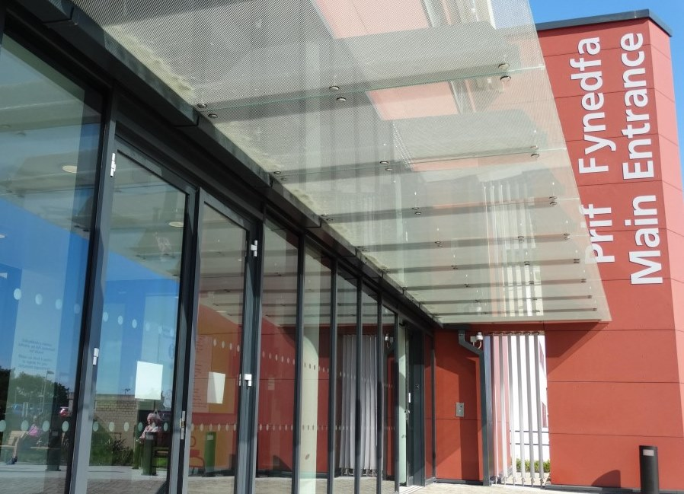
“We now have a platform to offer education and teaching so hopefully we can have a standardised approach and awareness across the site and improve patient outcomes as a result.”

People coming into hospitals – either through the ED or admitted to a ward – have their heart rate, blood pressure, oxygen levels and other vital signs scored in the National Early Warning Score (NEWS) system.

Any abnormal scores will trigger a further investigation into potential sepsis, using a standard screening tool.

As part of their campaign, the Morriston ED team have updated the screening tool using the latest research and data, making it more accurate and in-depth, yet easier to use.

Dr Mothukuri said: “The reason we put so much emphasis on early detection is because a lot of the interventions we can do are very simple and straightforward.

“It may be giving oxygen, giving some fluids, or giving the right antibiotics early. If you do those things you may just prevent the progress of the illness.”

Next month, the new screening tool will be rolled out to an initial 10 acute wards within Morriston Hospital, with the sepsis team providing training and support for ward staff.

Ultimately the aim is to make it available not only across Morriston but in all ABMU hospitals.

And just as the ED has its sepsis champions, so will the wards.

Hannah said: “It’s almost an impossible job for two people alone to spread that message across the hospital site, and to keep that momentum going.

“We are looking to find staff who are as passionate about the subject as we are and for them to take ownership of it in their clinical areas along with the ward managers.

“They will help make sure everyone is doing the best they can to pick up any potential cases of sepsis in their individual area.”

You can read an earlier story looking at how ABMU is tackling sepsis here
Source: Abertawe Bro Morgannwg University Health Board

