Nurse now providing vital link to support patients’ safe return home
Tuesday, 13 June 2017
Just a year after a successful trial began an initiative by ABMU to help get patients out of hospital and back to their homes is going from strength to strength.

Clare James only began working as community discharge liaison nurse between Morriston and Gorseinon hospitals in October but already her job has been extended so she can help more patients.

Her unique role sees her acting as a link between hospital staff and health and social care teams in the community. Focusing on reablement and independent living, she identifies the kind of support a patient requires so they can be safely discharged home.

Clare said: “This role is all about the early identification of what needs a patient has and the assistance they might require to go home. It’s a simple idea and not a new one - it’s about coordinating services better for the patient.”

And, she says, it is proving very beneficial.
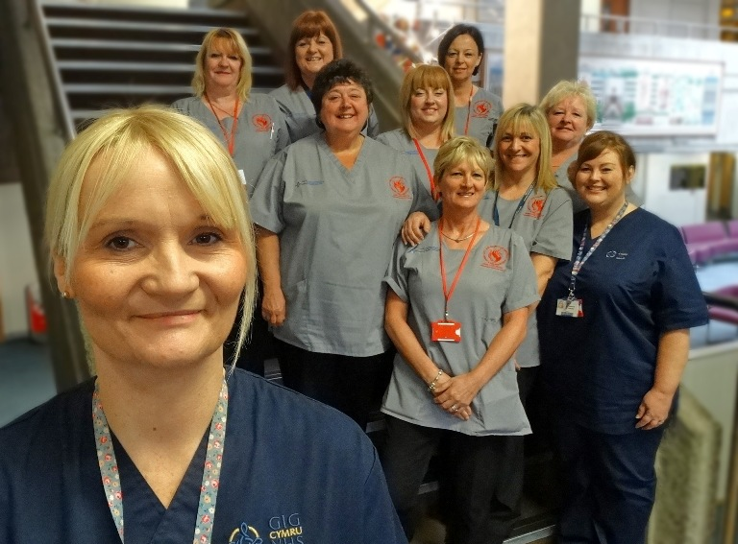
“A long period in hospital can result in a reduction in function and confidence. Our community team offers a patient the support they need to continue recovery in their own home.”

​Community discharge liaison nurse Clare James (front left), community reablement nurse Rebecca Jenkins (front right) with members of the community reablement team.

Clare’s role was created by Head of Nursing for Primary and Community Care Karen Gronert and Nicola Williams, Morriston Hospital’s Nurse Director, after a successful three-month pilot scheme.

The job has now been developed so Clare (left) is also supporting admissions to Gorseinon by screening patients to see if they are suitable for reablement there as well as reviving the hospital to home pathway.

“Before the pilot there were large waiting lists for people who needed packages of care. There was an average of 20 referrals each week in Morriston alone.

“We have eliminated waiting lists for the rehabilitation team by working as the gatekeepers for our service and introducing a direct referral system and criteria as well as educating hospital staff about our service.”

Each week between 130 and 140 people across Swansea are supported by a team of 75 community care assistants, three occupational therapists, managed by senior care assistants, the home care manager, Clare and community reablement nurse Rebecca Jenkins.

The nurses attend weekly meetings in Morriston, Singleton and Gorseinon hospitals to identify potential patients and promote early assessments.

The nurses then work with the hospital teams towards discharge and to advise on community support.

“We start on average 30 new packages of care every week with over half of our referrals coming via the hospital to home pathway. This method of referral has sped up the process for discharge.

“We are also very busy with community referrals, offering a rapid response service to prevent admissions to hospital or a care home.”

She explained: “We are work closely with care staff and occupational therapists as well as with social workers and hospital teams - our service is very much based on a team effort.

“By pooling out expertise and combining skills we can see what is needed in each case.”

Clare said one of the many positive aspects of her new post is seeing the reablement team members’ growing enthusiasm for their work.

“Initially the senior community care assistants were nervous about going into hospital and assessing patients but they have gained confidence with the support of their health colleagues. It has definitely helped build a bridge between hospital and community.

“As soon as a patient is identified for reablement we visit the ward and assess them. If they are appropriate for reablement and we have the capacity, patients are discharged the following day.”

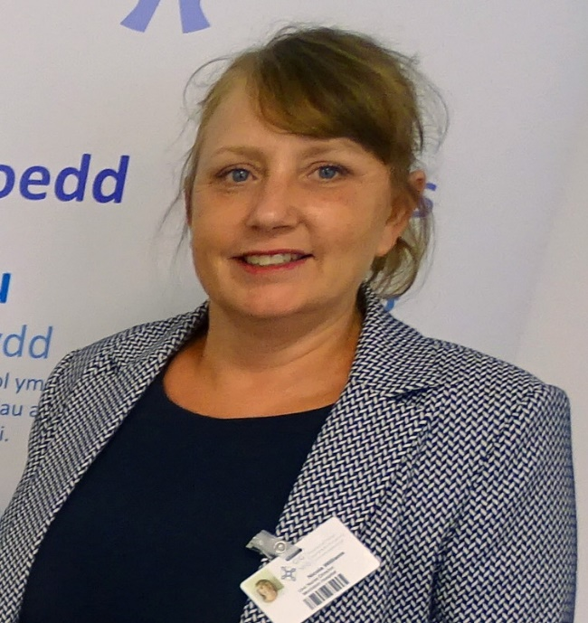
The reablement period is up to six weeks but patients are reviewed at regular periods and often need less time after reaching goals set by occupational therapists.

She added: “A large proportion of our patients will go on to require no further service and high number of those needing long-term support will see a reduction in the amount of care they require.”

Morriston Hospital Nurse Director Nicola Williams (right) said: “We are delighted to see the positive impact Clare’s role has had and the close working relationships that have developed with social care staff.

“Getting patients back home so they can recuperate in familiar surroundings is one of our top priorities. The longer patients remain in hospital the more they are at risk of having long-term deterioration in mobility and levels of dependency and of picking up infections.

“Having Clare and her team working to make that happen as soon and as smoothly as possible is reducing those risks to our patients.”

During her 20-year career Clare, who is from Port Talbot, has spent time in acute admissions into hospital as well as nursing in the community.

“I have worked in areas from admission to discharge so I understand the patient journey.”

Clare is delighted at how well received and effective her role has been and now wants to develop it by working more closely with third sector and other community teams.

She added: “I am passionate about promoting independence among our older people, to support them to be back at home and to remain at home.”

Source: Abertawe Bro Morgannwg University Health Board

