Patients can now have knee replacement surgery and be home the same day
Wednesday, 7 June 2017
People needing knee replacements can now have surgery at two ABMU hospitals and be home the same day.

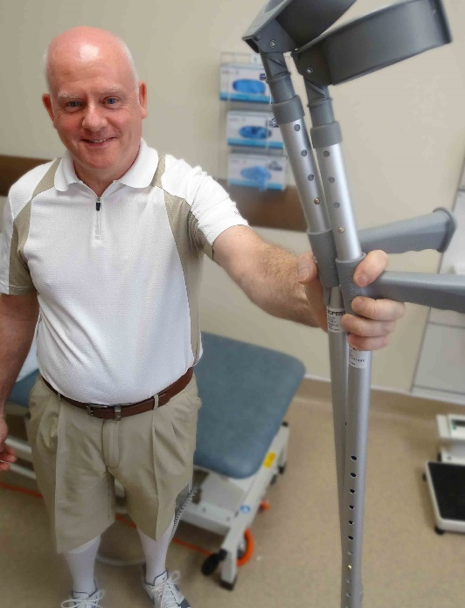
Princess of Wales and Neath Port Talbot hospitals are believed to be the first in Wales to offer day case surgery for both half and full knee replacements.

Although not suitable for all patients it has definite benefits for those who are eligible – and will help free up hospital beds too.

The first two day case knee arthroplasties have been carried out in the hospitals and the results in both cases have been excellent.

One of the patients involved, 53-year-old Neil Williams (left) from Bridgend, was getting around without crutches two weeks after surgery.

He said: “I’m 100 per cent happy I went down this road.

“Without shadow of a doubt I would recommend it for those people who meet the criteria.”

Traditionally, patients having total knee replacements would have stayed in hospital for 14 days.

But in 2009 this was reduced to five days with the introduction of ERAS – Enhanced Recovery after Surgery.

This is a rapid recovery system that encourages early mobilisation by avoiding opiates as regular painkillers, instead using a variety of other painkilling methods.

Now a multidisciplinary team led by ABMU consultant orthopaedic surgeon Amit Chandratreya has taken this even further following a fact-finding visit to Zuyderland Hospital in the Netherlands.

The hospital has been carrying out day-case knee arthroplasties for several years with great success.

Mr Chandratreya said: “It’s suitable for patients who are reasonably fit and well, who have no other medical problems and have someone who can look after them at home.

“They can have day case arthroplasty, which means they have the operation in the morning, be mobilised within six hours and then they can go home.

“Very often there is no reason to keep people in hospital other than the pain, and that can be managed just as well at home.

“As long as it is safe, they are better off at home. There is reduced risk of hospital-acquired infection and they can recover with their family in a familiar and more restful environment.”

The follow-up care is exactly the same as it is for inpatients, and if they have any problems or concerns they can call the team for immediate advice and support.

A full knee replacement on a patient from Maesteg was carried out at Neath Port Talbot Hospital by trauma and orthopaedics consultant Rahul Kotwal.

Neil had a half-knee replacement at Princess of Wales, along with an anterior cruciate ligament reconstruction at the same time.

He ruptured the ligament more than 30 years ago. It wasn’t repaired then and Neil carried on with sporting activities which, although he wore a support brace, gradually wore down the outside of his knee.

“I had quite advanced arthritis on that side, where there was no meniscus left. It was down to bone on bone and starting to calcify. That was causing me quite significant pain.

“Before the planned surgery I had a phone call from the team asking if I would consider being admitted as a day patient. My immediate reaction was – of course.

“Over that weekend I did a lot of reading, trying to prepare myself for what was going to happen.

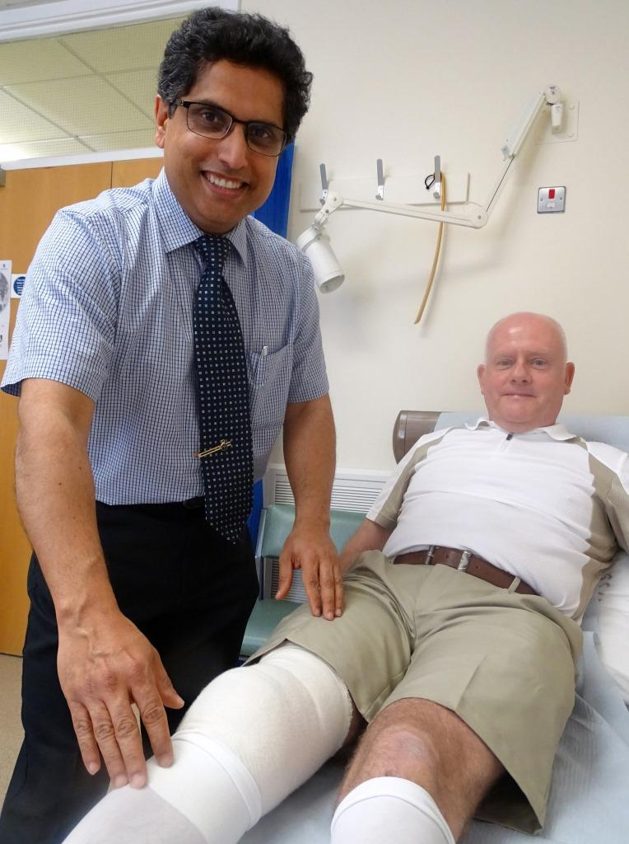
“It was about pain management, not to suffer with the pain when I got home but to take the painkillers I was prescribed. After a few days I was able to manage it with less powerful painkillers.

Right: Neil pictured with consultant orthopaedic surgeon Amit Chandratreya

Neil’s recovery also involved a series of knee exercises, which he started before surgery and continued several times a day at home afterwards.

“I was very motivated and I found that the knee regained significant strength and became mobile very quickly.”

He said his recovery would not have been possible without the support of his wife Maureen.

Neil added: “You need to have someone who is there all the time for you. It’s a team effort.

“When it was decided to do this as a day case, the team assessed Maureen separately to make sure she could cope. That has to be a consideration because you just can’t do it on your own.”

It’s a team effort in the hospitals too, involving day surgery, anaesthetic and theatre staff, physiotherapists and occupational therapists.

Between them, Princess of Wales and Neath Port Talbot hospitals carry out around 300 knee arthroplasties a year. Mr Chandratreya said more than 10 per cent of them could potentially be done as day cases.

He added: “That will help free up beds but, as importantly, it has considerable benefits for patients.”

Source: Abertawe Bro Morgannwg University Health Board

