Store staff's blitz helps hospice garden to blossom
Monday, 12 June 2017
The garden of Morriston Hospital’s Ty Olwen has received its own DIY makeover, thanks to kind-hearted Swansea shop workers.

Staff from the city’s Marks & Spencer store helped transform the area outside the hospice, giving shrubs a much needed trim, repainting fences and cleaning garden ornaments.

Under the guidance of Ty Olwen’s regular volunteer gardeners, the team from the store were able to carry out some of the heavier maintenance work that was needed during a one-day blitz.

Besides mowing the lawns and clearing borders, the eight-strong crew were able to jetwash patios, blow away leaves and give the area a real spring clean. Some of the more mature shrubs had grown so much over the winter they were obscuring the view from ward windows.

By the time the volunteers had finished patients and staff were able to enjoy looking out over the whole of the garden.
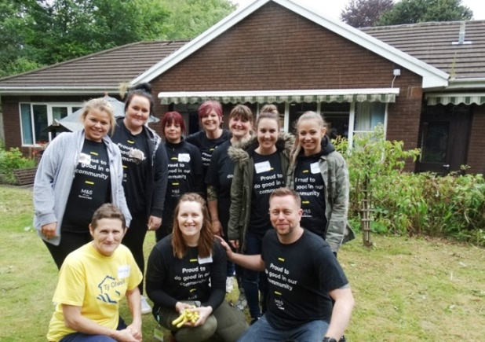
The makeover follows on from the successful transformation of the hospice’s day room last year by a team from Marks & Spencer as part of its initiative to assist local good causes.

The makeover team including (kneeling front) Ty Olwen’s Delyth Gough with Sophie Clout and Aled Bonnell in the garden and (below) how the shrubs looked before they were cut back.

It proved such a popular recipient that the store staff were happy to help again during the chain’s dedicated week of community volunteering.

Swansea store manager Aled Bonnell explained that the team had been organised by project hosts Sophie Clout and Chris Andrevics who had drawn up a list of the chores for staff.

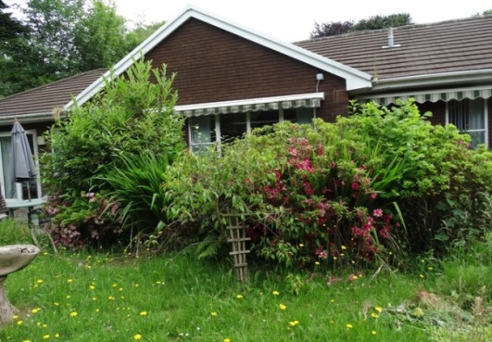
“We had £500 from M&S head office and we were able to collect a further £700 by holding various fundraising events in store to use for the makeover.

“I think that really goes to show the respect and affection people have for Ty Olwen. Everybody knows someone who has a connection to it and that is why we have chosen the Ty Olwen Trust as our store’s charity of the year so we will be doing more fundraising to help benefit it.”

Lowrie Heather took part in last year’s makeover and was delighted to return to do her bit outside.

“It’s good to be back, it’s lovely to see that our hard work last year paid off and the room is still looking good. We have had great support, the generosity of our customers has been amazing,” she said.
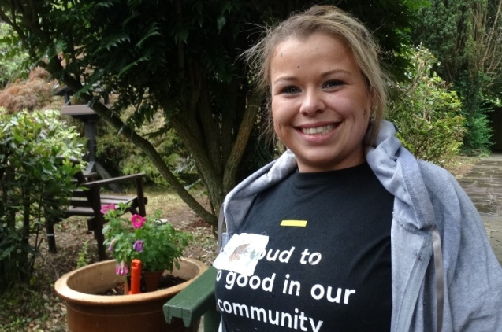
Her colleague Stacey Fox (left had a personal reason for wanting to be part of the team – her late father Paul passed away at Ty Olwen.

“When my dad was here I remember us coming out and sitting in this garden. I wanted to give something back and I have loved being here again today. If we have managed to do something to help the patients then that has made it all worthwhile.”

Receptionist Delyth Gough, who is also a trustee of the Ty Olwen Trust the charity which supports the work of the hospice, joined the M&S team on her day off.

She was delighted with all they managed to achieve and said the garden improvements are set to continue.

There are now plans for a summer house for patients as well as a ramp so patients using wheelchairs can access the top lawn.

Paul Freeman, of Pembrey, whose daughter Sian is being cared for at Ty Olwen said the outdoor area played a very important role families like his.

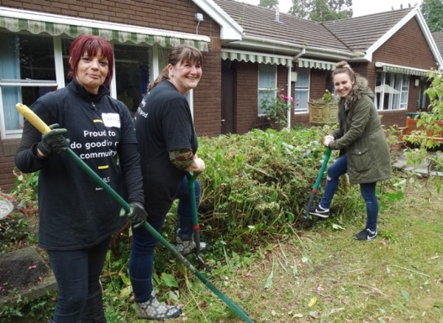
“The garden has been great for Sian’s granddaughters, this isn’t the best place for children to have to spend time but they have enjoyed being able to go out into the garden.

“They have played, found dens and had a chance to be creative – and that has been very important for them at this time.”

He added: “For adults the garden is our place of calm, it is where we can go to clear our heads and just take a look at the plants and the fish in the ponds. Having the garden has made a difference, it is so good to see it getting such good attention.”

Specialist palliative care consultant Beth Birch said: “The staff and patients in Ty Olwen have been overwhelmed by the generosity of M&S, their staff and customers.

“We know how important the environment in which someone is cared for at the end of their life is and now everyone will be able to access and enjoy the garden to its full potential. As always we are very grateful for all our volunteers help and the generosity of our community."

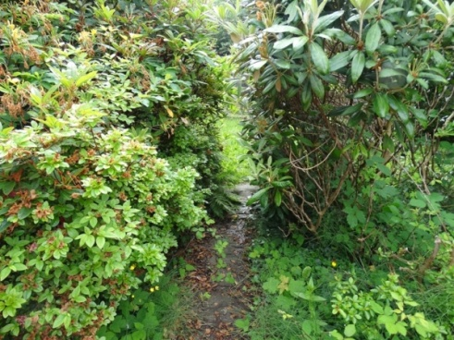

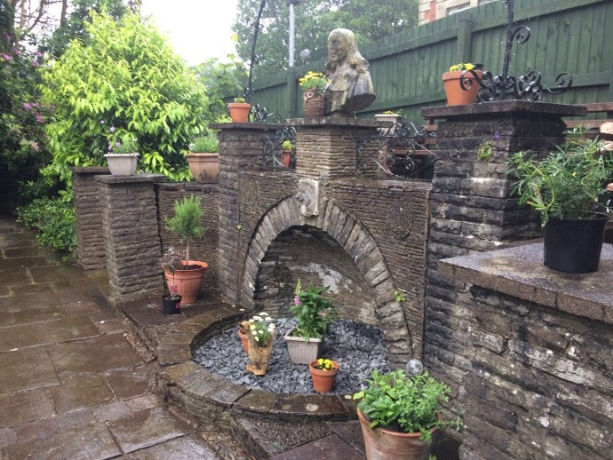
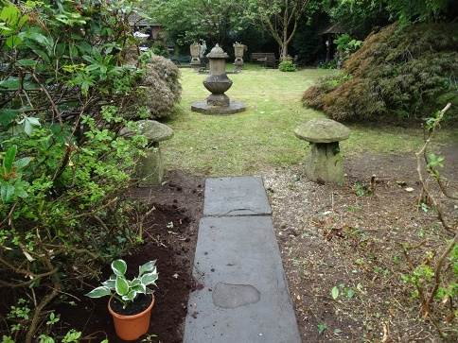

Source: Abertawe Bro Morgannwg University Health Board

