Wild West theme for Friends’ annual fete
Thursday, 15 June 2017
Maesteg Hospital League of Friends are holding their 55th annual fete on Saturday 17th June near Maesteg Market with help from Maesteg Council.
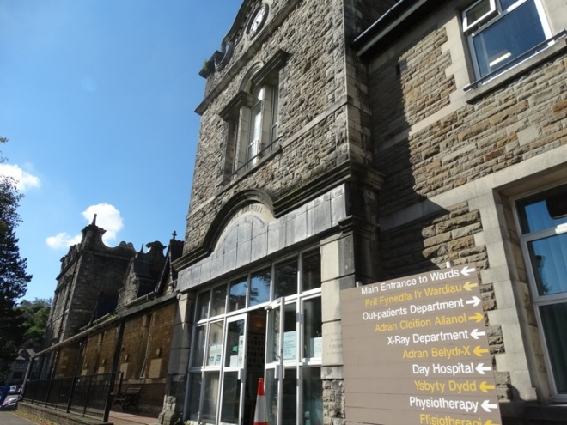
The event makes up part of the Gwyl Maesteg Festival and this year’s theme is the Wild West so don your cowboy hats and come and join the fun.

There are numerous stalls and attractions from a bucking bronco and coconut shy to bric a brac and a cantina. Maesteg Ukulele Band will perform from 10.30am to 11.15am followed by children’s entertainer Daily Bee from noon to 2pm with vocalist Alex John rounding up the day’s entertainment from 2pm to 3pm.

Other attractions include plate spinning and hula hoops, a bouncy castle, face painting, police fingerprinting, a visit from the mounted police, toy stall, cake stall, speciality sweets, jewellery, bag shop, handmade accessories and balloon modelling.

In addition there will be a bucket collection on Friday carried out by volunteers with all proceeds going to the League of Friends to buy equipment for the hospital.

All the hospital staff are immensely proud and grateful to the League for all its years of dedicated support and the truly supreme effort it puts in to helping the hospital.

Among those areas to have benefited is the Speech and Language Therapy Department which was bought special resources for its clinic at the hospital by the League

In return the therapists will be supporting the fete and are taking the opportunity to continue to publicise the Help Me Speak initiative which aims to show families how they can improve children’s speech and language development.

Preschool lead speech and language therapist Sue Koziel said therapists would be at fete from 10am to 2pm with information, advice and activities to support talking and speaking in children.
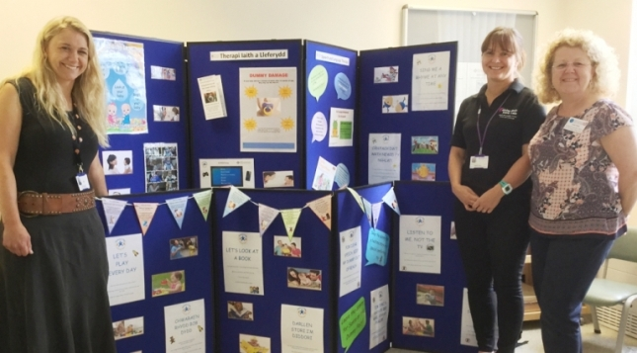
Speech therapist Lowri Roberts with speech and language therapy assistants Kate Ashton and Janine Phillips at Maesteg Hospital.

Sue said: “We had very positive feedback events we held in April so want to continue the good work.

“Parents appreciated the advice they received and felt it was really useful to have an open table where they could come to ask questions and get help.

“They asked about children who were not yet talking and for ideas for activities they could try at home. We had grandparents who said being able to talk to us gave them a chance to make sure they were doing the right thing, because times had changed since they raised their children.
“We also had others enquiries about speech development and the effect dummies could have on speech.”

Source: Abertawe Bro Morgannwg University Health Board

