Careers workshops offer insight into occupational therapy
Tuesday, 26 June 2018
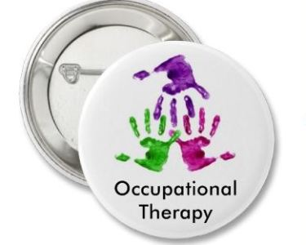
Fancy a career in occupational therapy?
ABMU Health Board’s occupational therapy service is holding special careers workshops to give people the chance to find out more about the profession.

The events aim to enhance understanding and knowledge and help those interested in pursuing a rewarding career.

The half-day workshops will provide an introduction into what occupational therapy really is and the variety of areas therapists work in. The events will also touch on the training involved to become an occupational therapist.
The career awareness workshops which will be on

• Tuesday 14th August 2018 at Singleton Hospital, Swansea
• Tuesday 6th November 2018 at Princess of Wales Hospital, Bridgend

To reserve a place, please email holly.jacobs@wales.nhs.uk

Attendees will need to be over 14 years of age.
Spaces fill up fast, so first come first serve!

Source: Abertawe Bro Morgannwg University Health Board

