New service shows why it’s not just good to talk - it’s healthy too
Friday, 1 June 2018
A new kind of prescription is available at one group of GP practices in Swansea – and it could involve a nice cup of tea and a chat.

The Cwmtawe cluster of GP surgeries is one of the first in Wales to have a social prescribing worker who can ‘prescribe’ for patients who need social help rather than medical treatment.

A fifth of people who go to see their doctor have social problems which can result in anxiety, low mood, grief, loneliness or financial worries.
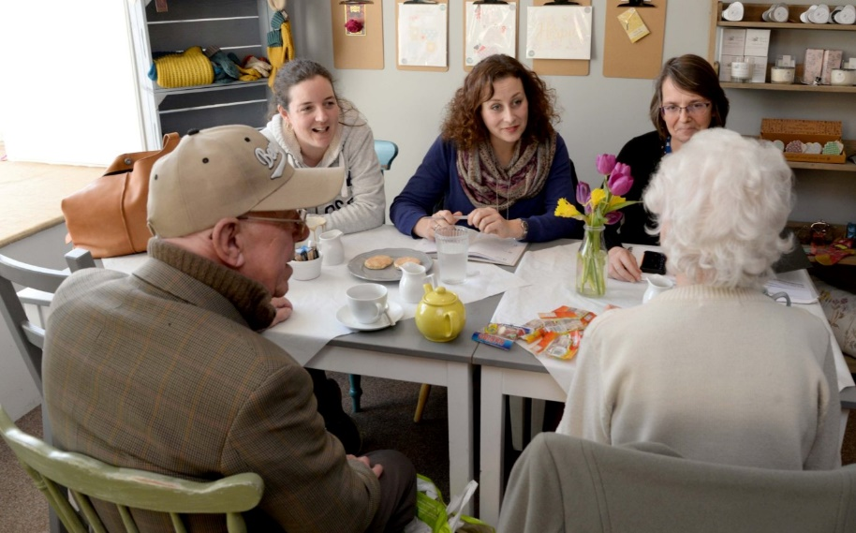
Now, instead of reaching for the prescription pad, GPs can send those patients to see Cindy Hayward.

Nothing like a good chat – the Conversation Club set up by social prescribing worker Cindy Hayward at Bronwen’s House in Clydach in full flow.

Cindy has only been in the role since October but has already helped a wide range of people.

“I find out what’s going on in the community and try to match people up with what’s available,” she said. “It’s amazing what’s out there.”

There are around 1,000 third sector organisations in Swansea with an interest in health and wellbeing, and with her background in community development work, Cindy is able to link patients up with the right service for them, which could be anything from Cruse, the bereavement charity counselling service, to Citizens Advice.

Cindy is also setting up group activities like art, gardening, yoga and walking – all things that are beneficial to her clients’ wellbeing.

Ideas bubble up from the ground as well, as people she’s helped want to give something back.

She said: “I’m pleased to say there has been a huge wave of support from the local community around this new service.”
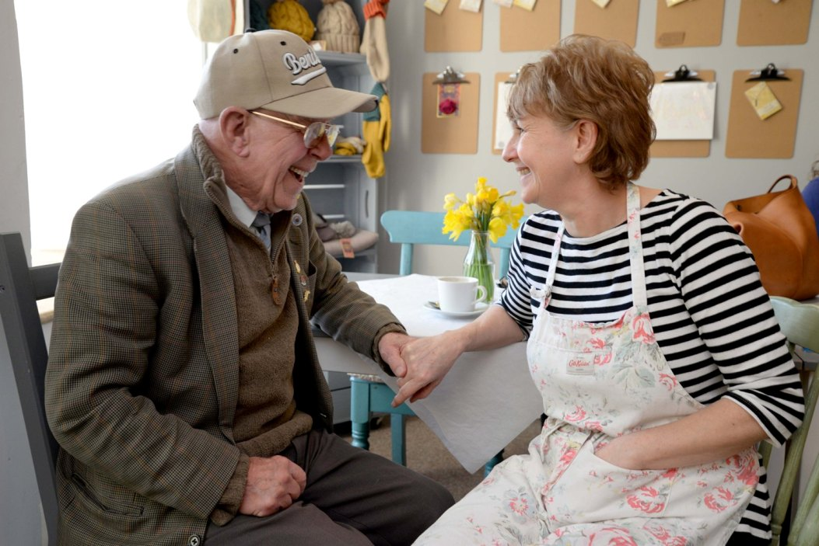
One example of that is a new Conversation Club that Cindy has set up with the help of café owner Helen Bialyj (left with Sid Jenkins).

A former audiologist, Helen opened Bronwen’s House in Clydach when she left the NHS.

“When I retired I opened my own café but I soon noticed how many people came in on their own and how many people seemed to be lonely,” she said.

The idea of the Conversation Club - where people can get together for a chat once a month - was born, and is now running on the first Wednesday of every month from 1.30 to 3pm.
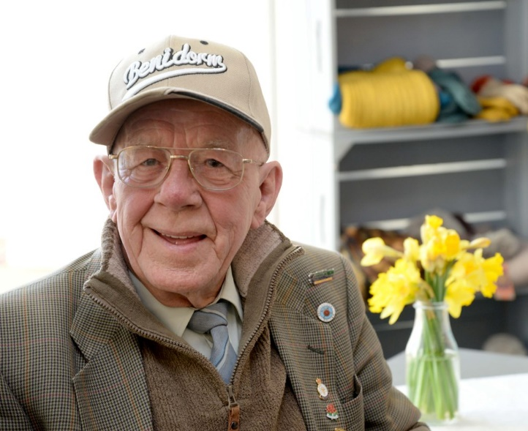
It’s been a great mood lifter for former engine driver Sid Jenkins, 83, from Clydach, (right) whose wife Barbara passed away recently.

He said: “I do get lonely now so it’s lovely to be able to come out and have a chat. I’ve spoken to Cindy a couple of times a week on the phone as well.”

Thirty-five-year old Andrea (left) also appreciates the help she has had from Cindy since her father died late last year.

She said: “I didn’t take it very well. He was my best friend and I saw him every day. I rang the doctor for help and they offered me tablets, but that would be a last resort for me. The doctor mentioned Cindy so I went to see her and I’ve been seeing her ever since.

“She has helped me in so many ways. She has helped me cope through listening to me and having time for me. She knows what help is out there and she put me in touch with various groups and organisations too.”

The work being done by Cindy is also helping to take pressure off GPs in the Cwmtawe cluster.

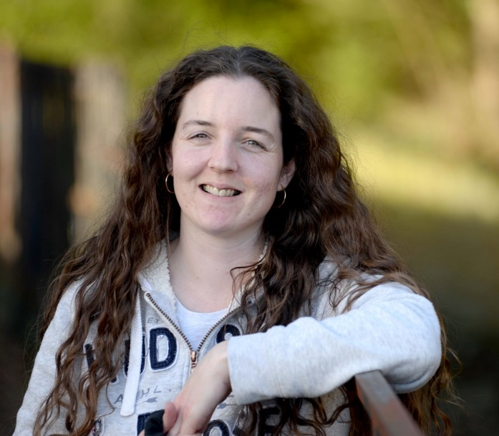
Iestyn Davies, the cluster lead GP, said: “A lot of people go to their doctor because they have nowhere else to turn.

“They may be socially isolated with no friends or family nearby and a lot of their health problems are socially related. Being able to refer them to the specialised social prescribing worker to find out what help is available to them will give us more time for the people who need medical help.”

The idea of social prescribing workers has been up and running in England for a while, but Cindy’s post is the first in this area. It’s been set up by a partnership between the Cwmtawe GP cluster, Swansea Council for Voluntary Service (SCVS) and the ABMU health board.

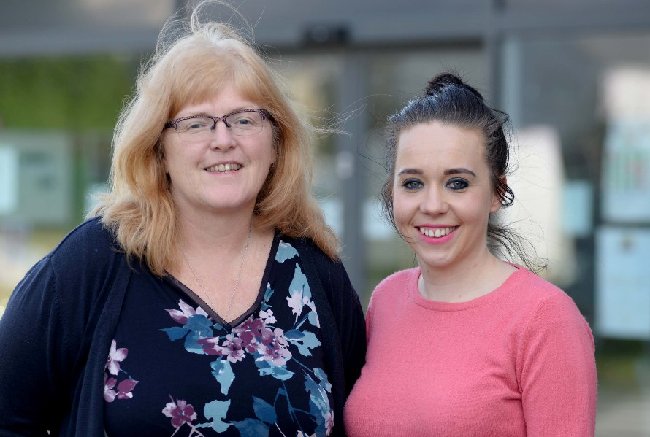
SCVS health and wellbeing manager Amy Meredith-Davies said: “As the umbrella organisation for voluntary activity in Swansea, we know that the voluntary sector has a huge role to play in supporting health and wellbeing.

Karen Edwards (left) with Amy Meredith-Davies.

“However, with lots of different services and groups out there it can often be very difficult for GPs to keep up to date with what’s available and how to refer people, so Cindy's role is really the link between the GPs and voluntary organisations.”

The part-time post, based at Clydach Primary Care Centre and New Cross Surgery in Morriston, is currently funded for 18 months, but it’s hoped that will be extended.

“The GP cluster has commissioned an evaluation of the role and its impact. If it’s found that there is a social return on the investment, it is more likely to get funding,” said Karen Edwards, Cwmtawe cluster support manager.

“Before we set up this post we did a lot of research and a significant number of people said they wanted a broader service that helps with their wellbeing as well as their health.

“So now instead of just prescribing anti-depressants, GPs can send patients to the social prescribing worker who can point them in the direction of other types of help and support - that will also give people the skills to manage better in the future.”

The social prescribing service is open to anyone over 18 who is registered with any of the GP practices that make up the Cwmtawe Cluster: Clydach Primary Care Centre, Llansamlet Surgery, New Cross Surgery, Strawberry Place Surgery and Sway Road Surgery. Referrals can be made by a GP or any health professional in the surgery.

https://www.youtube.com/watch?v=MMEIPilvMTI

Source: Abertawe Bro Morgannwg University Health Board

