Pioneering phone service taking the hassle out of patients' prescription orders
Monday, 18 June 2018
A new telephone ordering service is taking the hassle out of requesting a repeat prescription for Bridgend east patients.

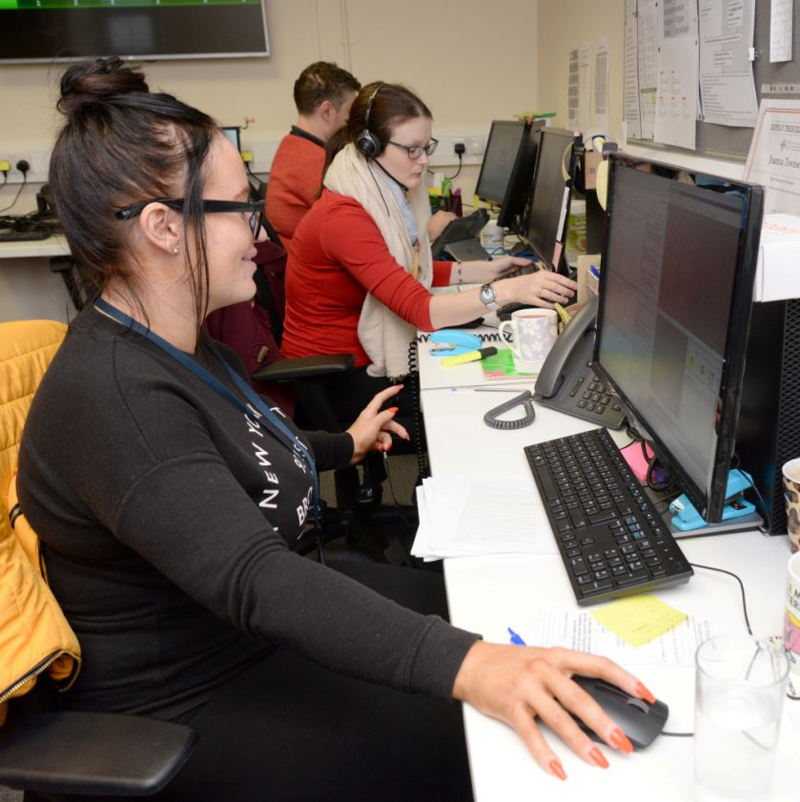
The service started last October and has already been so successful that it will be evaluated to see if it could be extended to other areas.

Many surgeries don’t take repeat prescription requests over the phone, which means patients having to visit their doctor’s or the local pharmacy.

Elderly and disabled patients and working people can find this difficult so they have welcomed the new Repeat Prescription Ordering Service, which means patients only have to make one phone call to get the medicines they need.

It’s available to patients at Pencoed Medical Centre, New Surgery Pencoed, Oaktree Surgery, Riversdale Surgery, and the now merged Ashfield and Newcastle surgeries.

They can ring 01656 311010 between the hours of 9am-4pm, Monday to Friday, to chat to trained staff based in a small call centre at Glanrhyd Hospital.

The call handler issues the prescription and it is then taken to the GP surgery for signing and then on to the patient’s chosen pharmacy for dispensing – all within three working days.

Eileen Brown, from Brackla, Bridgend, says the Repeat Prescription Ordering Service has saved her a lot of time and trouble.

Eileen suffers from severe osteoarthritis and takes several different medications. She attends Riversdale Surgery where patients can’t phone in for a repeat prescription.

“I think the new service is long overdue,” she said. “Our doctors are the best around but I don’t need the hassle over getting my prescriptions putting up my stress levels.

“Now I just have to make one phone call to request the medicines I need and they are delivered three days later.

“It’s the best thing that’s ever happened as far as I’m concerned. I’ve used it several times and I find the staff friendly and very helpful.”
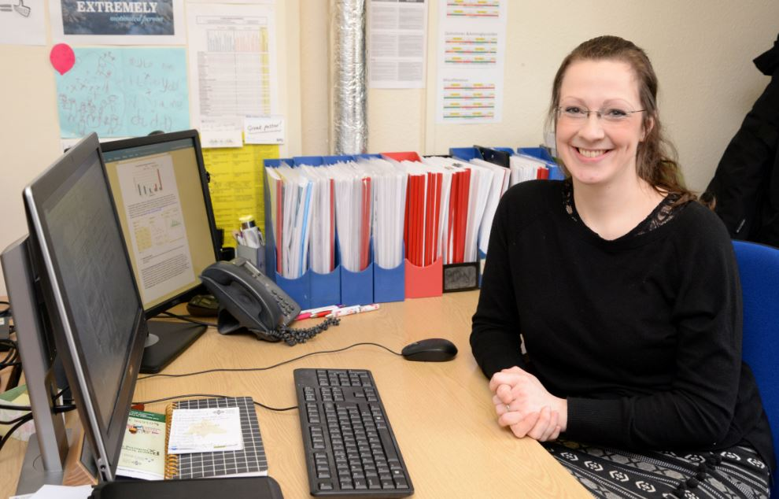
Avril Tucker, the project lead pharmacist (right), said the new service has the potential to deliver huge benefits to the NHS as well.

Prescription medicines worth around £4 million are destroyed each year in Swansea, Neath Port Talbot and Bridgend because they are not used or needed.

Avril said: “Medicines wastage is a huge problem for the NHS. This is often driven by the over-ordering of repeat items.

“Our call handlers have got time to chat with the patient and find out which medicines they actually need at the time they are ordering. I believe this empowers the patient to take responsibility for their own medication.

“Some patients with complex conditions can be on more than a dozen medications and with the average cost of each prescription item being £9, the savings can be considerable.

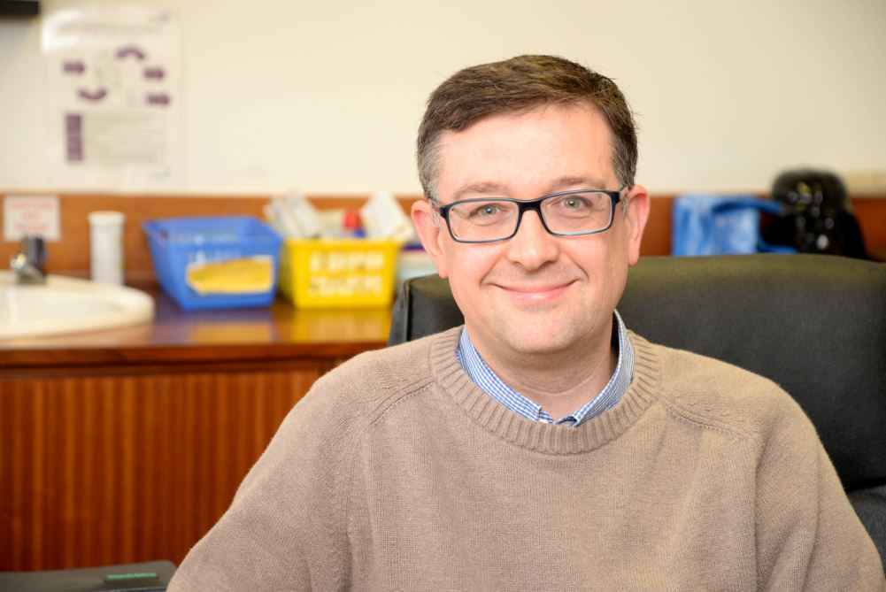
“We are aiming to save £800,000 a year – that’s 10 per cent of the annual drug bill for the cluster – by preventing over-ordering.”

The new service is also saving GPs and surgery staff a great deal of time in processing prescriptions.

Dr Matthew Peach, (left) of Riversdale Surgery, said: “It’s good for GPs because it takes a workload off our prescribing clerks and gives patients an additional way of ordering prescriptions.

“Older people like speaking to someone about their medicines, a service that busy surgeries struggle to offer.

“People seem to really like the new service and it is also good for the NHS because it cuts down on waste.”

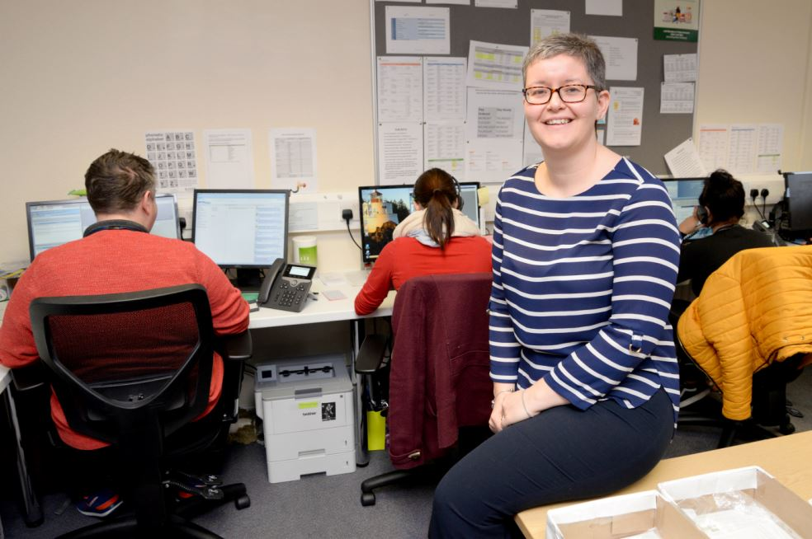
When the service was set up last year – the first of its kind in Wales - the goal was to process at least 50 per cent of all repeat prescriptions for the six GP practices, and it is well on the way to meeting that target.

Service manager Liz Hutchinson (right) said the call centre was handling around 800 calls a week (up from 84 in the first week) and that is expected to grow as more people become aware of the service.

She said: “We will recruit more staff as demand grows. At the moment the average time patients have to wait for their phone call to be answered is just 14 seconds and they will be on the phone to us for up to five minutes, depending on how many medicines they need to order.

“We have got time to talk to people, to get to know them and build relationships and the feedback we’ve had has been very good.”

Avril added: “We want to make it as easy as possible for patients to order the medications they need when they need them.

“Sometimes patients order medications when they don’t need them thinking they have to, or if they don’t they won’t get them when they do.

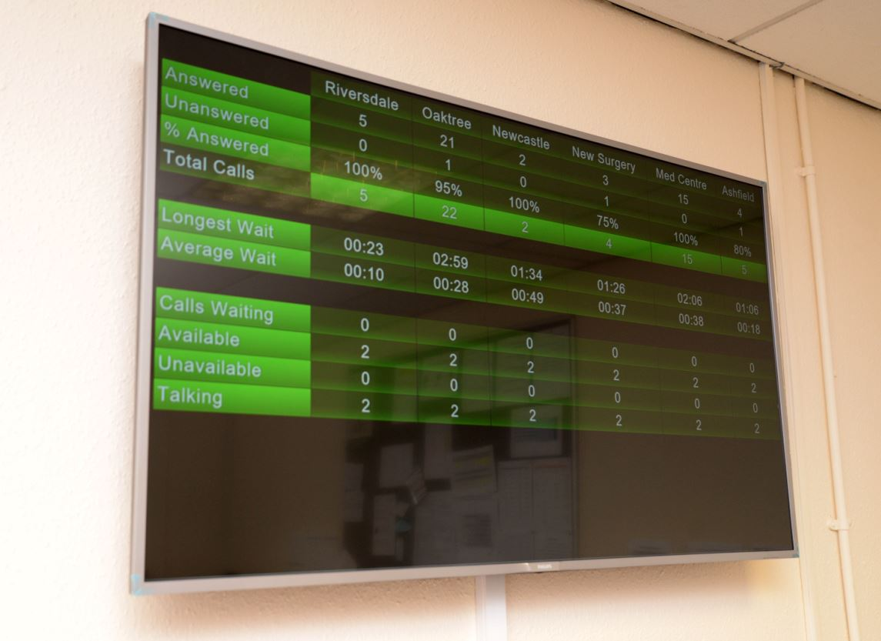
“This service will be able to reassure patients about their medication, answer medication queries, and help us to save potentially millions of pounds a year by reducing the amount of unused medication being prescribed.”

• The Repeat Prescription Ordering Service can be accessed on 01656 311010.
• Patients can still continue to order their repeat prescription directly with their GP surgery or via a pharmacy ordering service and/or a pharmacy delivery service.
• Patients in the ABMU Health Board area with access to the internet can also sign up for an online prescription ordering service via MyHealthOnline. To find out more about this service, visit www.wales.nhs.uk/nwis/myhealthonline

Watch it on video here: https://www.youtube.com/watch?v=hVDkjgMI3NI

Source: Abertawe Bro Morgannwg University Health Board

