Practices merger brings extra services to patients' doorsteps
Monday, 25 June 2018
Cwmtawe patients have a one-stop shop for their primary health care needs, thanks to a new way of working by local GPs

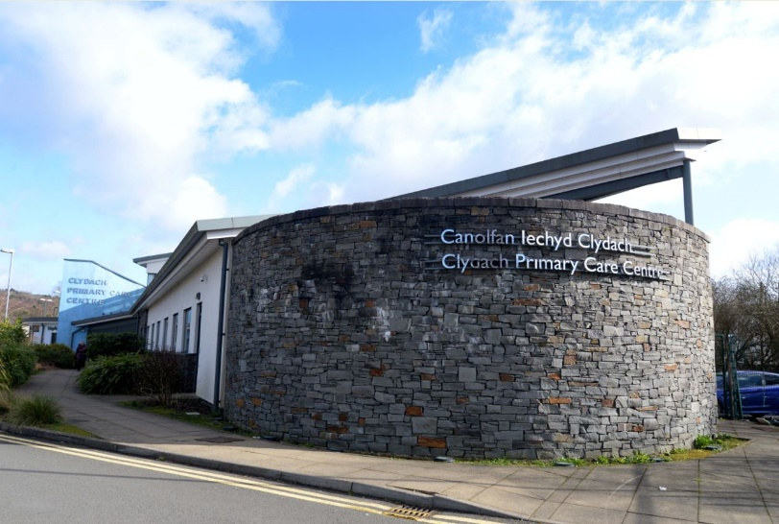
Patients used to have to go to hospital to access many of the services that are now available on their doorstep at Clydach Primary Care Centre and Sway Road Surgery, Morriston.

The two practices merged into the new Cwmtawe Medical Group at the beginning of this year to improve efficiency and sustainability. A third practice, New Cross Surgery, will merge with Cwmtawe Medical Group on 1st July 2018.

Change began a few years ago, however, when doctors found that increasing demand meant that they could no longer manage their workload under the traditional GP set up.

The practice introduced Telephone First, a system whereby patients are assessed over the telephone before being referred to any one of a number of health care professionals based at the health center.

The new Cwmtawe Medical Group has a multidisciplinary team with access to 11 doctors, two nurse practitioners, ten nurses, a mental health nurse, a paramedic, physiotherapist, audiologist, three pharmacists and a social prescribing worker.

It also hosts NHS clinics offering warfarin checks, phlebotomy, chiropody, wound nursing, diabetes, asthma, well woman and COPD.

GPs are on duty between 8am and 6.30pm and aim to deal with everyone who rings up on the day, with the support of the other health care professionals.

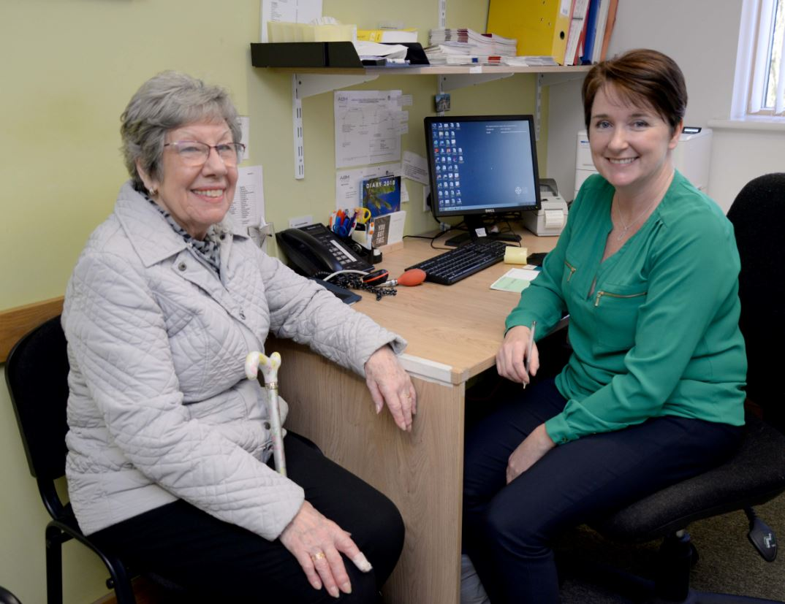
Patient Elizabeth Bevan with Vanessa Morton during one of her regular visits to the practice.

It’s popular with patients. Elizabeth Bevan, who suffers from an irregular heartbeat, takes warfarin to thin her blood and regularly attends the warfarin clinic at Clydach Primary Care Centre, instead of having to go to hospital.

She said: “It’s amazing. I only live up the road. I see the nurse and then the pharmacist and she tells me whether to up or lower the dose.”

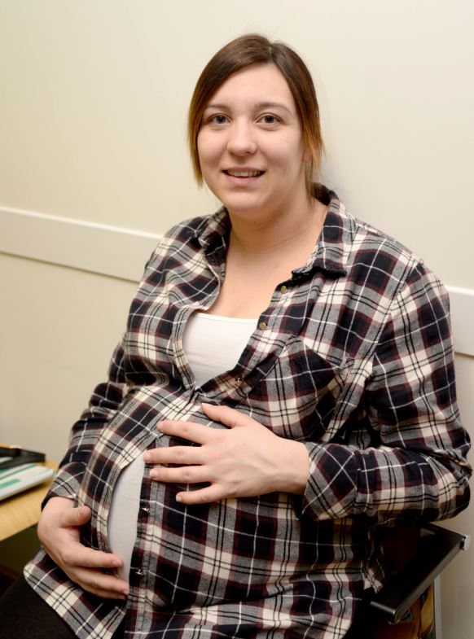
Some patients are still getting used to the Telephone First system and the fact that they can ring all day to make an appointment.

“Sometimes in the morning you have to ring over and over because the line is engaged,” said 18-year-old Beth Davies.

But expectant mother Tanya Humphreys, 29,(left) has found the system works for her.

“When you ring up they get back to you pretty quickly, especially if I am ringing up about my little girl. I’ve been attending the ante natal clinic every two weeks and it’s been very convenient being able to come here instead of going to the hospital.”

GPs are also happier: “We are much more relaxed working this way. We start every day afresh and aim to do all today’s work today,” said Dr Richard Tristham.

“Telephone First means we can direct the patient to the most appropriate professional in the first instance, which saves time for both patients and GPs.”

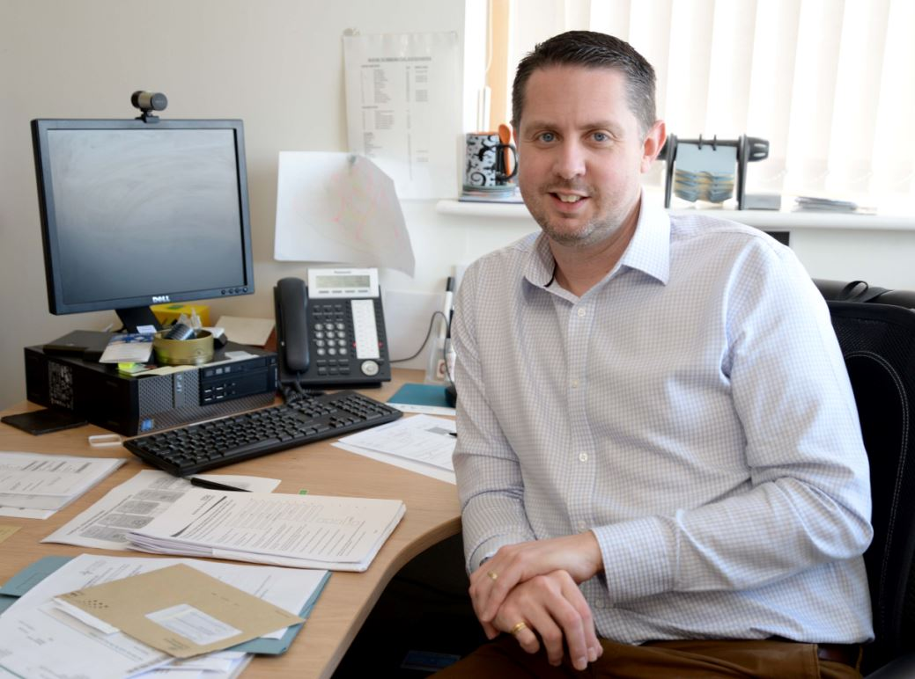
Practice manager Mike Garner (right) said: “There might be days when we get a lot of urgent calls but normally you would get called back or seen on the day.

“On the whole we get very positive feedback because people like the flexibility and the quick response. They also like the fact that they don’t have to get time off work and that we will call them back when they are available.”

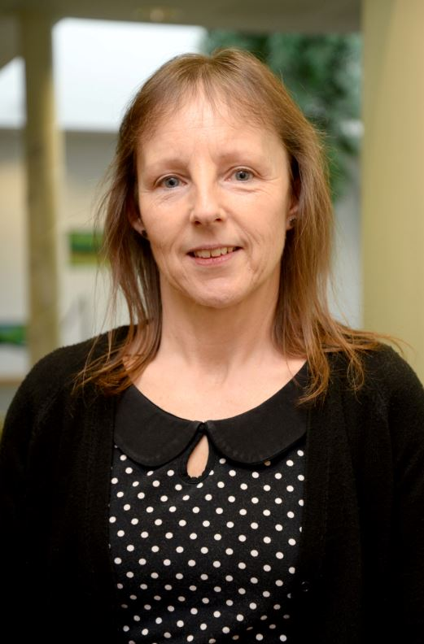
Office manager Andrea Hamer (left) added: “As a result of everything we do here, far fewer people have to go to hospital either as an in or an outpatient.

“Our GP partners also have specialisms which means they can deal with patients with COPD, dermatitis, diabetes, muscular skeletal and women’s health problems without the need to refer them to hospital.”

The multi-disciplinary way of working is helping to manage the ever-growing demand from patients.

“People are living longer with more complex conditions,” said Dr Richard Tristham, area clinical director. “It’s not uncommon for patients to have heart disease, diabetes and COPD.

“From 2003 to 2015, for example, there was a huge increase in face-to-face consultations in this practice. At the same time there are fewer and fewer GPs.”

The size of the new practice, however, has enabled partners to recruit more salaried doctors to serve their patient base of 19,000 people. Once New Cross Surgery merge with Cwmtawe Medical group on 1st July 2018, the patient population will be in the region of 26,000 people.

“There have been massive problems in recruitment with a lot of GPs retiring early or wanting to work part-time because the workload was putting them off,” said Mike.

“But having a bigger patient base has attracted GPs and clinicians wanting to work in a large, multidisciplinary environment, so the merger has made us much more stable for the future.”

A series of drop in sessions have been held throughout June 2018, where patients have had the opportunity to speak directly with the GPs and practice staff to find out more about the merger and what it means for patients. Additionally there is patient information available at each practice site such as poster information displayed; frequently asked questions and patients are able to speak directly to a member of the practice team if they wish to do so.

Source: Abertawe Bro Morgannwg University Health Board

