Swansea Half Marathon kick-starts ABMU's latest NHS 70th anniversary event
Wednesday, 27 June 2018
ABMU's celebrations for the 70th anniversary of the NHS have been stepped up with the start of a symbolic miners lamp relay.

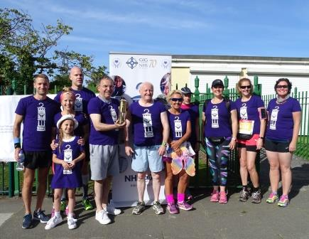
The relay was launched in the city's Victoria Park by the health board’s Chairman, Professor Andrew Davies, ahead of the Swansea Half Marathon.

Chairman Andrew Davies (holding the symbolic lamp) launches the relay at the start of the Swansea Half Marathon

Some 65 staff are taking part in the miners lamp relay, covering 96.4 miles between key health board sites - from Gorseinon Hospital in Swansea to the Princess of Wales Hospital in Bridgend.

The 70th anniversary is on Thursday 5th July and the relay will continue until the following day.

The lamp provides symbolic recognition of Aneurin Bevan and his link to the mining industry. It represents the close relationship between industry and the health service since it was founded in 1948.

A festival of music is also being held to coincide with the arrival of the lamp in each of the venues in the relay.

The first of these was held at Gorseinon Hospital where ABMU’s 70 Faces banner was also launched.

The banner features individual staff and teams that came forward to represent the diversity of roles across the health board.

ABMU’s first event during the anniversary year was the unveiling of a sculpture in a courtyard at Morriston Hospital’s Welsh Centre for Burns and Plastic Surgery in February.


The anniversary also featured prominently in major conferences held in Port Talbot and Swansea, and other events including Volunteer’s Week earlier this month.

This year’s Chairman’s VIP Awards, which recognise the innovative work of ABMU staff, will be held on 5th July to coincide with the anniversary.

In a joint statement, Professor Davies and ABMU Chief Executive Tracy Myhill said: “We cannot express enough the importance of recognising and celebrating the 70th Anniversary of the NHS and importantly the staff and colleagues that enable its services to run 70 years on from its establishment.

"A sincere thank you to all our staff for all that you do to provide exceptional care on a daily basis. We hope you enjoy the celebrations and that you celebrate with pride.”

Source: Abertawe Bro Morgannwg University Health Board

