Countdown to opening of £3m primary care centre for Brynhyfryd
Thursday, 9 March 2017
ABMU Health Board’s state-of-the-art £3 million primary care centre serving the community of Brynhyfryd will officially open its doors on Monday, 13th March.

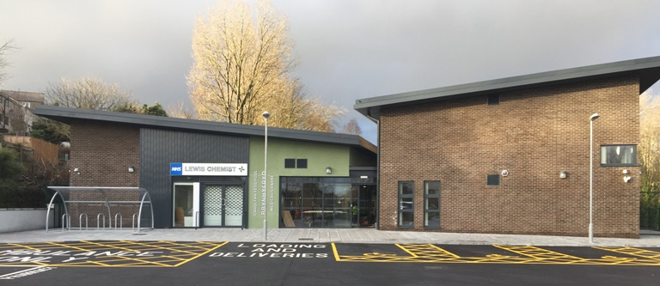The new Brynhyfryd Medical Centre has been designed to meet the changing demands and increasing number of patients in the area and replaces the existing surgery nearby.

Besides nine consultation rooms and two treatment rooms for the GPs practice, the 1,290 sq m custom-built centre boasts treatment room facilities for community services delivered by the health board.

As part of its design the centre in Llangyfelach Road also features dedicated space for training future GPs, a pharmacy and improved parking with disabled parking facilities for patients.

It has been developed in partnership between ABMU, Brynhyfryd Surgery and HPC (Wales) Ltd with the full support of Welsh Government and the City and County of Swansea.

Director of the ABMU’s Primary and Community Delivery Unit Hilary Dover (pictured) said: “We are delighted this new development is opening for our patients.”


“Our priority has always been to provide local residents with the healthcare services they need as close to home as possible.

“This new purpose built centre provides the community with much needed modern facilities and additional healthcare services.”

She explained that the new centre was much needed as demand for services in the community had changed radically since the previous surgery was originally opened in the mid-1990s.

“When it was built the surgery had 5,800 patients. That has grown considerably in the intervening years and now stands at 7,600, with the expectation this will increase in the coming years,” she added.

Source: Abertawe Bro Morgannwg University Health Board

