Family speak out after tragedy to help raise awareness of cot death
Wednesday, 1 March 2017
A Bridgend family who lost their 15-month old daughter to cot death want to share their story to help raise awareness of the condition and the fact older infants can still be at risk.

Emad and Jo Ewada, of Brackla, would also like to publically thank the team who helped them cope with their loss as well as supporting them through the subsequent safe arrival of little Aminah, who was born last March.
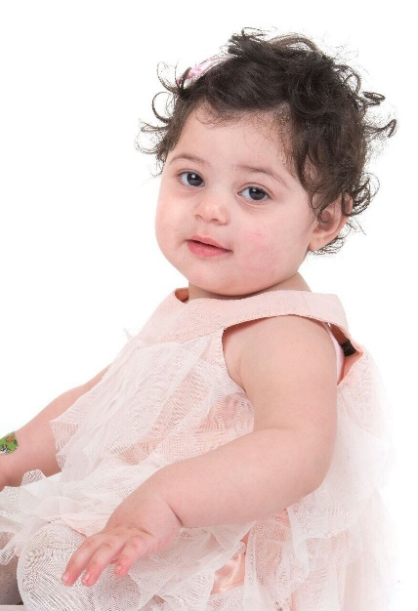
Members of the Flying Start team were on hand after the tragedy, to reassure the family during Aminah’s birth and as she now approaches the age her older sister Sophia (left) was when she died.

Jo said: “Sophia was fit and healthy, I was an experienced parent. I put her to bed as normal but when I found her in the morning she had died. It was completely unexpected.

“Everyone thinks that the risk of cot death lessens as they get older - you get the impression that once your child passes six months it’s plain sailing but people need to know the risks up are there until a child is five.

“I don’t think the condition should be called sudden infant death syndrome (SIDS), it would be more accurate to call it sudden death syndrome in children because it’s not just infants who are at risk.”

She and Emad now want to raise awareness of cot death and the advice offered by health visitors.

Although the Ewadas followed the guidance, it can help families reduce the risk of SIDS and includes always putting a baby on their back to sleep, keeping the baby smoke-free during pregnancy and never sleeping on a sofa or in an armchair with your baby. (See below for more advice)

“I feel so strongly about this. Important new research into cot death is going on but I still don’t have any answers.

“If by sharing our story, if just helps save one child then it will have been worth it,” said Jo.

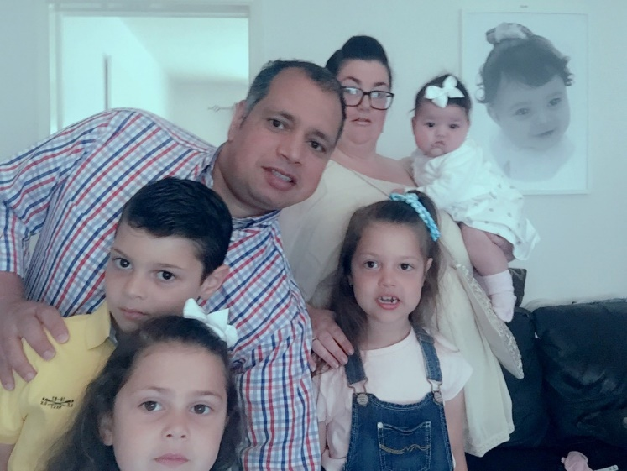
Sophia was the youngest of Jo and Emad’s children – her big brother Yusef is now 9 and sisters Tamara, 7 and Alia, 5 - and she was a healthy happy, baby enjoying nursery.

Immediately after her death Emad lost his job and Jo had to give up college where she was studying health and social care.

Flying Start health visitor Sam Knight, who began supporting the family after the tragedy, said: “Jo and Emad’s lives changed in a second, their stable family life was no more.

“Not only did it have an unimaginable impact on their family and emotions but they were also hit financially.

“We identified the needs of the family that had to be met and child and family support worker Rachel Pearce was able to give advice and practical solutions.

“Since then, as well as visiting regularly, I have been able to arrange counselling for Jo and Emad and for their children to have play therapy.”

Sam is always on hand to offer emotional support when they need it, said the couple.

“The time between Sophia’s death and her funeral was difficult for me because I come from a different culture where burial takes place straight away. That delay was killing me. But Sam is always here for me to talk to if I need to,” said Emad, originally from Egypt.
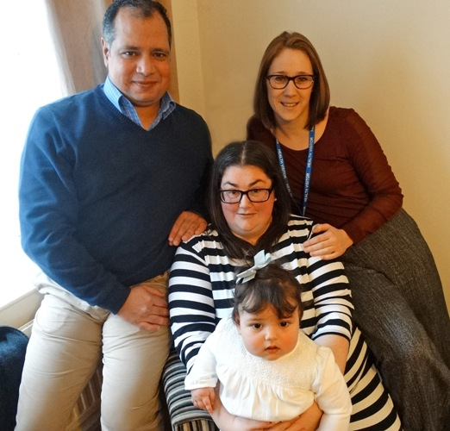
Sam was also there when Jo discovered she was pregnant again and was able to help address the couple’s anxieties over a new arrival.

Health visitor Sam Knight with Emad and Jo Ewada and little Aminah.

“We were happy and shocked when we found out Jo was pregnant but it was a different feeling to the other pregnancies,” said Emad.

Jo said: “We had talked about having another child but it happened so quickly. I had a perfectly normal pregnancy with Aminah – but my worries dominated everything. I felt all the time that something was wrong

“Fortunately I had a brilliant midwife in Julie Kemble – nothing was too much trouble for her.”

Early Years advisor Maria Harris also provided support to the family as she delivered an antenatal programme tailored to their situation.

“You think you know everything when you’ve had children before but after Sophia my confidence had completely gone.

“Maria has reassured me all the way. She is still amazing and is helping me work with Aminah’s sleep patterns because the whole area of sleep is the main cause of my anxiety.”

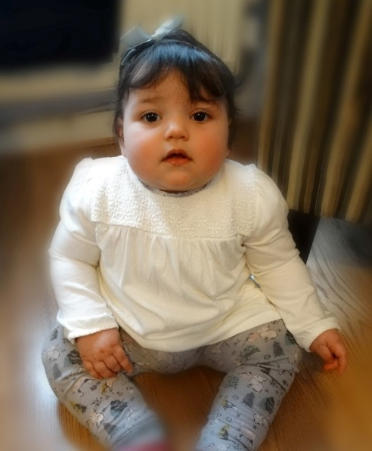
Following Aminah’s safe arrival, Sam arranged for her family to be part of the Care of the Next Infant (CONI) programme, a specialist service for bereaved parents, devised by cot death charity The Lullaby Trust.

“There has been a whole support network for us all and I am now at the stage when I don’t necessarily blame myself for what happened,” added Jo.

“All I can think about is just getting to Aminah’s first birthday and we will go from there.”

Aminah Ewada at her home in Brackla.

Her husband added: “Without the help we have had from Sam and everybody else we would be lost. We had a lot of problems but they came in and helped us.

“The whole team does a really, really good job for people who need help. The service does really important work – it’s been fantastic.”

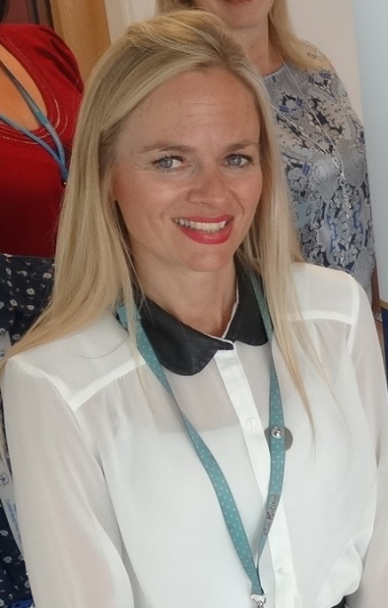
Sam said: “As a health visitor you don’t stop with just the baby, you extend that support to whoever needs it in the family.

“Jo and Emad are such an inspiration to all of us in the health visiting team because they’ve allowed us into their lives at such a difficult time and we have learned so much from them.”

ABMU’s lead health visitor for public health Jane O’Kane (left) said: “We are very proud of the service our health visitors offer to families at some of the most challenging times in their lives.

“To hear that our support and knowledge has been able to help the Ewadas is very gratifying indeed.“

She added: “We are very grateful that they have spoken out to share their story and help highlight cot death (sudden infant death).

“Our health visitors are here to support families as much as possible with caring for their little ones and we would offer the following advice.”

Things to do:
- Always place your baby on their back to sleep;
- Keep your baby smoke-free during pregnancy and after birth;
- Place your baby to sleep in a separate cot or Moses basket in the same room as you for the first six months;
- Breastfeed your baby;
- Use a firm, flat, waterproof mattress in good condition; and,
- To avoid accidents remove all pillows, soft bedding cot bumpers and soft toys from the cot
Things to avoid:
- Never sleep on a sofa or in an armchair with your baby;
- Don’t sleep in the same bed as your baby if you smoke, drink or take drugs or are extremely tired, if your baby was born prematurely or was of low birth weight;
- Avoid letting your baby get too hot; and,
- Don’t cover your baby’s face or head while sleeping or use loose bedding.
The Lullaby Trust, which provides support and advice, has more detailed information available to download:
Safer sleep for babies - A guide for parents
Safer sleep for babies - Easy read card
Sleeping products- Information sheet

For bereavement support call 0808 802 6868

For information and advice call 0808 802 6869

Source: Abertawe Bro Morgannwg University Health Board

