Friends step in to help with youngsters’ language skills
Tuesday, 14 March 2017
Youngsters have been given a helping hand to develop their language skills by dedicated fundraisers at Maesteg Hospital.

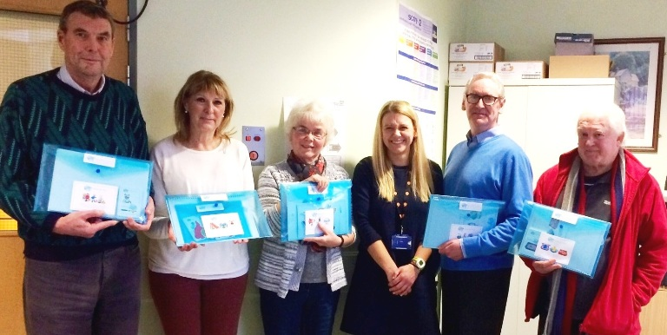The hospital’s League of Friends donated money collected at a variety of fundraising events to speech and language therapist Lowri Roberts who runs a clinic there.

League of Friends members with speech and language therapist Lowri Roberts and the Clear Pictoys they have bought for the clinic (above).

She was eager to be able to offer modern, colourful and engaging resources to her young patients and now, thanks to the Friends, she has been able to buy Clear Pictoys, which are part picture, part toy that help children explore sentence building.

“It’s amazing that cups of tea and cake sold by the Friends can turn into toys!

“These resources are brilliant because they are bright, colourful and catch children’s eyes.

“They let us assess and work on children’s understanding and use of language in an informal way,” said Lowri.

The children who visit Maesteg clinic are already enjoying the resources.

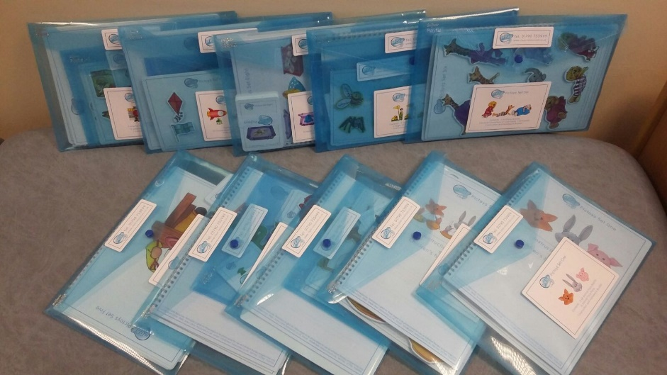
One delighted mum said: “The Pictoys are fab, I love the fact they have corresponding homework packs that enable me to carry on with activities at home my son after our speech therapy sessions!”

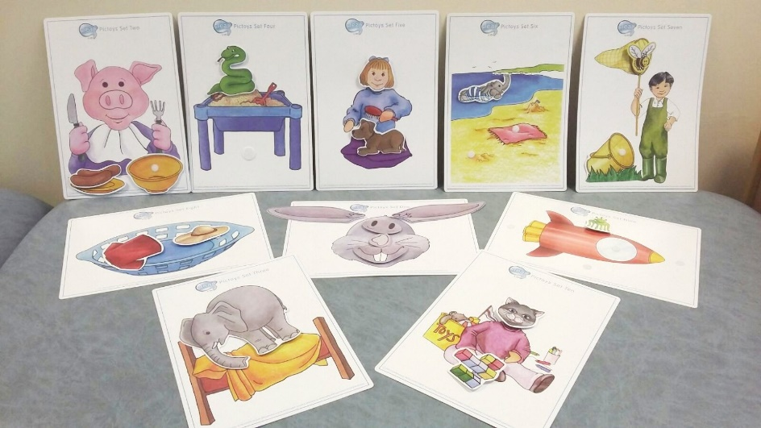
League of Friends chairman John Thomas added: “It’s always pleasing for us to see money we have raised throughout the year at the hospital fete and from various donations being put to good use for the benefit of all patients and departments at Maesteg Hospital.”

Head of speech and language therapy Alison Clarke said: “I’d like to thank the League for supporting the speech and language therapy service to deliver care to children and young people from the local area using modern resources.

“Both the therapists and the children appreciate having new materials to work with and play with.

“These will help children to explore early language skills leading from early word combinations to building sentences. The resources are attractive and fun and great for little hands.”

Source: Abertawe Bro Morgannwg University Health Board

