Health Secretary Vaughan Gething visits Morriston Emergency Department
Tuesday, 7 March 2017
Health Secretary Vaughan Gething has taken a behind-the-scenes look at one of the busiest emergency departments in Wales.
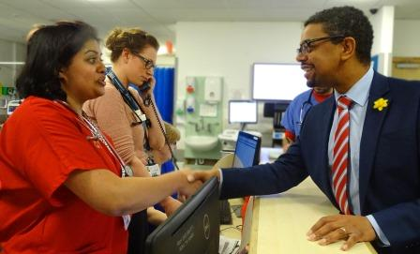
Mr Gething toured the ED at Morriston Hospital where he spoke to doctors and other clinicians, as well as senior managers.
Mr Gething talks to junior clinical fellow and ED sepsis champion Nisha Mallya

In addition to talking to them about their work on the frontline, Mr Gething also learnt about the steps being taken to combat sepsis within the ED.

Morriston Hospital emergency consultant Andy Macnab said: “I was very pleased to have the opportunity to show the Cabinet Secretary around the department.

“He has visited before and he’s been able to see some of the changes we’ve made to try to improve the experience of patients in the department despite the pressures we all know about.

“Mr Gething spoke to some of the middle grade and junior ED staff about their experience of working here and some of the novel roles we have introduced, such as our sepsis champions.”
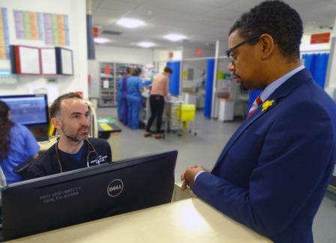
Last year Morriston ED embarked on a major campaign to raise awareness of sepsis among the public and clinical staff.

Sepsis is a potentially life-threatening condition, triggered by an infection or injury.

Right: Mr Gething pictured with emergency doctor Andrew Gemmell

The body’s immune system goes into overdrive as it tries to fight an infection, which can reduce the blood supply to vital organs such as the brain, heart and kidneys.

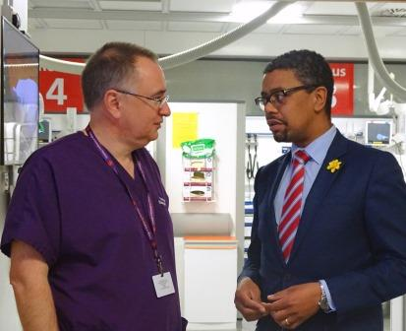
Without quick treatment sepsis can lead to multiple organ failure and death.

Among the clinicians Mr Gething spoke to was junior clinical fellow Nisha Mallya, one of the Emergency Department’s sepsis champions actively working to raise awareness.

Mr Macnab (pictured here with Mr Gething) added: “For me it was very good to be able to get across the perspective of a front-line clinician and the difficulties we face day in, day out – but particularly in the winter period.”

Source: Abertawe Bro Morgannwg University Health Board

