New initiative to tackle crime begins at Morriston Hospital
Wednesday, 1 March 2017
Police have joined forces with ABMU Health Board to prevent car crime and other offences being committed on hospital sites.

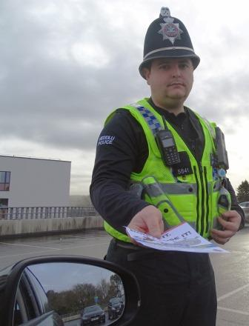
The initiative started with a police visit to Morriston Hospital today (Wed 1st March), with officers handing out vehicle crime prevention advice leaflets to patients, staff and visitors as they arrived.
One of the officers involved, PC Matthew Stanley, hands out leaflets in the Morriston Hospital multi-storey car park
Security staff then joined them to place the leaflets on vehicle windscreens in public and staff parking areas.

Similar exercises are planned at Singleton Hospital in Swansea and Bridgend’s Princess of Wales Hospital, while other initiatives tackling other types of crime are likely to take place later in the year.

ABMU’s Assistant Director of Strategy Des Keighan said vehicle crime was a comparatively small problem at Morriston Hospital – in fact, only 28 incidents had been reported in the last year across the health board.

These ranged from vehicles being damaged by other cars, to theft from, and of, vehicles.

Mr Keighan said: “We have been working with South Wales Police to marry their agenda for crime prevention with issues affecting the health board.

“We have now launched the vehicle crime initiative.

“We targeted visitors as they came into the hospital and did a leaflet drop on cars to raise awareness about good practice to keep vehicles and valuables secure.

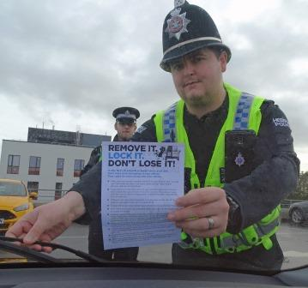
Right: PC Stanley is joined by PCSO Jamie Grey to distribute crime prevention leaflets

“We’re starting at Morriston Hospital and we are looking to run the same initiative at Singleton and Princess of Wales hospitals within the next month.

“Later in the year we will be working with the police to look at other issues we want to highlight, such as violence and aggression, and theft.”

Sergeant Gareth Prosser, Deputy Local Policing Inspector for the Morriston and Eastside sectors, said people could take simple steps such as ensuring vehicles were locked with no valuables left on display.

“It’s a very stressful time for patients and visitors, and we want to make sure everything is in order when they return to their vehicles,” added Sergeant Prosser.

“We regularly work with Morriston Hospital to reduce crime and the fear of crime, and we deal proactively with any offences that do take place.”

Source: Abertawe Bro Morgannwg University Health Board

