Sharing the message about staying healthy in pregnancy
Thursday, 2 March 2017

ABMU consultant Margery Morgan is hoping World Birth Defects Day on Friday will help remind mothers and mums-to-be how important it is to stay healthy.

Consultant obstetrician and gynaecologist Dr Morgan is lead clinician for the Congenital Anomaly Register and Information Service for Wales (CARIS) which is based at Singleton Hospital.

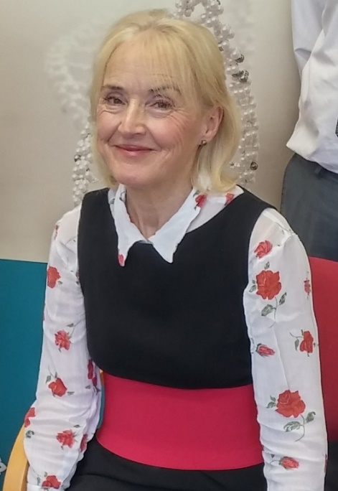
The service, which collects data about congenital anomalies and birth defects, has been highlighting problems that some infections can cause in pregnancy and what can be done to prevent unnecessary risks.

She said: “Infections can cause serious illness, developmental problems and lifelong disability such as hearing loss for the baby.”

Dr Morgan (left) has drawn up a list of tips for anyone who is pregnant or hoping to conceive soon.

These will help reduce the risk of infection in pregnancy and protect the baby as a result.

- Wash your hands before and after preparing food. Avoid soft or unpasteurised cheeses, pate and some fish – if you are unsure check with your midwife.
- Before you get pregnant, check your rubella (German measles) vaccination is up to date with your GP. Also current advice is not to travel to parts of the world which have the Zika virus if you are pregnant.
- Be careful with pets – do not change dirty cat litter and wash your hands after contact with any pet or farm animals.
- Avoid contact with anyone who has an infection.
- And wash your hands. . .
  - before and after food preparation,
  - when you are handling raw meat, eggs or unwashed vegetables
  - after gardening or touching dirt or soil
  - after touching pets and other animals
  - after playing with children, wiping runny noses and changing nappies
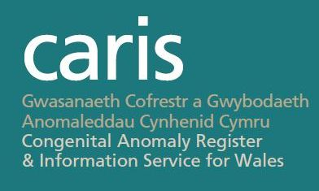
CARIS, which monitors variations in rates of anomalies and informs screening and support services, will be holding its annual meetings in November.

This year’s focus will be on congenital heart defects and their long-term significance and all health professionals are welcome to attend.

Details will be released closer to the event but for more information about the events or CARIS and its work go to www.caris.wales.nhs.uk or contact david.tucker2@wales.nhs.uk phone 01792 285241

To report a case email CARIS.SafehavenMailbox@wales.nhs.uk

Source: Abertawe Bro Morgannwg University Health Board

