Six of the best put ABMU staff in the frame for national awards
Thursday, 2 March 2017
Being in the running for a national award is a cause for celebration – and ABMU staff are up for no less than six of them.

Their skills, innovation and dedication to improving services have led to them becoming finalists at three prestigious awards ceremonies.

ABMU has three shortlisted finalists in the Advancing Healthcare Awards 2017, with the winners to be announced in London’s Chelsea Harbour Hotel on Friday 31st March.

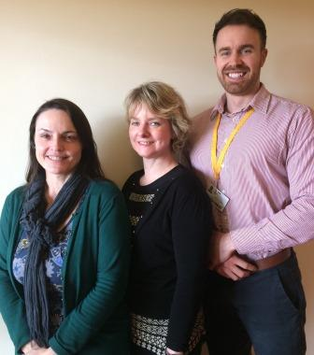
First up is the ABMU-wide Staff Wellbeing and Attendance Project, which is shortlisted in the Welsh Government Prudently Advancing Practice category.

Introduced using Welsh Government funding, it is spearheaded by workforce programme manager Beth Lavercombe, lead occupational therapist Rachel Turner and lead physiotherapist Mathew Tidball (pictured l-r here).

The project takes an innovative approach to improving staff health and wellbeing by using the unique skills of allied health professionals and workforce managers.

Mathew said the team wanted to thank ABMU Head of Staff and Wellbeing Margaret Lake, who submitted the initial funding bid and had been a constant source of advice and guidance.

He added: “We are delighted to have been shortlisted. The success of this project is due to the partnership working between our team and staff, managers, union representatives, operational HR and learning and development.

“Improving staff health and wellbeing is a jigsaw and we have tried to bring the pieces together working collaboratively with a number of our colleagues within the health board.”

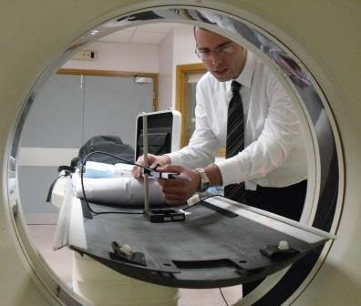
Meanwhile, Mark Edwards (right), lead clinical scientist in the medical physics and clinical engineering department at Singleton Hospital, has been shortlisted for the HSL Rising Star Award.

Colleagues describe Mark as a superb clinical scientist and a model NHS employee, who has successfully taken on many new challenges.

Junior colleagues and other staff groups often turn to Mark’s knowledge and sound judgement to deal with clinical problems. Mark has also taken the lead on several projects which bring benefits to patients.

Mark said: “I was delighted to find out I had been shortlisted for the Rising Star award.
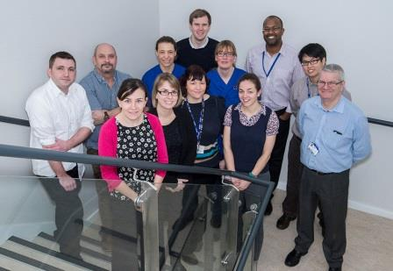
“I am very grateful to my colleagues for nominating me and recognising the contribution I make to the radiotherapy physics team at Singleton.”

Left: Staff from the Rehabilitation Engineering Unit at Morriston Hospital, which hosts PUPIS

Also making the final, this time for the Academy of Healthcare Science award for innovation, is the Pressure Ulcer Prevention and Intervention Service (PUPIS).

Part of the medical physics and clinical engineering department, PUPIS is a multi-professional team that takes innovative approaches to timely healing and long-term prevention of pressure ulcers.

This not only has obvious benefits for patients but helps reduce the demand pressure ulcers place on NHS resources.

Principal clinical scientist Mark Bowtell said the team was fully committed to opening new doors for the benefits of patients.

He added: “We are delighted to have been shortlisted and be part of raising the profile of innovation within the health board.

“It’s time to look at new ways of communicating among professionals and crucially how we interact with patients – and we are seeing more of them engaged in their care.”
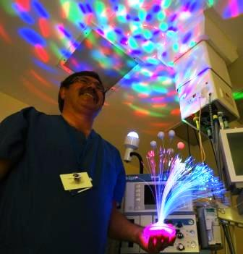
ABMU has also two finalists in the BMJ Awards 2017 – the first of which has already won an NHS Wales award.

Right: Paul Harris from Princess of Wales Hospital’s theatre team, demonstrates a light show used to help put patients at ease as part of the SPA experience

Soothing Patient Anxiety (SPA), a unique initiative at Princess of Wales Hospital, is in the running in the anaesthesia team category.

SPA involves the theatre team going to extraordinary lengths to make sure patients with learning disabilities feel at ease ahead of surgery.

This could mean playing a favourite film or music to a patient as they go to sleep or using an array of props ranging from disco lights to remote controlled toys to help relax them.

Speaking on behalf of the team, specialist trainer Paul Harris said they were honoured to reach the final stage of such a prestigious award.

He added: “It is recognition of how the team have listened to and worked with the unique vulnerable users of our service to redesign the way we care for them.

“Our approach ensures they can access treatment by making essential reasonable adjustments and they have positive experiences of their trip to an operating theatre.”

Another ABMU initiative, Managing Antibiotics Wisely, has been shortlisted in the clinical leadership team category.

It involves reducing the use of antibiotics in babies at Singleton’s neonatal unit, without adversely affecting outcomes. In fact, reducing inappropriate antibiotic use may improve health outcomes in babies for life.
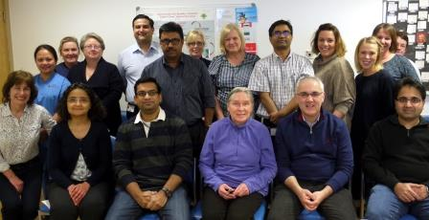
Pictured: The Singleton neonatal team

The project has seen a 43 per cent reduction in antibiotic use – double the original target and sustained over 12 months – with the unit recording one of its lowest death and serious illness rates of recent years.

Consultant neonatologist Dr Sujoy Banerjee, who led the project, said the team had put in a lot of hard work and it was great all those involved were being recognised for their efforts.

“The biggest challenge is to sustain this improvement over a longer period and we are planning to extend this work to our postnatal ward.

“Hopefully our experience can be replicated in other neonatal units in Wales and the rest of the UK.”

The winners of the BMJ Awards 2017 will be announced at the Park Plaza Westminster Bridge, London, on 4th May.

Finally, a service that transforms the lives of people with lymphoedema, a previously incurable condition, is a finalist in the specialist services category of the 2017 HSJ Value in Healthcare Awards.
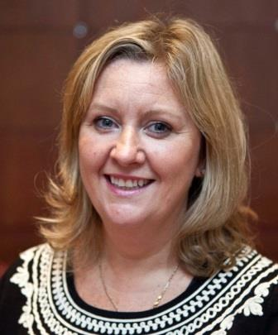
In 2015, Wales became the only UK nation to offer lymphatic venous anastomosis (LVA) on the NHS. The service is provided by Lymphoedema Network Wales in partnership with ABMU.

It uses super-microsurgery to bypass damaged lymph vessels and is carried out by specialist surgeons Amar Ghattaura and Tom Bragg at Neath Port Talbot Hospital.

Melanie Thomas (pictured right), National Clinical Lead for Lymphoedema in Wales, said they were delighted to have been shortlisted.

“Lymphatic venous anastomosis can be life changing for individuals with lymphoedema.

“We are so proud that Wales is the only country offering this service on the NHS to primary and secondary lymphoedema patients who meet the eligibility criteria.”

The HSJ Value in Healthcare Awards will be announced at Grosvenor House, London, on 24th May.

Source: Abertawe Bro Morgannwg University Health Board

