Staff set to share help on staying healthy and hydrated
Friday, 10 March 2017
ABMU staff are working together to make sure they have got plenty on the menu to mark this year’s Nutrition and Hydration Week.
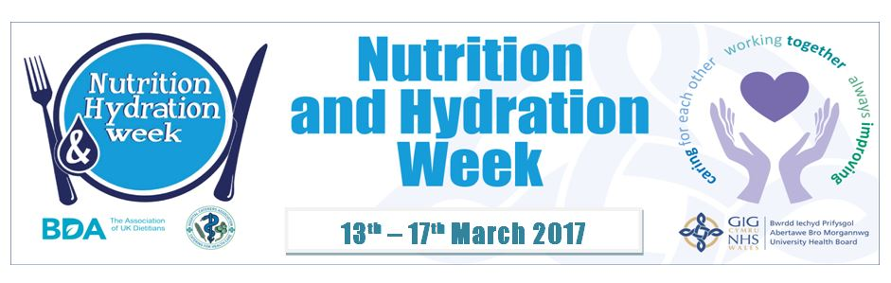The national event, now in its 6th year, is being enthusiastically supported by caterers, dietitians, nursing staff, and speech and language therapists across ABMU.

They have teamed up again to raise awareness of the importance of the nutrition and hydration care provided to patients.

The teams are also using the week, which starts on Monday, to promote some healthy eating messages.

There will be information stands at Neath Port Talbot, Morriston, the Princess of Wales and Singleton hospitals. Staff will be on for one day at each site for two hours in the middle of the day hand to offer advice and information.

On Tuesday, 14th March, staff will be promoting the importance of snacks for inpatients that are nutritionally at risk. Healthy snacks will be promoted at patient education groups.

The highlight of the week will be the traditional afternoon tea will be served on each ward on Wednesday 15th March, with patients being offered a variety of cakes. Some wards will be holding their own tea party to mark the event.

On Fruity Friday - 17th March – the children’s wards will be involved by hosting a game encouraging young patients to taste fruit.

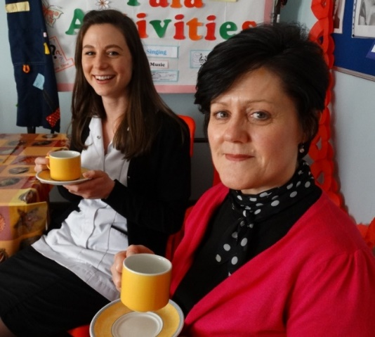
Flashback to last year’s afternoon tea party held to mark Nutrition and
Hydration Week at Neath Port Talbot Hospital.

In addition, the Neuro Rehabilitation Unit at Neath Port Talbot Hospital will be hosting a texture modified lunch for members of its multidisciplinary team, which will include thickened fluids that are given to patients who have problems with swallowing.

Members of the team at the Stroke Unit at Princess of Wales Hospital in Bridgend will be taking part in a three-day texture modified diet challenge to help raise awareness of the challenge of meeting patients’ nutritional requirements.

Clinical lead for nutrition and dietetics Debbie Lavelle said: “Nutrition and hydration are so important when it comes to our patients’ wellbeing and getting them on the road to recovery.

“We are delighted that once again so many of our colleagues from different teams and sites will be working together to help raise awareness during the week.

“We look forward to seeing staff, patients and their families as we spread the message about staying healthy and hydrated.”

For more information about the events, which is supported by the Hospital Caterers’ Association and the British Dietetic Association, contact the caterers, dietitians, nursing staff or speech and language therapists on each site.

Source: Abertawe Bro Morgannwg University Health Board

